Hong Kong Institute of Information Technology
Higher Diploma in Software Engineering
Final Year Project (ITE4116M
Final Report

(2025/2026)

StudyQuest

Supervisor: | Mr. Rory Lau
Co-supervisor: | Mr. CHENG Pok Hong
Student: | Cheung King Wa  Wang Wai Shing  Liang Fai Hung

We declare that this is a group project and that no part of this submission has been copied from any other student’s work or from any other source except where due acknowledgement is made explicitly in the text, nor has any part been written for us by another person.

Student | Contribution to the project (%)  (Total 100%) | Signature
Cheung King Wa 230360616 | 33.3 | Cheung King Wa
Wang Wai Shing 240213349 | 33.3 | Wang Wai Shing
Liang Fai Hung 240034175 | 33.3 | Liang Fai Hung

Table of Contents
1 ACKNOWLEDGEMENT 7
2 INTRODUCTION 9
2.1 Background 9
2.2 Project Overview 9
2.3 Purpose of This Report 10
2.4 Scope 10
2.5 Report Structure 11
3 LITERATURE REVIEW AND THEORETICAL FOUNDATION 12
3.1 Introduction 12
3.2 Educational Research Foundation 13
3.2.1 Gamification in Education 13
3.2.2 Study Habit Formation and Student Engagement 15
3.2.3 Parental Involvement in Learning 16
3.2.4 Artificial Intelligence in Education 18
3.3 Technology Trends in Educational Applications 21
3.3.1 The Digital Transformation of Education 21
3.3.2 Benefits of Educational Technology 21
3.3.3 Risks and Challenges of Educational Technology 22
3.3.4 How StudyQuest Addresses These Challenges 23
3.4 Gap Analysis: What Current Solutions Miss 24
3.4.1 Limitations of Existing Study Apps 24
3.4.2 The Integration Gap 24
3.4.3 How StudyQuest Fills the Gaps 24
4 PROBLEM ANALYSIS 26
4.1 The Problem Students Face 26
4.1.1 Additional Barriers to Studying 27
4.2 The Problem Parents Face 27
4.2.1 The Information Gap 27
4.2.2 The Conflict Trap 28
4.3 Why Current Solutions Don't Work Well 28
4.4 How StudyQuest Addresses These Needs 29
5 SOLUTION 32
5.1 Overall Design Approach 32
5.2 Core Features and How They Work 33
5.2.1 Study Time Tracking 33
5.2.2 Gamification Elements 34
5.2.3 Planned Social and Collaborative Features (Not Implemented in Interim Prototype) 35
5.2.4 AI-Powered Study Assistant 36
5.2.5 Planned Schedule Recommendations (Not Implemented in Interim Prototype) 38
5.3 Parent Dashboard Features 39
5.4 Technical Implementation 41
5.4.1 Progressive Web Application Approach 41
5.4.2 Frontend Technologies 41
5.4.3 Backend Server 42
5.4.4 Database 42
5.4.5 Authentication and Security 43
5.4.6 AI Integration 43
5.4.7 Deployment and Hosting 43
5.4.8 Why These Technologies 44
5.4.9 Development and Testing Workflow 44
5.4.10 Offline Capability 45
5.4.11 Performance Optimization 45
5.4.12 Scalability Considerations 45
5.5 User Interface Design 46
5.6 Educational Foundation and Research Basis 48
6 Requirements Specification 50
6.1 Use Case Diagram 50
6.1.1 Use Case Descriptions 50
6.2 Functional Requirements 60
6.2.1 Implemented Functional Requirements 65
6.2.2 Pending Functional Requirements (Planned for Final Release) 70
6.2.3 Out-of-Scope / Deferred 70
6.2.4 System Administration 70
6.3 Non-Functional Requirements 71
6.3.1 Performance Requirements 71
6.3.2 Reliability Requirements 71
6.3.3 Security Requirements 72
6.3.4 Usability Requirements 73
6.3.5 Compatibility Requirements 74
6.3.6 Maintainability Requirements 74
6.3.7 Data Requirements 75
6.4 System Constraints 75
7 Requirements 77
7.1 System Architecture 77
7.2 Scope 77
7.3 Provided Functionality and Processed Data 78
7.3.1 Core Learning Functionality 78
7.3.2 Gamification Engine 78
7.3.3 AI Tutoring Functionality 78
7.3.4 Family Link Functionality 79
7.4 Non-functional Requirements 79
7.4.1 Performance 79
7.4.2 Reliability 79
7.4.3 Security 79
7.4.4 Usability 79
7.5 Interfaces with Existing Systems 80
7.5.1 Kimi API (Moonshot AI) 80
7.5.2 Supabase Platform 80
7.5.3 Deployment Platform 80
8 DOCUMENTATION FOR PROBLEM ANALYSIS 81
8.1 Data Model 81
8.1.1 Entity Relationship Diagram 81
8.1.2 Component Architecture Diagram 87
8.2 Dynamic Model 89
8.2.1 Sequence Diagram: Study Session Start/End 89
8.2.2 Sequence Diagram: Parent-Child Linking 91
8.2.3 Sequence Diagram: Archive Alchemist 91
9 System Design 92
9.1 System Architecture (As-Built) 92
9.2 Database Design 94
9.2.1 Core User Tables 95
9.2.2 Study Activity Tables 97
9.2.3 Gamification Tables 99
9.2.4 Family / Parent Linking Tables 103
9.2.5 AI / Tutoring Tables 104
9.2.6 Tables Created but Not Fully Implemented Yet 107
9.3 API Design 110
9.3.1 Base URL & Conventions 110
9.3.2 Student API (/api/student) 111
9.3.3 Leaderboard API (/api/leaderboard) 115
9.3.4 Authentication API (/api/auth) 117
9.3.5 Tasks API (/api/tasks) — CRUD + Summary Statistics 121
9.3.6 Study Sessions API (/api/sessions) — Start/End/Active/History/Stats 126
9.3.7 Family Linking API (/api/family) — Parent/Student Linking 130
9.3.8 Tutor API (/api/tutor) — AI Tutor Sessions 133
9.4 User Interface Design 136
9.4.1 Student Mobile App Screens 136
9.4.2 Ai 144
9.4.3 Parent Web Dashboard Screens 146
9.4.4 Teacher Web Dashboard Screens 150
9.4.5 Mobile Responsiveness 156
9.4.6 Accessibility Features 156
9.5 Integration Architecture 156
9.5.1 Third-Party Services Integration 156
9.5.2 Real-Time Data Synchronization 157
9.6 Security Architecture 157
9.6.1 Authentication Flow 157
9.6.2 Data Protection 158
9.7 Performance Optimization 159
9.7.1 Caching Strategy 159
9.7.2 Scalability Considerations 159
10 IMPLEMENTATION 160
10.1 Implementation Work Log 160
10.1.1 Phase 1: Foundation Phase 160
10.1.2 Phase Two: Core Functionality 160
10.1.3 Phase 3: AI Integration 160
10.1.4 Phase Four: Refinement 161
10.2 Test Plan and Results — Point Form 161
10.2.1 Authentication & Onboarding (TP-001) 161
11 Critical Evaluation 163
11.1 Problems and Difficulties Encountered 163
11.2 Changes in Project Scope 164
11.3 Limitations of the suggestion system 165
11.4 Potential Difficulties for Final Development 165
12 IMPLEMENTATION PLAN 166
12.1 Software Process Model 166
12.1.1 Why Agile for StudyQuest 166
12.1.2 Our Agile Approach 167
12.1.3 Comparison with Waterfall 167
12.1.4 Development Practices 168
12.2 Project Schedule 168
12.2.1 Phase 1: Foundation and Core Features (Sep 2025 - Jan 2026) 169
12.2.2 Phase 2: Social and AI Features (Feb 2026 - Mar 2026) 170
12.2.3 Phase 3: Refinement and Deployment (Apr 2026) 170
12.2.4 Gantt Chart 171
12.3 Team Organization and Responsibilities 171
12.3.1 Team Member Roles 171
12.3.2 Rotating Coordination Role 172
12.4 Resources and Tools 173
12.4.1 Software Tools and Technologies 173
12.4.2 Hardware and Facilities 174
12.4.3 Budget Considerations 174
12.5 Deployment Strategy 175
12.5.1 Development Environment 175
12.5.2 Staging Environment 175
12.5.3 Production Environment 175
12.5.4 Monitoring and Maintenance 176
13 APPENDICES 176
13.1 A1 Original Project Plan (from Interim Report) 176
13.2 Revised Project Plan (Actual Execution) 179
14 REFERENCES 182
15 Appendices 184

ACKNOWLEDGEMENT

The authors would like to express sincere gratitude to the project supervisors, Mr. Rory Lau and Mr. CHENG Pok Hong, for their continuous guidance, technical expertise, and constructive feedback throughout the development of StudyQuest.

We also thank the Hong Kong Institute of Information Technology (HKIIT) for providing the academic environment and resources necessary for this Final Year Project. Special appreciation goes to our fellow students who participated in user acceptance testing and provided valuable feedback on the gamification and AI tutoring features.

Cheung King Wa (230360616)
Wang Wai Shing (240213349)
Liang Fai Hung (240034175)

ABSTRACT
This interim report provides an overview of StudyQuest's progress. StudyQuest is a progressive web application designed to help secondary school students develop good study habits through time tracking, gamification, family involvement, and AI assistance. The goal of this interim phase is to validate the feasibility of the three-tier architecture by implementing a working prototype. The prototype connects a React frontend to an Express.js backend and integrates with a Supabase PostgreSQL database. Currently, the prototype supports user authentication, learning session tracking, points-based gamification, an achievement system, leaderboard viewing, task management, parental control panel access, and initial AI tutoring/scheduling modules. This report documents the updated requirements, the implemented system architecture, database schema, API interface, and key UML diagrams. Furthermore, the report assesses the difficulties encountered during implementation and proposes updated plans to complete remaining features, improve reliability, security, and usability before final release.

INTRODUCTION

Background
One of the most difficult things for today's secondary school students is to study regularly. Many students are aware that they should study on a regular basis, but many are not motivated to do so. Conventional study techniques are tedious, and students don't receive feedback on their work right away. This makes it challenging to develop long-lasting study habits.

Parents have their own obstacles to overcome while still wanting to support their children's education. They have no idea how much their kids truly study, what areas require greater focus, or how to effectively inspire them. Parents frequently lack the resources necessary to make learning a constructive, cooperative experience, and checking on kids can cause conflict in the family.

Current solutions fall into distinct categories: educational platforms like Khan Academy provide content but lack habit-building features; time-tracking apps like Forest concentrate only on productivity metrics without involving students; and general gamification apps like Habitica offer rewards unrelated to real learning. There is currently no platform that combines cross-subject applicability, AI-powered tailored support, real-time parental oversight, and evidence-based gamification into a cohesive system created especially for secondary education.

Project Overview
StudyQuest is a mobile web app that helps secondary school students between ages 13 and 18 build better study habits. The app combines game-like features with family connection tools and an AI study assistant to keep students motivated. The app serves three main groups of users. Students use it to track their study time and stay motivated through points and badges. Parents can monitor their child's progress and provide timely support. Teachers can integrate the app into their classroom activities to track student work. What makes StudyQuest different from other apps is how it brings everything together. Most study apps either track time, teach content, or gamify learning, but not all three. StudyQuest combines motivation tools, family support features, and learning assistance in one place, creating a complete study support system.
What makes StudyQuest different is how it brings everything together. Most study apps do ONE thing: they track time, OR teach content, OR gamify learning. StudyQuest combines all three approaches PLUS family involvement. Students stay motivated through games, parents stay informed through the dashboard, and AI provides personalized help—all in one platform.

Purpose of This Report

This report aims to address three interconnected problems in student learning. First, many students struggle to maintain a consistent study routine. They lack motivation, are easily distracted by phones and social media, and cannot see their own progress. This lack of visible improvement leads to frustration and reduced study time. Second, parents want to support their children's learning but often don't know where to begin. They can't see what their children are learning or how much effort they're putting in. This makes it difficult for parents to determine when to encourage their children and when to give them enough space. This lack of information leads to frustration for both parents and children. Third, existing learning apps fail to meet all these needs simultaneously. Time-tracking apps simply record time but are tedious to use. Learning apps teach concepts but fail to cultivate study habits. While some social learning apps exist, none effectively connect students and parents.

By developing a single platform that allows parents to keep informed, students to monitor their progress, and everyone to stay motivated through game-like features, StudyQuest seeks to address these issues. By combining these components, we want to improve the consistency, assistance, and overall effectiveness of studying.

Scope
"StudyQuest is a Progressive Web Application (PWA) that works on phones, tablets, and computers. The app has three main parts:
For Students: A study timer, points and badges system, leaderboards, and friend features
For Parents: A dashboard showing their child's study time, progress, and goals
For Teachers (Optional): Classroom challenges and student verification
The app does NOT create lessons or teaching content. It only helps students build better study habits."

The main system consists of a parent dashboard that shows student progress, a points and badges system that promotes persistent work, and a study timer that automatically measures concentrate time. Additionally, students can use leaderboards to compare their progress with classmates and receive homework assistance from an AI chatbot.

We have purposefully restricted the focus on motivation and habit formation. The software does not provide instructional materials, offer live tuition, or offer video courses. Instead of attempting to be a comprehensive learning platform, our targeted strategy enables us to excel at solving the particular issue of study consistency.

The project timeline runs from September 2025 to April 2026, with development divided into three main phases: design and planning, implementation, and testing and refinement.

Report Structure
This report is organized into seven chapters that document our project from research through to implementation planning.

Following this introduction, Chapter 2 explains the research behind our design. We review studies about gamification, study habits, parental involvement, and AI in education.

Chapter 3 analyzes the specific problems that StudyQuest addresses. We examine current student study challenges, review existing solutions in the market, and identify gaps that our project fills.

Chapter 4 presents our proposed solution in detail. We describe the system architecture, explain our choice of technologies, and outline the main features and how they work together.

Chapter 5 specifies both functional and non-functional requirements. We define what the system must do and establish performance, security, and usability standards it must meet.

Chapter 6 shows the technical design: database tables, API endpoints, and screen mockups.

Finally, Chapter 7 presents our implementation plan with timeline, resource allocation, risk assessment, and testing strategy.

LITERATURE REVIEW AND THEORETICAL FOUNDATION

Introduction
This chapter examines the research foundation that supports StudyQuest's design and development. Understanding how gamification, study habit formation, parental involvement, and artificial intelligence impact education is essential for creating an effective learning support system.

The chapter answers a central question: "How can software engineering combine gamification, family collaboration, and AI to help secondary school students build better study habits?"
To answer this question comprehensively, this chapter reviews existing academic research in four key areas:
Gamification in Education - How game elements motivate students and what makes gamification effective or ineffective
Study Habit Formation and Student Engagement - What researchers know about building consistent learning behaviors
Parental Involvement in Learning - How family support impacts student success
Artificial Intelligence in Education - The promises and risks of using AI to support learning
Each section explains how research findings influenced our design decisions.

Educational Research Foundation

Gamification in Education
What is Gamification?

Gamification is the application of features of game design to non-gaming environments. Gamification, according to Deterding et al. (2011), incorporates components such as leaderboards, badges, levels, and points into non-gaming activities. By incorporating game-like rewards and challenges into study activities, gamification in education seeks to increase student engagement.

What Research Shows
A comprehensive review by Ruiz et al. (2024) analyzed 90 studies on gamification in schools from 2013-2023. The research revealed both benefits and limitations:
Benefits:
- Students report increased motivation when learning includes game elements (Khan et al., 2017)
- Classroom participation improves with gamified activities (Garcia-Sanjuan et al., 2018)
- Students show greater confidence in problem-solving (Rachels & Rockinson-Szapkiw, 2018)
- Gamification can enhance collaboration among students (Maxwell, 2016)
Limitations:

- While gamification increases motivation, many studies found no significant improvement in test scores compared to traditional methods (Chen & Chiu, 2016; Rachels & Rockinson-Szapkiw, 2018)
- The relationship between increased motivation and actual learning outcomes remains unclear (Hanghøj et al., 2018)

Why Gamification Sometimes Fails
Researchers identified five main problems (Ruiz et al., 2024):
- Narrow focus on motivation - Most studies only measured if students felt more motivated, not if they actually learned more
- Short implementation periods - Many studies only used gamification for a few weeks; longer periods are needed to build lasting habits
- Lack of teacher training - Only 3% of studies focused on training teachers to use gamification effectively
- One-size-fits-all approach - What motivates one student may not motivate another
- Isolated subject implementation - When used only in one subject, gamification becomes a novelty rather than an integrated learning approach

What Makes Gamification Effective
Research identifies five key design principles (Su & Cheng, 2015; Bilbao-Aiastu & Miranda-Urquij, 2022):
- Clear learning objectives - Game mechanics must connect directly to educational goals
- Immediate feedback - Students need to see progress and receive feedback right away
- Variety of rewards - Use multiple types of recognition (points, badges, levels, social acknowledgment)
- Social elements - Collaboration and friendly competition enhance learning outcomes
- Personalization - Adapt game elements to individual student interests and learning styles
Application to StudyQuest
Based on this research, StudyQuest incorporates several evidence-based design decisions:
- Multiple engagement dimensions: The system tracks not only motivation but also actual study time, consistency, and progress toward learning goals
- Clear connection to learning: Points and rewards are tied to actual study activities, not just logging into the app
- Immediate feedback: Students see their points, streaks, and progress update in real-time after each study session
- Variety of rewards: The system includes points, levels, badges, streaks, and social recognition through leaderboards
- Long-term use design: StudyQuest is designed as a semester-long or year-long tool, not a short-term novelty
- Cross-subject integration: Students can track study time across all subjects, seeing their overall study patterns rather than isolated subject performance
However, StudyQuest extends beyond traditional gamification research by integrating family collaboration and AI support—features that most gamification studies did not examine.

Study Habit Formation and Student Engagement
The amount of time and effort students put into learning activities is referred to as student involvement (Kuh, 2009). Behavioral (participation), emotional (interest), and cognitive (deep thought) are its three dimensions.

Current Challenge
A 2024 survey found that 75% of school leaders identified students' lack of focus as the top barrier to learning (Goldman, 2024). Common problems include:
- Difficulty maintaining attention during lessons
- Lack of motivation to complete homework
- Preference for immediate digital rewards over delayed academic rewards
- Inability to self-regulate study time
What Research Says About Building Study Habits
Five key findings from research:
- Consistency over intensity: Regular, shorter study sessions produce better learning than irregular cramming (Fredricks et al., 2004)
- Visible progress: When students see their improvement through clear metrics and charts, they maintain motivation longer (Su & Cheng, 2015)
- Streak motivation: Tracking consecutive days of activity creates psychological momentum that encourages daily engagement (Rachels & Rockinson-Szapkiw, 2018)
- Goal setting: Students who set specific, measurable goals show higher engagement than those with vague objectives (Fredricks et al., 2004)
- Immediate rewards: Immediate feedback and rewards maintain engagement more effectively than delayed rewards (Anunpattana et al., 2021)
Application to StudyQuest
StudyQuest applies these findings through:
- Automatic time tracking that makes progress visible
- Daily streak counter that motivates consistency
- Visual progress charts showing improvement over time
- Immediate point rewards after each study session
- Goal-setting tools for specific targets
- Self-regulation support through pattern analysis

These features transform studying from an abstract obligation into a concrete, trackable activity with visible progress and immediate rewards.

Parental Involvement in Learning
Why Parental Involvement Matters

Parental participation has a positive impact on students' academic outcomes, according to numerous studies. Students whose parents actively participate in their education receive better scores, have better attendance, show more favorable views toward school, and are more likely to do their homework, according to Education Week's examination of research findings (Stanford, 2023).

Parental participation has advantages that go beyond elementary school. Appropriate parental involvement benefits even secondary school pupils, but as kids grow more independent, the type of interaction needs to alter.

Support vs. Control: A Critical Distinction
Not all parental involvement helps students. Research distinguishes between supportive involvement and controlling involvement (Hempenstall, 2025):
Supportive Involvement includes:
- Showing interest in school activities and learning
- Providing resources and a conducive study environment
- Celebrating achievements and progress
- Setting collaborative goals with the child
- Maintaining positive communication about education
- Offering help when requested
Controlling Involvement includes:
- Constantly checking homework and demanding to see every assignment
- Using threats or punishment to force studying
- Making all educational decisions without child input
- Creating stress and anxiety about academic performance
- Focusing exclusively on grades rather than learning

According to research, controlling participation can worsen parent-child relationships, raise anxiety, and lower intrinsic motivation, whereas supporting involvement improves student results (Stanford, 2023).

The Information Gap Problem
Many parents wish to encourage their kids' education, but they don't have access to trustworthy data regarding their progress and study habits. Conventional communication techniques lead to issues:
- Asking "Did you study today?" often leads to dishonest answers and arguments
- Waiting for report cards means problems are discovered too late
- Checking physical homework is difficult when most schoolwork is digital
- Relying on teacher communication provides only periodic updates
Without objective information, parents face two poor choices:
- Ask too many questions, creating conflict and resistance
- Ask too few questions, missing problems until academic performance suffers
Research-Based Recommendations
Studies suggest that effective parental involvement in secondary education should:
- Provide objective data that eliminates the need for interrogation (Stanford, 2023)
- Focus on effort and progress rather than only final grades
- Enable collaborative goal-setting where parents and students decide together
- Celebrate consistency and improvement, not just perfect performance
- Maintain positive communication about education

Researchers stress that by offering clear, unbiased information that promotes constructive dialogue rather than inciting conflict, technology might improve parental participation.

Application to StudyQuest
StudyQuest implements research-based parental involvement through several mechanisms:
- Parent Dashboard: Provides objective data about study time, subjects studied, and streak maintenance without requiring parents to ask intrusive questions.
- Collaborative Goal Setting: Parents and students can set study goals together through the app, creating shared ownership of objectives.
- Positive Progress Focus: The system highlights consistency, improvement, and achievement rather than only pointing out deficiencies.
- Reward System: Parents and students can agree on real-world rewards for achieving study goals, creating positive reinforcement.
- Reduced Conflict: By eliminating daily questioning about studying, the system removes a common source of parent-child arguments.
- Privacy Balance: Students maintain some autonomy (parents see study time but not specific homework content), respecting developmental needs for independence.

These features aim to transform parental involvement from a source of conflict into a source of support, using objective data to facilitate positive communication about education.

Artificial Intelligence in Education
The Growing Role of AI
Artificial intelligence is rapidly becoming integrated into education. Recent research examines both the opportunities and risks of AI in learning environments.
Potential Benefits of AI in Education
Research identifies several ways AI can enhance learning:
Personalized Learning: AI systems can analyze individual student patterns and provide customized recommendations that would be impossible for teachers to generate for every student individually (Schwartz, 2024).
24/7 Availability: AI tutors can answer questions and provide support at any time, filling gaps when teachers and parents are not available (Kestin et al., 2025).
Pattern Recognition: AI can identify learning patterns, study habits, and areas of difficulty that might not be obvious to students or teachers.
Immediate Feedback: AI systems can provide instant responses to student questions and work, supporting the learning process without delays.
Adaptive Content: AI can adjust difficulty levels and content presentation based on individual student performance and progress.
Risks and Concerns About AI in Education
However, research also identifies significant concerns:
Over-Reliance and Reduced Effort: Students may use AI to get quick answers rather than engaging in productive struggle necessary for learning. A recent survey found that students feel overwhelmed by too much technology in education (Paulo & Othman, 2025).
Reduced Critical Thinking: When AI provides complete solutions, students may not develop problem-solving skills and independent thinking abilities (BBC News, 2025).
Equity Concerns: Not all students have equal access to AI tools, potentially creating or widening achievement gaps.
Data Privacy: AI systems collect significant amounts of student data, raising concerns about privacy and data security.
Replacement of Human Connection: Over-automation may reduce valuable teacher-student and peer-to-peer interactions that are essential for learning.
What Makes AI Effective in Education
Research suggests that AI supports learning most effectively when it:
Provides Scaffolded Support: Rather than giving complete answers, effective educational AI asks guiding questions and provides hints that maintain productive struggle (Kestin et al., 2025).
Augments Rather Than Replaces: AI should support teachers and parents, not replace human instruction and guidance (Schwartz, 2024).
Focuses on Process, Not Just Answers: AI should help students understand how to solve problems, not just provide solutions.
Maintains Student Agency: Students should remain in control of their learning, with AI as a tool rather than a director.
Protects Privacy: Educational AI must handle student data responsibly and transparently.
Current Trends and Future Directions
According to research from Stanford's Graduate School of Education, technology is reinventing education through AI-powered tools that can provide personalized learning experiences at scale (Schwartz, 2024). However, researchers emphasize that successful integration requires:
- Clear educational objectives guiding AI implementation
- Teacher training on effective AI use
- Student education about appropriate AI use
- Ongoing evaluation of AI impact on learning outcomes
- Attention to equity and access issues
The BBC reports that while AI tools like ChatGPT can help students with studying, they also raise important questions about when assistance becomes doing the work for students rather than helping them learn (BBC News, 2025).
Application to StudyQuest
StudyQuest incorporates AI in two specific, research-informed ways:
1. AI Study Assistant Chatbot
The chatbot is designed to provide guided support rather than complete answers:
- Asks clarifying questions to help students think through problems
- Provides hints and explanations rather than solutions
- Available 24/7 when teachers and parents cannot provide immediate help
- Maintains productive struggle by guiding thinking rather than replacing it
- Focuses on understanding concepts, not just completing assignments
2. AI Schedule Optimizer
The schedule optimizer analyzes individual study patterns to provide personalized recommendations:
- Identifies when each student studies most effectively
- Suggests optimal study times based on historical performance
- Recommends subject rotation based on individual patterns
- Adapts to changing schedules and preferences
- Provides data-driven insights while respecting student autonomy
Both AI features are designed to support learning without replacing human thinking or interaction. The AI serves as a tool that students control, providing assistance and insights while maintaining student agency in the learning process.

Technology Trends in Educational Applications

The Digital Transformation of Education
Education has undergone significant technological transformation over the past decade. The COVID-19 pandemic accelerated adoption of digital learning tools, making technology integration essential rather than optional in modern education.
However, this rapid digitization has created both opportunities and challenges that StudyQuest must address.

Benefits of Educational Technology
Research and news sources identify several benefits of technology in education:
Accessibility and Flexibility: Digital tools allow students to learn anywhere, anytime, breaking traditional constraints of classroom-bound education (Schwartz, 2024).
Personalized Learning: Technology enables customization of learning experiences to individual student needs, paces, and preferences in ways that traditional classroom instruction cannot achieve.
Immediate Feedback: Digital systems can provide instant feedback on student work, supporting the learning process more effectively than delayed grading.
Engagement Tools: Interactive digital content and gamified learning experiences can increase student interest and motivation compared to traditional methods.
Data-Driven Insights: Educational technology generates data that helps teachers, parents, and students understand learning patterns and make informed decisions.
Resource Availability: Students gain access to vast educational resources, expert knowledge, and learning materials beyond what physical schools can provide.

Risks and Challenges of Educational Technology
However, research also identifies significant risks:
Screen Time Concerns: The BBC reports growing concerns about excessive screen time affecting children's physical health, sleep patterns, and social development (BBC News, 2025).
Digital Distraction: Educational technology must compete with entertainment apps and social media for student attention. Many educational apps fail because they cannot maintain engagement against more entertaining alternatives.
Over-Digitization: Some educational institutions have digitized processes that work better in traditional formats, creating unnecessary complexity and reducing effectiveness.
Equity Issues: Not all students have equal access to devices, internet connectivity, and technical support, potentially widening achievement gaps.
Privacy Concerns: Educational apps collect significant student data, raising questions about privacy protection, data security, and appropriate use of information.
Reduced Human Connection: Excessive reliance on technology may reduce valuable face-to-face interaction between teachers and students or among peers.
Shallow Learning: Some educational technology encourages surface-level engagement rather than deep understanding, prioritizing completion over comprehension.

How StudyQuest Addresses These Challenges
Based on research and current trends, StudyQuest makes specific design decisions to maximize benefits while minimizing risks:
Balancing Screen Time:
StudyQuest tracks study time but does not require constant app interaction. Students study their actual schoolwork; the app simply records their effort. This approach avoids adding unnecessary screen time while providing digital tracking benefits.
Purpose-Driven Technology:
Every feature in StudyQuest serves a specific educational purpose. The app avoids unnecessary complexity and focuses on essential functions: tracking study time, providing motivation, and facilitating family communication.
Supporting Traditional Learning:
StudyQuest does not replace traditional studying or teaching. It supports existing study habits by making them visible, measurable, and rewarding. Students still complete their regular homework and school assignments.
Privacy by Design:
StudyQuest minimizes data collection, storing only essential information about study time and progress. The system does not track homework content, personal communications, or other private information.
Enhancing Human Connection:
Rather than replacing parent-child or teacher-student interaction, StudyQuest facilitates better communication by providing objective information that supports positive conversations about education.
Promoting Deep Learning:
The AI chatbot guides thinking rather than providing easy answers. The app rewards actual study time, not just quick completion, encouraging students to engage meaningfully with their work.

Gap Analysis: What Current Solutions Miss

Limitations of Existing Study Apps
Current study applications typically focus on one aspect of the learning process:
Timer Apps (Forest, Flora): These apps track study time and provide focus tools but lack academic integration, family involvement, and meaningful rewards beyond virtual trees.
Educational Platforms (Khan Academy, Duolingo): These platforms teach specific content but do not help students organize their regular schoolwork or develop general study habits.
Gamified Learning Apps: Many apps add game elements but fail to connect them meaningfully to actual learning goals, making gamification shallow entertainment rather than educational support.
Parent Monitoring Apps: Most monitoring apps create surveillance rather than collaboration, damaging trust and creating conflict instead of support.

The Integration Gap
Research shows that effective educational support requires integration of multiple elements:
- Gamification that connects to real learning goals
- Family involvement that supports rather than controls
- AI assistance that guides rather than replaces thinking
- Habit tracking that promotes consistency
- Immediate rewards that reinforce effort
No existing application successfully integrates all these elements. Current solutions address isolated aspects without creating a comprehensive system.

How StudyQuest Fills the Gaps
StudyQuest uniquely combines:
- Gamification with Purpose: Points and rewards tied to actual study effort, not just app usage
- Family Collaboration: Transparent information sharing that facilitates support without surveillance
- AI Guidance: Intelligent assistance that helps thinking rather than providing shortcuts
- Cross-Subject Integration: Tracking study habits across all subjects, not just one area
- Habit Formation Focus: Long-term design for building consistent study behaviors
This integrated approach addresses the limitations of existing solutions by treating student success as requiring multiple types of support working together.

PROBLEM ANALYSIS

The Problem Students Face
Most secondary school students know they should study regularly, but actually sitting down to study feels almost impossible. The problem is not laziness. Students face real barriers that make studying feel like a battle they lose every day.
Lack of Motivation and Focus: Nothing exciting occurs when a pupil opens a textbook. There are no levels to unlock, no points to accrue, and no instant sense of achievement. Pushing a big rock upwards with no obvious destination is how studying feels. The learner leaves the book feeling exactly the same after reading about history or working through math problems for an hour. Did anything really take place? It's hard to tell. Compare this to opening Instagram or starting a video game. Within seconds, something happens. A notification appears. A friend likes your post. You complete a quest and earn points. The brain gets an immediate reward. Studying offers none of this instant feedback, so the brain naturally resists it. School administrators in the US are aware that this issue is becoming worse. According to a 2024 poll, three out of four school administrators stated that kids' incapacity to concentrate has grown to be a significant obstacle to learning (Goldman, 2024). Although the issue is not new, social media and cellphones have made it much more difficult for students to focus on tedious, unfulfilling tasks like studying.

No Clear Goals:

Imagine embarking on a journey with no idea where you're going. After an hour of walking, you consider stopping or continuing. You don't know if you're even near or halfway there. The majority of students approach their studies in this manner. A pupil chooses to focus on math. She takes a seat with her textbook. Thirty minutes go by. She questions whether she should continue or stop right now. She lacks a goal, a finish line, and a means of determining whether she has accomplished enough. An hour later, feeling unsure, she puts the book down. Did she do enough studying? Should she have spent more time studying? She doesn't know. This absence of specific objectives makes it simple to give up early and causes ongoing uneasiness.

Additional Barriers to Studying
Time management is another major obstacle. Today's students juggle academics, extracurricular activities, family responsibilities, and social lives. When they finally sit down to study, they often waste time on various distractions. A student might plan to study for two hours but spend half that time checking her phone, getting distracted, or staring blankly at the pages. After studying, she feels guilty for wasting time but doesn't know how to improve next time. Studying also brings feelings of loneliness and isolation. While friends are texting online, sharing photos, and playing games together, this student sits alone in her room, facing her textbook. This sense of isolation turns studying into a punishment rather than a positive experience. Research shows that students disconnected from their learning groups have lower motivation and poorer academic performance (Hari Rajan et al., 2024). When studying means being alone, students naturally avoid it. Finally, encountering difficulties without any help can lead to frustration and giving up. One student encountered a perplexing math problem at 9 pm. Her parents couldn't remember advanced algebra. Her teacher had already gone home. Her friends were equally confused. She stared at the problem for twenty minutes without making any progress, and finally gave up in frustration. This repeated experience of helplessness leads students to believe that learning only brings frustration, not success.

The Problem Parents Face
At night, parents worry about their kids' schooling. They want to assist, yet they are unsure of what to do and feel helpless. There appears to be an argument at the end of every discussion regarding homework. It feels like every inquiry is bothering you. Parents are faced with a challenging circumstance for which there are no good answers.

The Information Gap

Parents are often completely unaware of their children's learning situation. A parent asks, "Did you study today?" The child replies, "Yes, two hours." But what exactly happened during those two hours? Was the child diligently studying, or scrolling through social media? Did the child understand the material, or were they overwhelmed by difficult problems? Parents have no idea. This lack of information creates a thorny dilemma. If parents ask too many questions, the child feels interrogated and becomes resentful. If parents ask nothing, the child may fail a course months later before the report card comes out, and the parents will be completely unaware. Parents can't monitor their children every moment, but they need to understand the truth about their children's learning. Research confirms that parental involvement can improve students' academic performance, but this only happens when parents have accurate information about their children's learning (Stanford University, 2023). Without this information, parents cannot provide appropriate support. They either over-help, creating dependency, or under-help, leaving the child to struggle alone.

The Conflict Trap

Most parents try to encourage their children's learning by asking questions and setting expectations. Unfortunately, this often leads to conflict rather than cooperation. The conversation follows a familiar pattern: Parent: "Have you finished your homework?" Child: "I'll do it later." Parent: "You said that yesterday too. Do it now." Child: "Stop nagging! I said I would!" Parents feel frustrated because the child needs constant reminders. The child feels controlled and resentful. Both sides feel stressed. This recurring pattern damages the parent-child relationship and doesn't actually increase the child's learning motivation. Research shows that controlling or interfering parental interventions actually harm children's academic performance, rather than help them (Hempenstall, 2025). However, most parents lack other options. They know nagging doesn't work, but they don't know what else they can do. They lack the tools or strategies to actively support their children's education. Parents also struggle to find a balance between support and independence. They want their children to be self-taught learners, able to study independently without prompting. But they also worry that giving their children too much freedom will lead them to give up on learning altogether. Finding the right balance requires the information and tools that most parents lack.

Why Current Solutions Don't Work Well

Many products claim to help students learn better, but each has serious limitations and fails to truly solve the problem. Time-tracking apps like Forest and Flora, while accurately recording study time, lack family involvement, fail to provide personalized learning pattern analysis, and rely on superficial gamification mechanics, such as planting virtual trees, which quickly become tedious. Educational platforms like Khan Academy and Duolingo, while effective in teaching specific subjects, fail to cultivate general learning habits, don't provide parents with insights into their child's progress, and often feel like just another assignment rather than a motivating tool. Whether paper or electronic, homework schedules list tasks but fail to track actual study time, requiring constant manual input. Students often forget or avoid tasks, frequently leading to arguments between parents and children about whether tasks have been truly completed. Parental monitoring apps like Google Family Link display overall screen time, but they create an environment of surveillance rather than collaboration, failing to distinguish between productive study and leisure time, ultimately damaging the trust between parents and children. General gamified apps like Habitica make learning tasks more engaging through gamified rewards, but they aren't specifically designed for learning. Rewards are often disconnected from actual learning outcomes, and they lack parental involvement or family collaboration mechanisms. The core problem is that no solution currently successfully integrates accurate time tracking, meaningful gamification, family collaboration, personalized AI insights, and social incentives into a unified platform. Most apps excel in one aspect while neglecting others, forcing students to piece together multiple unrelated tools. What students truly need is a comprehensive solution that addresses the cultivation of good study habits holistically, achieving this goal within a unified system.

How StudyQuest Addresses These Needs

Based on the problems students and parents face, StudyQuest provides an integrated solution:
1. Makes Studying Immediately Rewarding
The Need: Students need to see visible progress and feel accomplished after each session.
How StudyQuest Solves It:
- Every study session earns points (1 point per minute)
- Real-time progress bars show advancement toward next level
- Badges unlock for specific achievements
- Leaderboards create friendly competition
- Similar to games that make players feel successful, but tied to real studying
2. Provides Clear, Achievable Goals
The Need: Students need specific targets, not vague intentions like "study more."
How StudyQuest Solves It:
- Students and parents set specific goals together ("study 30 minutes daily")
- Visual progress bars show exactly how close to achieving each goal
- Goals break down into manageable daily steps
- System tracks progress automatically
3. Tracks Time Accurately and Automatically
The Need: Simple tracking that students will actually use consistently.
How StudyQuest Solves It:
- One-tap start/stop timer
- Tracks in background (app can be closed)
- No manual entry required
- Provides objective data parents can trust
4. Creates Social Connection
The Need: Transform studying from lonely isolation into social activity.
How StudyQuest Solves It:
- Students form study teams with friends
- Leaderboards show peer progress
- Group goals create collective motivation
- Share achievements and encourage teammates
5. Provides Immediate Help When Stuck
The Need: Instant guidance when encountering difficult problems or losing motivation.
How StudyQuest Solves It:
- AI chatbot available 24/7 for study strategy questions
- Asks guiding questions instead of giving direct answers
- Provides personalized advice based on student's own patterns
- Helps with "how to study" not "what are the answers"
6. Gives Parents Real Information
The Need: Objective data about studying without interrogating the child.
How StudyQuest Solves It:
- Parent dashboard shows study time, subjects, and streaks automatically
- Real-time updates (no need to ask "did you study?")
- Information comes from the system, not from arguments
- Creates positive conversations based on facts
7. Enables Family Collaboration
The Need: Parents and students working as teammates, not adversaries.
How StudyQuest Solves It:
- Joint goal-setting (both parties agree beforehand)
- Collaborative reward system (child earns agreed-upon rewards)
- Positive notifications celebrate achievements together
- Shifts dynamic from conflict to cooperation
8. Provides Personalized Optimization
The Need: Study schedules that work with each student's natural rhythms.
How StudyQuest Solves It:
- AI analyzes when student focuses best
- Generates personalized weekly schedule recommendations
- Identifies peak productivity times for each subject
- Adapts as patterns change over time

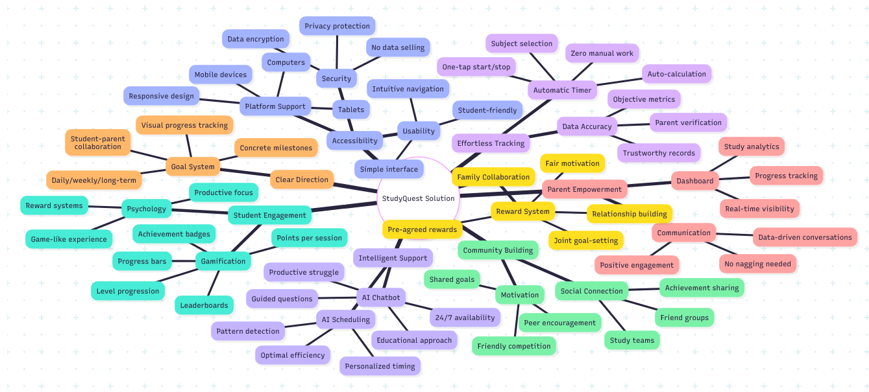
Figure 3.4: Comprehensive Overview of How StudyQuest Addresses Identified Needs

SOLUTION

Overall Design Approach

StudyQuest aims to address the interconnected challenges students and parents face in the learning process. This app integrates multiple research-proven strategies into a platform that students genuinely enjoy using. Its design follows three core principles that guide every feature and decision. First, the app must be engaging and fun, encouraging students to use it willingly, rather than seeing it as another chore imposed on them by adults. Second, the app must support genuine learning, not just make learning easier without truly helping students understand the knowledge. Third, the app must strengthen family relationships by fostering collaboration between parents and students, rather than creating new conflicts. These principles permeated the entire development process and guided specific design decisions. The app uses gamification elements such as points, levels, and badges to make learning feel rewarding and fun. However, these gamification features are carefully designed to encourage genuine learning, not allow students to exploit loopholes. An AI chatbot offers assistance when students encounter difficulties, but it asks guiding questions rather than providing direct answers, ensuring that students still engage in the critical thinking required for genuine learning. Parents can view their children's learning data through their own control panel, but the system emphasizes positive progress and collaboration rather than monitoring and control. The overall architecture consists of three seamlessly collaborating main components. Students use mobile and web applications to track study time, receive AI assistance, display learning progress, and enable social features. Parents access a separate control panel that displays learning analytics, target progress, and provides tools to set collaborative rewards. Behind both interfaces, a cloud-based backend system securely stores all data, runs AI models, calculates scores and levels, and ensures all data is synchronized across different devices. Each feature is designed based on research into effective methods in education. The gamification system draws on research showing that immediate feedback and visible progress enhance learning motivation. The AI ​​chatbot follows research principles of effective tutoring and scaffolded learning. The parent control panel reflects research findings that providing support rather than pressure is more beneficial for children's learning when parents are involved. The social features reflect research showing that students learn better when they feel connected with a group of peers working towards similar goals. This application uses modern cloud technology to ensure stable operation on mobile phones, tablets, and computers, while protecting data security and privacy. Students and parents do not need to understand these technical details. For them, the application will function normally anytime, anywhere, whenever needed.

Core Features and How They Work

Study Time Tracking

StudyQuest's core feature is its precise and automatic tracking of study time. When students begin studying, they simply open the app and tap the prominent green "Start Studying" button. A drop-down menu then appears, allowing students to select a subject, such as math, science, history, or English. The timer immediately starts, displaying the elapsed time in large, clear numbers. While the timer is running, students can close the app and use their textbooks, notebooks, or other study materials as usual. The timer continues running in the background, eliminating the need for the app to remain open. After finishing their study session, students reopen the app and tap the red "Stop" button. The app automatically saves the study record, including subject, duration, and timestamp, requiring no further action from the student. This simple two-step process makes tracking study time easy and convenient. Students don't need to estimate time afterward or record anything in a notebook. The app easily captures accurate study data. Over time, this data accumulates into a complete study record, including total study time, study time for each subject, daily study patterns, and consecutive study days. The timer interface is designed to be clean and uncluttered. Large buttons make starting and stopping quick and easy. The subject selection list includes common school subjects, and students can also add custom subjects as needed. Color coding helps students distinguish different subjects at a glance. The timer's operation screen is clear and eye-catching, but contains no distracting animations or unnecessary messages to avoid affecting student learning. All recorded times are automatically synced to the cloud, meaning students can start learning on their phones and then view their complete learning records on tablets or computers. The data is always up-to-date and accessible from any device. Parents can also view this data through the control panel to obtain objective information about their child's learning habits without having to ask or have the student manually report.

Gamification Elements

StudyQuest transforms the abstract concept of "learning more" into tangible progress through a comprehensive gamification mechanism. Points are earned for every minute of learning, and accumulating points allows users to level up, similar to gaining experience points in a role-playing game. As students earn points and level up, they can unlock badges and rewards, receiving immediate and tangible feedback on their achievements.

The points system uses a simple formula: one minute of learning equals one point. For example, 30 minutes of learning immediately adds 30 points to a student's score. Points accumulate continuously with no upper limit. The app prominently displays the current score on the main screen, along with a progress bar indicating the student's progress towards the next level.

Higher levels require more points, resulting in a growing sense of accomplishment. The initial levels may only require 100 points and can be achieved with just a few sessions. Higher levels, however, require thousands of points, representing weeks or even months of continuous learning. This progressive system provides short-term goals for beginners and long-term challenges for dedicated learners.

As students earn points, the progress bar fills, eventually leading to the next level. These progress bars update in real-time, clearly jumping forward when a study session is completed, providing an immediate sense of accomplishment. When students reach new levels, the app displays an animated celebration interface, similar to leveling up in a game. This sense of achievement brings psychological satisfaction and motivates students to continue their efforts.

Badges not only recognize accumulated study time but also acknowledge specific achievements. For example, students can earn a "Weekend Warrior" badge for studying on Saturdays and Sundays; a "Subject Master" badge for studying the same subject for five consecutive days; or a "Marathon" badge for studying for more than two hours at a time. The app includes dozens of different badges covering various achievement types, allowing students to gain a sense of accomplishment from multiple perspectives.

The continuous study days tracking feature records the number of consecutive study days, encouraging students to develop a daily study habit rather than occasional cramming. The app prominently displays the current continuous study days and provides reminders when a student's study record is about to end. Many students report that maintaining a study streak has become a powerful motivator, encouraging them to continue studying even on days when they initially feel unmotivated. Research shows that cultivating habits through daily consistency is one of the most effective ways to build long-term behavioral change.

Leaders add elements of social comparison and healthy competition to gamified systems. Students can view their ranking among friends, study groups, or the broader StudyQuest community. Leaderboards can display various metrics, including total score, current level, longest winning streak, or study time over the past week. This social element stimulates students' innate competitive instincts while creating a student community where all students are working towards the same goal: more consistent learning.

All these gamification elements serve a carefully designed purpose, not just entertainment. They provide immediate feedback and visible progress, making learning meaningful rather than meaningless. They set specific goals, addressing the problem of students not knowing what to strive for or when they are done. They cultivate learning habits by tracking learning winning streaks and providing ongoing rewards. Research consistently shows that well-designed gamification, when implemented effectively in educational settings, can increase engagement and actual learning outcomes.

Planned Social and Collaborative Features (Not Implemented in Interim Prototype)

Learning can often feel lonely and isolating, significantly reducing motivation. StudyQuest addresses this issue with a range of features designed to create a learner community where everyone can work together towards a common goal.

Students can form study groups of 2 to 10 people to study together online. Group members can see each other's total study time, work together to achieve team goals, and celebrate achievements together. For example, a group can set a goal of studying together for 100 hours in a month, with each member contributing their time to reach the goal. A progress bar shows the group's progress, and milestones such as reaching the halfway point or the final goal are notified.

Study groups enhance accountability and social support. When a student feels unmotivated, seeing teammates studying can inspire them to start studying themselves. Group members can send each other encouraging messages via the app's chat function. Members can also quickly respond to each other's learning updates using emojis like likes or flames, receiving immediate positive feedback.

Beyond small group learning, a broader leaderboard system fosters a sense of belonging, integrating students into a larger community dedicated to learning. Students can browse leaderboards filtered by school, city, or globally. Seeing thousands of other students spending similar amounts of time studying normalizes learning, making it feel like something many others are doing, rather than a solitary endeavor.

The app also includes an optional achievement-sharing feature, allowing students to post their accomplishments to the community feed. When a student reaches a new level, completes a series of lessons, or earns a rare badge, they can share these achievements with the wider community. Other students can view these feeds, gain inspiration, and offer congratulations. This feature is entirely optional; students who wish to maintain their learning privacy can disable it.

All social features include appropriate privacy controls and security measures. Students can choose the visibility of their profiles, such as visible to all, visible only to friends, or completely private. The chat function includes content filtering to block inappropriate content. Parents can view their children's social interactions through a parental control panel and adjust privacy settings as needed.

AI-Powered Study Assistant

Students often feel frustrated and even give up when they encounter difficulties in their studies and don't receive help. StudyQuest's AI chatbot provides 24/7 real-time assistance, meeting students' critical need for immediate support.
Students can access the chatbot through a prominent icon on their main learning screen. Clicking the icon opens the chat interface, allowing them to type questions in natural language, just like asking a real tutor. The AI ​​can understand questions about math problems, scientific concepts, historical events, writing assignments, and almost any academic topic a secondary school student might learn.

However, the chatbot is designed to promote learning, not just provide quick answers. This design is based on extensive research showing that students learn better when actively exploring problems rather than receiving immediate, complete answers. When students ask questions, the chatbot typically provides guiding questions, hints, or suggestions to help them think about the next steps, rather than giving a direct answer.

For example, if a student seeks help solving a quadratic equation, the chatbot might ask what methods are available for solving quadratic equations or suggest they try factorization first. If students remain confused, the chatbot will gradually provide more specific hints, eventually guiding them step-by-step through the problem-solving process when necessary. This progressive support maintains the active exploration needed for genuine learning while preventing students from getting stuck for too long and ultimately giving up due to frustration.

The chatbot also monitors the conversation to detect if students are merely seeking answers to assignments without actually learning. If this pattern is identified, the chatbot will steer the conversation towards understanding concepts rather than completing the assignment. It might explain that it can help students learn how to solve similar problems, but cannot directly complete the assignment for them.

Behind the interface, the chatbot uses advanced natural language processing and machine learning techniques to understand students' questions and generate helpful responses. The system is specifically trained for educational purposes and follows pedagogical principles developed by educational researchers. Unlike general-purpose AI assistants that prioritize providing maximum assistance, this system prioritizes educational outcomes, even if it means the initial answers may not be immediately direct.

All chatbot conversations are logged and can be reviewed by parents through the parent dashboard. This transparency ensures parents know what kind of help their children receive and creates accountability for appropriate use of the AI assistance.

Planned Schedule Recommendations (Not Implemented in Interim Prototype)
What sets StudyQuest apart from other simple learning tracking apps is its ability to analyze learning patterns and provide intelligent suggestions on when and how to study more effectively.

The app's AI system continuously analyzes each student's learning records, looking for patterns and trends. It analyzes a student's typical study time, which times of day they study the longest, their most frequently studied subjects, and the relationship between these patterns and other factors, such as the day of the week or the time of year.

Based on this analysis, the system generates personalized learning plan suggestions designed to help each student optimize their study habits. For example, the AI ​​might notice that a student typically spends a long time studying math on Saturday mornings but struggles with math on weekday evenings. The system would then suggest that the student schedule math study for weekend mornings, as students tend to concentrate better on weekends.

As data accumulates, these suggestions become increasingly accurate and personalized. After students have used the app for a few weeks, the AI ​​has gathered enough information to provide very specific suggestions regarding ideal study times, appropriate study durations for different subjects, and even to issue alerts when a student might interrupt their learning progress.

These suggestions are presented gently, rather than as mandatory requirements. For example, the app might display a notification: "Based on your learning history, you typically learn English best on Tuesday afternoons. Would you like to schedule an English class for 3 PM tomorrow?" Students can accept, modify, or ignore these suggestions according to their preferences. The goal is to provide helpful guidance that aligns with each student's natural learning pace and preferences, rather than imposing a rigid, controlling schedule.

Personalized systems can also adapt to changing circumstances. If a student's learning patterns change due to new extracurricular activities or seasonal changes, the AI ​​will identify these changes and adjust the suggestions accordingly. The system is designed to respond flexibly, rather than adhering to assumptions that have worked in the past.

Parent Dashboard Features
Parents can access StudyQuest through a separate interface designed specifically for their needs and perspective. This dashboard allows parents to understand their child's learning progress without frequent inquiries or constant monitoring.

The core information displayed on the parent dashboard is the same as that seen by students, but organized to better suit parents' most pressing concerns. The main screen shows total study time for the day, week, and longer periods. Parents can easily see whether their child is studying consistently and how their current engagement compares to previous weeks. Subject breakdowns show whether the child is focusing evenly across all subjects or neglecting any.

Activity feeds display recent study records in reverse chronological order, including the time, subject, and duration of each study session. These feeds provide concrete evidence of learning, allowing parents to offer affirmation and encouragement. Parents no longer need to ask, "Did you study today?" and receive a perfunctory "Yes" or an excuse like "I'll study later," but instead can see objective data accurately showing the time and duration of their child's study.

The consecutive study days tracking feature displays the number of consecutive days the child has studied, encouraging parents to acknowledge and support their child's consistency. A seven-day learning log provides parents with concrete positive feedback, allowing them to share with their children and strengthen parent-child relationships by acknowledging their efforts rather than criticizing their shortcomings.

The dashboard also displays progress towards goals jointly set by parents and students. Visual progress bars show the completion of daily, weekly, or milestone goals. When a goal is achieved, both parents and children receive notifications with the opportunity to celebrate and receive rewards.

This collaborative reward system operates through the parent dashboard. Parents and students can collaboratively set rewards associated with specific goals through a simple configuration interface. Parents can enter descriptions of rewards, such as "Family Movie Night" or "An Extra Hour of Screen Time," and associate them with goals, such as "Reaching Level 10" or "Learning Every Day This Week." When the student achieves a goal, the app notifies the parent to distribute the agreed-upon reward. Parents confirm the reward distribution through the dashboard, and the system records this confirmation message so both parties are clearly aware of the fulfillment of their commitments.

This structured reward system avoids various problems common in informal reward arrangements. The system avoids disagreements arising from reward commitments because rewards are documented in writing. It also prevents parents from forgetting to give rewards, as the app sends reminder notifications. Furthermore, because the system objectively tracks progress, it prevents students from falsifying their progress.

Parents can also view their child's conversations with the AI ​​chatbot through the control panel. This transparency serves two purposes. First, it allows parents to monitor the type of help their child is receiving, ensuring that AI is used appropriately for learning, not for cheating. Second, it helps parents understand the knowledge points their child is most confused about, allowing them to provide additional support or seek tutoring when necessary.

All functions of the control panel emphasize collaboration and positive support, rather than monitoring and control. The interface highlights achievements, progress, and effort, rather than focusing on failures or shortcomings. Notifications celebrate milestones instead of nagging about missed lessons. The overall design encourages parents to be their children's teammates and cheerleaders, not supervisors and critics.

Privacy controls allow families to customize what information is visible and what information needs to be kept confidential. Students can choose whether certain data is displayed on the parent control panel or is only visible to the student. This respects student autonomy while ensuring appropriate parental involvement. The goal is to find a balance between providing parents with sufficient information to offer support and ensuring that students do not feel their privacy is completely violated.

Technical Implementation

StudyQuest is designed to function as a Progressive Web Application (PWA) on any web browser-equipped device. It is not necessary for parents or students to download apps from app stores. They just use Chrome, Safari, Firefox, or any other contemporary browser to access the website.

Progressive Web Application Approach
Progressive Web Apps (PWAs) combine the advantages of websites and mobile applications. Students can use StudyQuest directly in their browser or install it on their phone or computer's home screen for quick access. Once installed, it functions almost identically to a native app, but without the need for review by the Apple or Google app stores.

The PWA model means StudyQuest can use the same codebase to run on iPhones, Android phones, tablets, and computers. There's no need to create separate versions for different devices. The interface automatically adjusts to fit different screen sizes, displaying perfectly from small phones to large desktop monitors.

Frontend Technologies

The interface seen by students and parents is built using React.js 18 or later. React.js is a popular JavaScript library that simplifies the construction of interactive web applications. It organizes the interface into reusable components, much like building modules. For example, a study timer is one component, a progress bar is another, and a leaderboard is yet another. These components can be combined and reused throughout the application.

The visual design uses Tailwind CSS, a modern styling framework that makes it easy to create responsive designs. Tailwind provides pre-built categories for common design patterns such as buttons, cards, and layouts. This means the interface looks good and works well on all screen sizes without the need to write complex custom CSS for each element.

PWA functionality supports several important features. Students can install StudyQuest onto their phone's home screen with a single tap, and it opens like a normal application. The application can be used offline for some basic functions, such as viewing study history and progress. When the network connection is interrupted, the application will save the learning session to the local machine and automatically synchronize it to the server when the connection is restored.

Backend Server

The backend server handles all business logic, data processing, and communication with the database. It's built on the Node.js and Express frameworks. Node.js allows server-side code to be written in JavaScript, which is also used for frontend development. This makes development more convenient, as the team can use the same programming language for all tasks.

Express is a lightweight framework that makes it easy to build REST APIs. It handles requests from the frontend, processes them, and sends responses back to the backend. For example, when a student stops learning, the frontend sends a request to the backend. The backend calculates the earned points, checks badge unlock status, updates the database, and sends the results back to the frontend.

Database

All user data, learning records, achievements, and other information are stored in a PostgreSQL database. PostgreSQL is a powerful relational database that stores data in well-structured, relational tables. For example, the `users` table stores account information, the `study_sessions` table stores each learning session, and the `achievement_unlocked` table records the badges earned by each student.

PostgreSQL was chosen because it efficiently handles complex queries, maintains data integrity through constraints, and scales well as the number of users grows. It supports advanced features such as indexes for fast searches and transaction processing to ensure data consistency even when multiple users access the data simultaneously.

Authentication and Security

User authentication uses JSON Web Tokens (JWTs). Once a student or parent successfully logs in, the server creates a JWT containing their user ID and permissions. This token is sent with every subsequent request to verify the user's identity. For security reasons, the token expires after one hour, but the user can use a refresh token to obtain a new access token without logging in again.

All communication between the browser and the server is encrypted using HTTPS to protect data in transit. Passwords are never stored in plaintext; instead, they are hashed using bcrypt (a secure one-way encryption algorithm). Even the database administrator cannot see the actual passwords.

AI Integration

StudyQuest integrates an external AI service (Kimi API) to support learning assistance features. In the transitional prototype, all AI-related functions (such as learning techniques, content summarization, quiz generation, and tutor-guided responses) are implemented by calling the Kimi API through the backend interface. This design provides AI functionality without deploying internal models, while centralizing AI access to the backend, ensuring security, facilitating logging, and controlling costs.

Deployment and Hosting

The front-end and back-end are deployed on different cloud services optimized for their respective purposes. The front-end React application is hosted on Vercel, a platform designed for modern web applications. Vercel provides automatic deployment for code updates, a global Content Delivery Network (CDN) for fast global loading, and full PWA support, including Service Workers for offline functionality. Students and parents access StudyQuest through a custom domain pointing to the Vercel server. The back-end servers run on Railway or Render, two cloud platforms specifically designed for hosting Node.js applications. These services offer auto-scaling, meaning they can automatically increase server capacity to handle more users during peak periods. They also provide automatic SSL certificates, health monitoring, and easy deployment from the code repository. The PostgreSQL database is hosted on Railway or Supabase. These hosted database services automatically handle backups, security updates, and expansion. The development team does not need to directly manage the database servers. Both services offer daily automatic backups and store backups in multiple geographic locations to prevent data loss.

Why These Technologies

These technology choices were made for specific reasons supporting the project's goals. React.js is widely used and well-documented, making it easy for the team to find assistance and learning resources. It also boasts a large ecosystem of ready-made components, accelerating development. Progressive Web Applications (PWAs) eliminate the need for separate iOS and Android apps, reaching users on all devices. This is especially important for student projects with limited time and resources. Node.js and Express are lightweight and fast, ideal for building APIs. Using JavaScript in all aspects means the team can share code between the front-end and back-end, allowing developers to handle both simultaneously. PostgreSQL is a free, open-source, and extremely reliable database. It handles the complex relationships in StudyQuest's data model better than simpler databases. The chosen deployment platform offers a free plan or very low price, ideal for student projects, while also providing professional features such as automatic scaling and backup. An external AI API enables StudyQuest to provide intelligent functionality without requiring the team to have machine learning expertise or the computing resources needed to run AI models. Because AI-powered calls are limited to specific functions used only occasionally, rather than being used continuously, the costs remain manageable.

Development and Testing Workflow

The development process follows modern best practices. Code is stored in a Git repository on GitHub, facilitating team collaboration and change tracking. Once a developer completes a feature, they push the code to GitHub. This triggers an automated deployment to a pre-release environment, allowing the team to test changes before releasing it to users. Each time the code is updated, automated tests are performed to check if the new changes break existing functionality. These tests cover critical functionalities such as user authentication, session tracking, and points calculation. Once a feature is tested and approved in the pre-release environment, it is deployed to production for use by real users. Vercel and Railway automatically handle this deployment when the code is merged into the main branch.

Offline Capability

A key feature of PWAs is offline support. StudyQuest utilizes Service Worker technology to function even during temporary network outages. If a student begins learning offline, the application saves the learning materials to their local browser. Once the network connection is restored, these materials are automatically synced to the server. Offline functionality is limited to core features. Students can start and stop learning, view their learning history, and check their current level and score. Features requiring real-time data, such as leaderboards and AI chatbots, will be disabled until the network connection is restored.

Performance Optimization

StudyQuest employs several technologies to ensure fast loading and smooth response. The front-end uses code splitting, meaning that only the code needed for the current page is loaded initially. Other code is loaded from the backend as needed. Images and icons are optimized and served via CDN, so they are loaded from servers geographically closer to the user. The Tailwind CSS framework is configured to include only styles actually used, reducing file size. The backend uses caching for frequently used data such as leaderboards. Instead of querying the database every time, the system stores leaderboard data in memory and refreshes it every five minutes. This reduces database load and speeds up response times. Database queries are optimized by indexing frequently used columns. For example, finding student session records is fast because the database maintains an index on the `student_id` field.

Scalability Considerations

While the initial target users were hundreds of students, the architecture can scale to thousands. The backend employs a stateless design, meaning any request can be handled by any server. This allows for easy addition of more servers as traffic increases. The database uses connection pooling to efficiently handle large volumes of concurrent requests. Read-intensive operations (such as viewing analytics data) can be directed to a replica of the database instead of the primary database, thus distributing the load. If future costs allow, services like Redis can be added for caching, and Cloudflare can be used to provide additional CDN capabilities and DDoS protection.

User Interface Design
The user interface design prioritizes simplicity, clarity, and ease of use, allowing students to focus on learning rather than struggling to figure out how to use the application.

The student application's main screen clearly displays the most important information. A prominent "Start Learning" button occupies the center of the screen, making the main operation immediately apparent and allowing for quick start with a single tap. Above the button, the current level and score are displayed in bold numbers, along with a progress bar showing progress towards the next level. Below the button, today's learning time and the current consecutive learning days are clearly displayed. This layout ensures that students can immediately see key data upon opening the application, while the main operations remain clearly visible.

The color scheme uses bright, vibrant colors that attract the attention of young people while maintaining good readability. The primary color is a vibrant blue, conveying an atmosphere of trust and focus. Green represents proactive action, red represents stopping, and gold represents achievement; these secondary colors enhance visual interest and convey rich meaning through color psychology. The interface avoids using overly dark or muted colors to prevent a serious, rigid, uninteresting, and unengaging feel.

The font selection prioritizes readability and hierarchical structure. Large, eye-catching headings make chapter titles immediately clear. Oversized fonts display time, scores, and grades, ensuring visibility even from across the room. The text maintains a comfortable reading size, while operation buttons are bold and easily visible.

The timer interface during study sessions features a deliberately minimalist design. The running timer is displayed in large numbers at the top of the screen, next to the selected subject. Below is a simple "Stop" button. This minimalist design avoids distractions during study and allows students to easily pause or end their study session.

Different sections of the application are navigated via a tab bar at the bottom of the screen, clearly labeled with icons for "Home," "Analytics," "Social," "AI Chat," and "Profile." This standard navigation is familiar to smartphone users, allowing access to all main functions from anywhere in the application with a simple double tap.

The parental control panel features a more professional and business-like design, suitable for adult users. The interface emphasizes data visualization through clear charts and graphs, rather than gamified elements. The sidebar navigation menu provides access to different sections, including overview, detailed analysis, goal management, reward settings, and chatbot conversation reviews. The dashboard works perfectly on desktop monitors and tablets, with a responsive layout that automatically adapts to different screen sizes.

All interactive elements adhere to iOS and Android platform specifications, making the application feel natural and smooth, rather than stiff or confusing. Buttons, input fields, and controls behave exactly as users expect based on their experience with other mobile applications. This adherence to platform standards reduces the learning curve, allowing users to get started immediately without extensive tutorials.

Accessibility features ensure the application is suitable for all students, including visually impaired or other disabled individuals. All text meets minimum readability contrast requirements. Interactive elements are large enough for easy clicking even for users with limited motor control. The application supports dynamic text resizing, allowing visually impaired users to increase the font size in the interface. Screen reader compatibility enables visually impaired students to navigate the application using assistive technologies.

The overall design philosophy emphasizes simplifying the learning tracking process while clearly displaying learning progress and achievements. Every design decision is made to support the core objective of making learning feel beneficial and valuable, rather than difficult and meaningless.

Educational Foundation and Research Basis
Every major feature of StudyQuest is based on research into how students learn effectively and how to motivate them to persist. Its design is not based on assumptions or guesswork, but on evidence from educational psychology and learning science.

The gamification system draws on self-determination theory, which explains that motivation stems from three basic psychological needs: competence, autonomy, and belonging. StudyQuest satisfies students' competence through a ranking system and badges, clearly demonstrating their increasing mastery. It supports student autonomy, allowing them to choose when, what, and how long they study, rather than being forced to follow a rigid schedule. It enhances students' sense of belonging through social features such as study groups and leaderboards, connecting them with their peer groups.

Research on effective feedback shows that immediate, specific, and positive feedback improves learning motivation and outcomes. StudyQuest provides immediate feedback, rewarding points immediately after learning. The feedback is highly specific, accurately showing points earned and progress towards the next level. Feedback emphasizes positive progress rather than criticism, praising everything regardless of the length of time spent learning.

The continuous learning log feature leverages research on habit formation, which shows that consistent daily study is more effective at fostering lasting behavioral change than sporadic, high-intensity study. When students study even just a little each day, learning becomes an automatic habit, rather than a decision that requires willpower each time. The continuous learning log makes this daily consistency visible and motivates them to maintain this learning pattern.

The AI ​​chatbot is designed following the principles of effective tutoring and the Zone of Proximal Development (ZPD) theory. The ZPD refers to the gap between a student's ability to complete a task independently and their ability to complete it with appropriate assistance. Effective learning occurs within this zone when students learn challenging content with scaffolded support. The chatbot provides progressive assistance, keeping students within their ZPD rather than leaving them completely stumped or eliminating all challenges by providing immediate answers.

The collaborative reward system is based on research showing that parental involvement, when conducted in a supportive rather than controlling manner, improves student learning outcomes. Research consistently finds that controlling or interventionist parenting styles harm student academic performance, while supportive involvement helps improve it. StudyQuest's shared goals and reward system foster a supportive and engaging environment, allowing parents and students to collaborate like teammates.

Personalized learning plan recommendations are based on research into circadian rhythms and individual differences in optimal learning times. Different students are most attentive at different times of the day according to their natural biological rhythms. By analyzing the time each student naturally finds themselves able to complete longer or more efficient learning sessions, AI can recommend learning plans that align with, rather than contradict, each student's learning style.

The emphasis on social functions reflects the findings of numerous studies demonstrating that students' sense of belonging and connection to their learning community significantly impact their motivation and perseverance. Students who feel isolated are more likely to give up when faced with difficulties, while those who feel part of a learning community are able to persist longer and achieve better results.

All these research-based principles are reflected in StudyQuest's integrated design. The system does not merely apply a single theory but integrates multiple evidence-based strategies into a comprehensive solution to address the complex and interconnected challenges students face in learning.

Requirements Specification
This chapter defines what StudyQuest must do (functional requirements) and how well it must perform (non-functional requirements). These requirements guide the development process and help measure whether the system successfully meets user needs.

Use Case Diagram

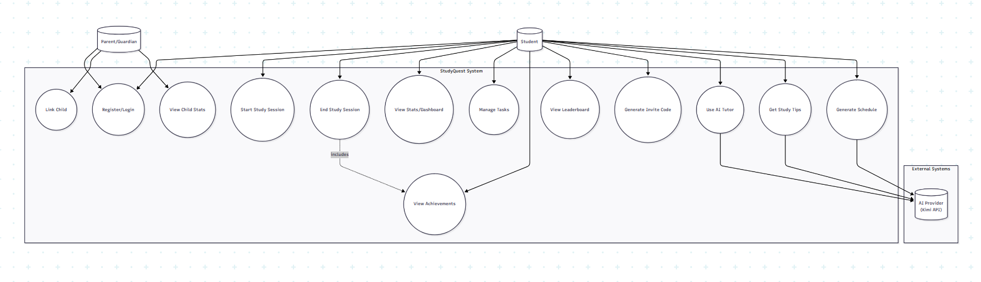

Use Case Descriptions

UC-01: Start Study Session

Use Case ID: UC-01
Use Case Name: Start Study Session
Primary Actor: Student

Preconditions:

Student is authenticated with valid JWT token

No active study session exists for this student

Trigger: Student taps "Start Studying" button and selects a subject

Main Flow:

Student opens the app and navigates to home screen

Student taps "Start Studying" button

System displays subject/topic selection dropdown

Student selects subject and optionally enters topic

System creates new study_sessions record with status='active'

System returns session ID and confirmation

Timer begins displaying elapsed time

Alternative Flows:
A1: Active session exists

System returns 400 error: "You already have an active session"

Student must end existing session first

A2: Invalid subject

System returns 400 error with validation message

Postconditions:

New row in study_sessions with is_active=true, status='active'

Session visible via GET /api/sessions/active

API Evidence: POST /api/sessions/start
Database Tables: study_sessions
UC-02: End Study Session with XP/Streak/Achievement Update

Use Case ID: UC-02
Use Case Name: End Study Session
Primary Actor: Student

Preconditions:

Student is authenticated

Student has an active study session

Trigger: Student taps "Stop" button to end study session

Main Flow:

Student taps "Stop" button

System calculates duration from started_at to now

System validates duration ≥ 1 minute

System calculates XP earned (approximately 1 XP per minute with bonuses)

System updates student's total XP and recalculates level

System updates streak (increment if studied today, reset if gap)

System checks all achievement criteria against new stats

System unlocks any newly qualified achievements

System updates study_sessions record with ended_at, duration, xp_earned, status='completed'

System returns summary with XP gained, level progress, achievements unlocked

Alternative Flows:
A1: Session too short (<1 minute)

System returns 400 error: "Session too short. Please study for at least 1 minute."

Session remains active

A2: Session not found

System returns 404 error: "Active session not found"

Postconditions:

study_sessions.status = 'completed', ended_at populated

students.xp incremented, level potentially updated

students.current_streak updated

Any new achievements written to student_achievements

API Evidence: POST /api/sessions/:sessionId/end
Database Tables: study_sessions, students, student_achievements
UC-03: View Student Stats

Use Case ID: UC-03
Use Case Name: View Student Stats
Primary Actor: Student

Preconditions: Student is authenticated with valid JWT token

Trigger: Student navigates to dashboard or stats page

Main Flow:

Student opens app or navigates to stats screen

System retrieves student record from database

System aggregates study_sessions for totals (today, week, all-time)

System calculates level progress percentage

System retrieves recent sessions list

System calculates weekly distribution by day

System returns consolidated stats payload

Alternative Flows:
A1: No study sessions yet

System returns stats with zero values

Empty sessions array

Postconditions: Student views current stats including XP, level, streak, study time

API Evidence: GET /api/student/stats
Database Tables: students, study_sessions, tasks
UC-04: Manage Tasks (CRUD)

Use Case ID: UC-04
Use Case Name: Manage Tasks
Primary Actor: Student

Preconditions: Student is authenticated

Trigger: Student accesses task management features

Main Flow:
Create Task:

Student taps "Add Task" button

Student enters title, description, subject, priority, due date

System validates required fields (title)

System creates task record with status='pending'

System returns created task

Update Task:

Student selects existing task

Student modifies fields

System updates task record

If status changed to 'completed', system sets completed_at

Toggle Task:

Student taps checkbox on task

System toggles between 'pending' and 'completed'

Delete Task:

Student taps delete on task

System removes task record

Alternative Flows:
A1: Task not found - System returns 404 error
A2: Missing title on create - System returns 400: "Title is required"

Postconditions: Task created/updated/deleted in tasks table

API Evidence: GET/POST /api/tasks, PUT/DELETE /api/tasks/:id, PATCH /api/tasks/:id/toggle
Database Tables: tasks
UC-05: Parent Link via Invite Code

Use Case ID: UC-05
Use Case Name: Link Parent Account via Invite Code
Primary Actor: Parent/Guardian (with Student generating code)

Preconditions:

Student account exists and is authenticated

Parent account exists and is authenticated

Parent and student not already linked

Trigger: Parent wants to monitor child's study progress

Main Flow:
Step 1 - Student generates code:

Student navigates to Family settings

Student taps "Generate Invite Code"

System creates 6-character unique code

System stores code with 15-minute expiry

Student shares code with parent (verbally, text, etc.)

Step 2 - Parent links using code:

Parent navigates to "Add Child" screen

Parent enters the 6-character code

Parent optionally specifies relationship (Mother, Father, Guardian)

System validates code exists, not expired, not used

System creates family_links record

System marks code as used

Parent sees child's basic info (name, level)

Alternative Flows:
A1: Code expired - System returns 400: "Code has expired"
A2: Code already used - System returns 400: "Code has already been used"
A3: Already linked - System returns 409: "Already linked to this student"
A4: Student tries to use link endpoint - System returns 403: "Only parents can link to children"

Postconditions:

family_links record created with guardian_id and student_id

connection_codes.used_at populated

Parent can now view child stats

API Evidence: POST /api/family/generate-code (student), POST /api/family/link-child (parent)
Database Tables: connection_codes, family_links, students
UC-06: Parent View Child Stats

Use Case ID: UC-06
Use Case Name: View Child Stats
Primary Actor: Parent/Guardian

Preconditions:

Parent is authenticated

Parent has linked child account via invite code

Trigger: Parent opens parent dashboard

Main Flow:

Parent logs in and navigates to dashboard

System retrieves all family_links where guardian_id = parent's ID

For each linked child, system retrieves:

Basic profile (name, level, XP)

Study statistics from study_sessions

Current streak

System returns children array with stats

Parent views consolidated dashboard with all children

Alternative Flows:
A1: No linked children

System returns empty children array

UI prompts parent to add child via invite code

Postconditions: Parent has view access to child's study progress (read-only)

API Evidence: GET /api/family/children-stats
Database Tables: family_links, students, study_sessions
UC-07: AI Tutor Session

Use Case ID: UC-07
Use Case Name: Use AI Tutor
Primary Actor: Student
Secondary Actor: AI Provider (Kimi API)

Preconditions: Student is authenticated

Trigger: Student needs help understanding a topic

Main Flow:
Start Session:

Student opens AI Tutor feature

Student selects subject, topic, and mode (learn/quiz/hint/explain)

System creates tutor_sessions record

System sends context to Kimi API

AI returns initial greeting/question

System stores message in tutor_messages

Send Message:

Student types question or response

System sends message with conversation history to Kimi API

AI processes and returns response

System stores both messages in tutor_messages

System updates message_count

End Session:

Student ends session or session times out

System calculates duration and XP earned

System updates tutor_sessions with end_time, xp_earned

Alternative Flows:
A1: AI API unavailable - System returns 503 error - Student prompted to try again later
A2: Session already ended - System returns 400: "Session has ended"

Postconditions:

tutor_sessions record with duration and XP

tutor_messages contain full conversation history

Student XP potentially increased

API Evidence: POST /api/tutor/session/start, POST /api/tutor/session/message, POST /api/tutor/session/end
Database Tables: tutor_sessions, tutor_messages, students
UC-08: View Leaderboard

Use Case ID: UC-08
Use Case Name: View Leaderboard
Primary Actor: Student

Preconditions: Student is authenticated

Trigger: Student navigates to leaderboard screen

Main Flow:

Student taps Leaderboard tab

Student selects period filter (weekly, monthly, all-time)

System queries student_leaderboard view/aggregation

System ranks students by XP/study time for selected period

System returns ordered list with rank, username, level, XP, stats

Student views their position among peers

Alternative Flows:
A1: Get personal rank only

Student requests their own rank

System returns single rank object with position

Postconditions: Student views comparative ranking information

API Evidence: GET /api/leaderboard/global?period=..., GET /api/leaderboard/my-rank?period=...
Database Tables: students, study_sessions (or student_leaderboard view)

Functional Requirements
Functional requirements describe the specific features and capabilities the system must provide. They are organized by user role to clearly show who uses each feature and why.

The initial requirements described the expected final system. After the MVP implementation, the requirements were reclassified into two parts: (i) the implemented requirements validated through the implemented endpoints and database tables; and (ii) the requirements pending in the final version.

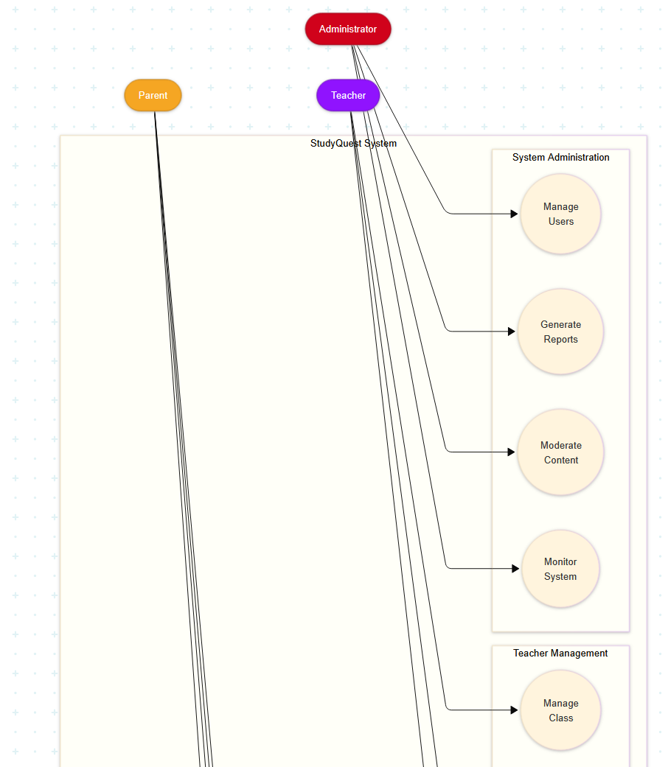

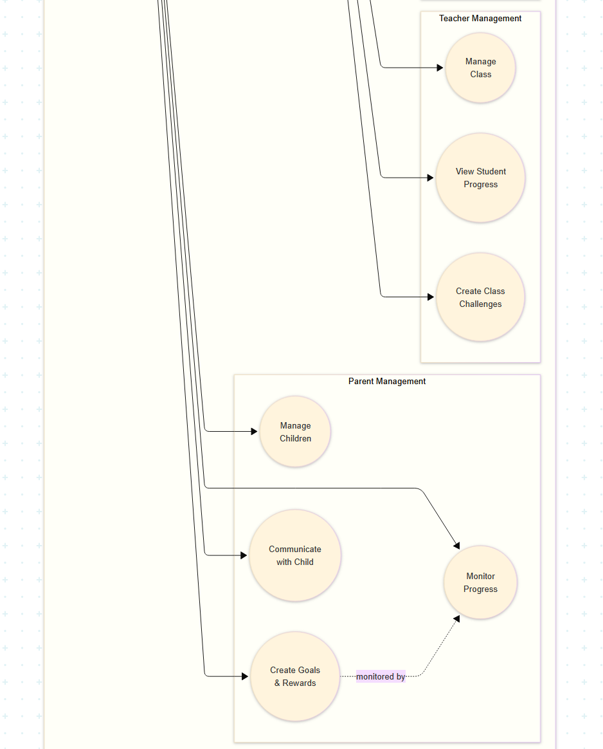

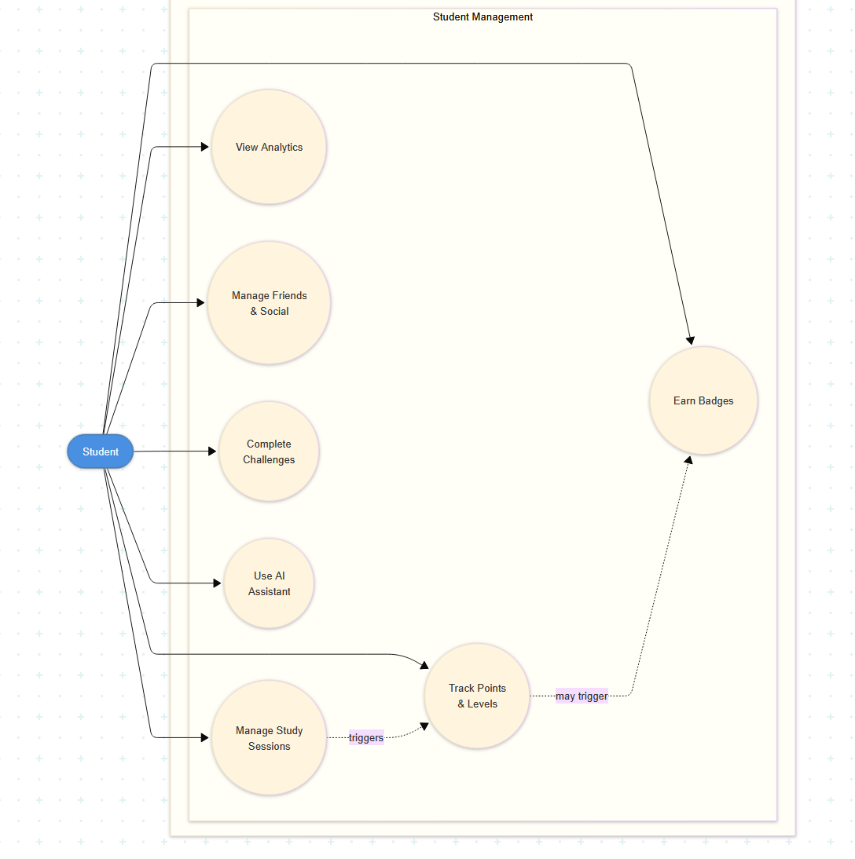

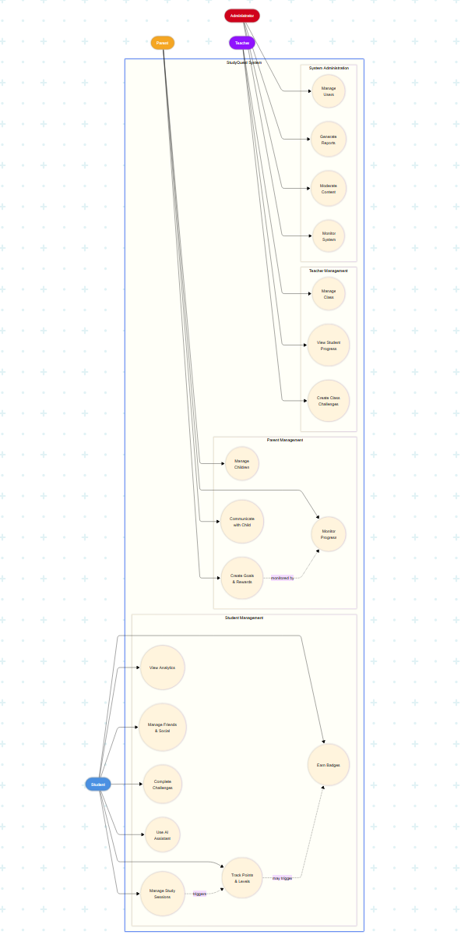

Implemented Functional Requirements
FR‑I01 User Registration

Statement: The system shall allow a user to register an account (student by default; parent supported).
API evidence: POST /api/auth/register
Tables: students (role field distinguishes student / parent)
Valid roles: student, parent; invalid defaults to student.

FR‑I02 User Login and JWT Issuance

Statement: The system shall authenticate users and issue a JWT for subsequent API access.
API evidence: POST /api/auth/login
Tables: students (credentials + profile), (login timestamp if tracked)
Protected routes require Authorization: Bearer <token>.

FR‑I03 Study Session Start

Statement: The system shall allow a student to start a study session with subject/topic.
API evidence: POST /api/sessions/start, GET /api/sessions/active
Tables: study_sessions
Prevents starting if an active session exists.

FR‑I04 Study Session End + XP Awarding

Statement: The system shall allow a student to end a session and update XP/streak/stats.
API evidence: POST /api/sessions/:sessionId/end
Tables: study_sessions, students (xp, level, streak fields)
Rejects <1 minute sessions; supports duration override or server-computed duration.

FR‑I05 Session History Viewing

Statement: The system shall allow a student to view session history with pagination/filtering.
API evidence: GET /api/sessions/history, GET /api/sessions/stats
Tables: study_sessions
Stats include breakdowns (subject, recent activity).

FR‑I06 Task Management (CRUD + Toggle)

Statement: The system shall allow students to create, update, delete, and toggle tasks.
API evidence:
GET /api/tasks
POST /api/tasks
PUT /api/tasks/:id
PATCH /api/tasks/:id/toggle
DELETE /api/tasks/:id
Tables: tasks
Includes status summary counts.

FR‑I07 Achievements Listing + Student Achievement Status

Statement: The system shall provide achievement definitions and indicate which are unlocked per student.
API evidence: (your system indicates /api/achievements* exists; screenshot shows GET /api/student/achievements)
If both exist, document both:
GET /api/student/achievements
and/or GET /api/achievements
Tables: achievements, student_achievements
Response includes unlocked boolean and unlocked_at.

FR‑I08 Achievement Checking (Server-side Evaluation)

Statement: The system shall evaluate whether achievements are unlocked after progress changes.
API evidence: POST /api/achievements/check (as you listed)
Tables: student_achievements (writes unlocks), reads from study_sessions, tasks, etc.
In dissertation: mention it supports rule-based awarding.

FR‑I09 Global Leaderboard Viewing

Statement: The system shall provide global leaderboard rankings by period.
API evidence: GET /api/leaderboard/global?period=...
Tables/views: typically student_leaderboard (view/materialized view) or aggregation over students + sessions
confirms fields: rank, level, xp, total_study_time, total_sessions, current_streak.

FR‑I10 Personal Rank Retrieval

Statement: The system shall allow a student to retrieve their own rank for a period.
API evidence: GET /api/leaderboard/my-rank?period=...
Tables/views: student_leaderboard
Returns rank object.

FR‑I11 Parent/Guardian Linking via Invite Code

Statement: The system shall support linking a parent account to a student using a time-limited code.
API evidence:
POST /api/family/generate-code (student-only)
POST /api/family/link-child (parent-only)
Tables: connection_codes, family_links
Code expiry + one-time use enforced.

FR‑I12 Parent Views Child Progress

Statement: The system shall allow a linked parent to view child stats.
API evidence: GET /api/family/children-stats
Tables: family_links + stats from students / study_sessions

FR‑I13 Student Views/Manages Guardians

Statement: The system shall allow students to view and remove linked guardians.
API evidence:
GET /api/family/guardians
DELETE /api/family/guardians/:linkId
Tables: family_links
Ownership checks enforced for delete.

FR‑I14 Student Stats Summary

Statement: The system shall provide a consolidated stats payload for the student dashboard.
API evidence: GET /api/student/stats
Tables: students, study_sessions, tasks, (possibly achievements)

FR‑I15 AI Study Utilities (Tips / Summaries / Quiz Generation)

Statement: The system shall provide AI endpoints for study tips, summarization, and quiz generation.
API evidence: your MVP list says /api/ai/*:
GET /api/ai/tips
POST /api/ai/summarize
POST /api/ai/quiz (or similar; use your actual route names)
Tables: ai_conversations (if logging), maybe ai_sessions

FR‑I16 AI Tutor Session (Start/Message/End + History)

Statement: The system shall support an AI tutor session flow and store the interaction history.
API evidence:
POST /api/tutor/session/start
POST /api/tutor/session/message
POST /api/tutor/session/end
GET /api/tutor/sessions
GET /api/tutor/stats
Tables: tutor_sessions, tutor_messages

FR‑I17 Dashboard Summary + Weekly Stats (if implemented)

Statement: The system shall provide dashboard aggregates (overview + weekly).
API evidence: GET /api/dashboard/* (you listed: summary + weekly stats)
Tables/views: likely aggregated from study_sessions, tasks, students

FR‑I18 Dashboard: Weekly Stats

Statement: The system shall provide weekly aggregated study statistics grouped by day.

API evidence: GET /api/dashboard/stats/weekly (Auth: Yes)
Tables: study_sessions

FR‑I19 AI: Study Buddy Chat

Statement: The system shall provide an authenticated AI chat endpoint for study guidance.

API evidence: POST /api/ai/chat (Auth: Yes)
Tables: ai_conversations

FR‑I20 AI: Generate Study Schedule

Statement: The system shall generate an optimized study schedule for the authenticated student.

API evidence: POST /api/ai/generate-schedule (Auth: Yes)
Tables: scheduled_sessions, study_sessions for analysis

FR‑I21 AI: Study Tips

Statement: The system shall provide AI-generated study tips.

API evidence: GET /api/ai/tips (Auth: Yes)
Tables: ai_conversations

FR‑I22 AI: Conversation History

Statement: The system shall allow the authenticated student to retrieve AI conversation history.

API evidence: GET /api/ai/history (Auth: Yes)
Tables: ai_conversations
FR‑I23 AI: Scheduled Sessions Retrieval

Statement: The system shall allow the authenticated student to retrieve scheduled sessions generated/stored by the system.

API evidence: GET /api/ai/sessions (Auth: Yes)
Tables: scheduled_sessions

Pending Functional Requirements (Planned for Final Release)

Teacher module (deferred)
Social/friends/groups (deferred)
Rewards/messaging (planned)
Push notifications/offline advanced sync (planned)

Out-of-Scope / Deferred

System Administration
While not visible to students or parents, the system requires administrative capabilities for maintenance and support.
FR-A1: User Management
- System administrators must be able to view all registered users
- Administrators can deactivate accounts if necessary (e.g., policy violations)
- Administrators can reset passwords for users who cannot access their accounts
FR-A2: Data Management
- Administrators must be able to export aggregate usage statistics
- Administrators can generate reports on: Total users, Total study time logged, Most popular features, Active users per day
- Administrators cannot view individual student study content or private messages
FR-A3: Content Moderation
- Administrators must be able to review reported user content (e.g., inappropriate usernames or messages)
- Administrators can remove inappropriate content
- Administrators can issue warnings or suspend accounts for policy violations
FR-A4: System Monitoring
- Administrators must have a dashboard showing system health metrics: Server uptime, Database performance, API response times, Error rates
- Alerts must be sent if critical issues are detected

Non-Functional Requirements
Non-functional requirements define how well the system must perform. These requirements ensure StudyQuest is fast, reliable, secure, and easy to use.

Performance Requirements
NFR-P1: Response Time
- The app must load the home screen within 2 seconds on a standard mobile device with 4G connection
- Starting and stopping study sessions must respond within 1 second
- Loading analytics dashboards must complete within 3 seconds
- AI chatbot responses must appear within 5 seconds for simple queries
NFR-P2: Concurrent Users
- The system must support at least 10,000 concurrent active users without performance degradation
- The database must handle at least 100 study sessions being logged per second
- Leaderboards must update within 10 seconds of a session being completed
NFR-P3: Data Synchronization
- When a student logs a session on one device, it must appear on all their devices within 5 seconds
- Parent dashboards must reflect child activities within 10 seconds
- Offline sessions must sync automatically when the device reconnects to the internet
NFR-P4: Scalability
- The system architecture must support horizontal scaling to handle growth
- Adding new users must not require system downtime
- The system must be designed to handle 100,000+ users

Reliability Requirements
NFR-R1: Availability
- The system must maintain 99.5% uptime (no more than 3.65 days of downtime per year)
- Planned maintenance must be scheduled during low-usage periods (e.g., 2-4 AM local time)
- Users must receive at least 24 hours notice before planned maintenance
NFR-R2: Data Integrity
- Study sessions must never be lost once saved to the database
- Points and levels must be calculated consistently and accurately
- Database backups must occur automatically every 24 hours
- Backups must be stored in geographically separate locations
NFR-R3: Error Handling
- If a study session fails to save, the system must retry automatically up to 3 times
- If synchronization fails, the system must queue data locally and retry when connection is restored
- Users must receive clear error messages when actions fail, with suggestions for resolution
NFR-R4: Recovery
- In case of server failure, the system must restore from backup within 4 hours
- Student data must be recoverable up to the last 24-hour backup
- Critical features (session tracking) must have redundant infrastructure

Security Requirements
NFR-S1: Authentication
- All users must create accounts with email and password
- Passwords must be at least 8 characters long and include letters and numbers
- Passwords must be hashed using industry-standard algorithms (bcrypt) before storage
- Failed login attempts must be limited to 5 per account per hour to prevent brute force attacks
NFR-S2: Data Encryption
- All data transmitted between app and server must use HTTPS encryption
- Database must encrypt all stored data at rest
- Sensitive information (passwords, personal messages) must use additional encryption layers
NFR-S3: Privacy Protection
- Students must explicitly consent to parent or teacher connections
- Students can revoke parent or teacher access at any time
- Users must be able to download all their data (GDPR compliance)
- Users must be able to request complete account deletion
NFR-S4: Age Verification
- The system must verify users are at least 13 years old (COPPA compliance)
- Parent accounts must verify they are at least 18 years old
- Teacher accounts must verify professional credentials
NFR-S5: Access Control
- Users can only access their own data and data they have permission to view
- Parents can only see data for children who have approved the connection
- Teachers can only see data for students who have added them
- Database queries must enforce row-level security to prevent unauthorized access

Usability Requirements
NFR-U1: Ease of Learning
- New students must be able to complete their first study session within 2 minutes of account creation
- The interface must not require a user manual or tutorial for basic features
- Advanced features must be discoverable through clear labels and intuitive navigation
NFR-U2: Interface Design
- The student app must use a colorful, engaging design appropriate for teenagers
- The parent dashboard must use a professional, data-focused design
- All text must be readable (minimum 14pt font size for body text)
- Color contrast must meet WCAG 2.1 AA accessibility standards
NFR-U3: Error Prevention
- The system must confirm before performing destructive actions (e.g., deleting goals, removing friends)
- Form inputs must validate in real-time and show helpful error messages
- The app must prevent users from making impossible configurations (e.g., negative point rewards)
NFR-U4: Consistency
- The app must use consistent terminology throughout (e.g., always "study session," never "session" in one place and "study time" in another)
- Navigation patterns must be consistent across all screens
- Colors must have consistent meanings (e.g., green always means positive/start, red always means stop/warning)
NFR-U5: Responsiveness
- The app must work on screen sizes from 4-inch phones to 27-inch desktop monitors
- Layouts must adapt automatically to different orientations (portrait and landscape)
- Touch targets must be at least 44x44 pixels to prevent mis-taps

Compatibility Requirements
NFR-C1: Device Support
- The mobile app must support iOS 14 or later and Android 9 or later
- The web app must support current versions of Chrome, Firefox, Safari, and Edge
- The app must work on devices with at least 2GB RAM
NFR-C2: Network Conditions
- The app must function on 3G, 4G, 5G, and WiFi connections
- The app must handle intermittent connectivity gracefully
- Core features (study session tracking) must work offline and sync later
NFR-C3: Timezone Handling
- The system must correctly handle users in different timezones
- Streaks must be calculated based on the user's local timezone
- Analytics must display data in the user's local time

Maintainability Requirements
NFR-M1: Code Quality
- Code must follow established style guides for each language (e.g., Airbnb JavaScript Style Guide)
- Functions must be well-documented with comments explaining complex logic
- Code must be modular with single-responsibility components
NFR-M2: Testing
- All new features must have automated unit tests with at least 80% code coverage
- Critical features must have integration tests
- The system must have end-to-end tests for primary user flows
NFR-M3: Monitoring
- The system must log all errors automatically
- Performance metrics must be collected continuously
- Administrators must receive alerts for critical issues within 5 minutes
NFR-M4: Documentation
- All APIs must have complete documentation
- Database schema must be documented
- Deployment procedures must be documented step-by-step

Data Requirements
NFR-D1: Data Retention
- User data must be retained indefinitely while accounts are active
- Deleted account data must be permanently removed within 30 days
- Backup data must be retained for at least 90 days
NFR-D2: Data Export
- Users must be able to export all their data in JSON or CSV format
- Exports must be generated within 5 minutes for typical user data volumes
- Exports must include all study sessions, achievements, and goals
NFR-D3: Data Accuracy
- Point calculations must be accurate to the exact minute
- Time tracking must be accurate to within 5 seconds
- Analytics must reflect the most recent data (no more than 10 seconds lag)

System Constraints
These constraints define limitations on the system design and implementation.
C1: Budget Constraints
- The project must use free or low-cost services where possible
- AI API costs must not exceed $100/month during development
- Cloud hosting must use free tiers or student credits
C2: Timeline Constraints
- The MVP must be completed within the academic year (by April 2026)
- Phase 1 (core features) must be ready for testing by January 2026
- Phase 2 (social features) must be completed by March 2026
C3: Team Constraints
- The team has 4 members with limited availability during exam periods
- Development must account for team members' varying skill levels
- Knowledge transfer must occur to ensure no single point of failure
C4: Technical Constraints
- The system must use technologies the team can learn within the project timeline
- Third-party services must have reliable free tiers or educational discounts
- The system must be deployable without requiring expensive infrastructure

Class Diagram
The class diagram shows the main software components and how they interact. This represents the object-oriented design of the backend system.
ERD

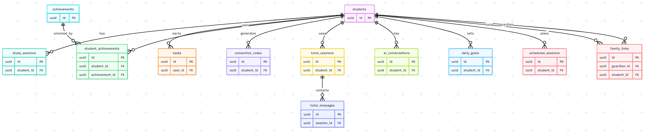

Requirements

System Architecture
StudyQuest is implemented as a Progressive Web Application (PWA) with a three-tier architecture, designed to support secondary school students, parents, and teachers. This architecture separates the presentation layer, application layer, and data layer to ensure maintainability and security.

The presentation layer uses React 19 and Tailwind CSS, deployed as a PWA on Vercel. This layer handles all user interactions on mobile and desktop devices and implements responsive design patterns and Service Workers for offline functionality. The application layer consists of a Node.js 20 runtime and Express.js 4.18, hosted on Render. This layer exposes RESTful API endpoints organized by functional domains (authentication, session, task, family association, AI tutoring). A JWT-based authentication middleware protects all protected routes, and role-based access control differentiates between students, parents, and teachers. The data layer uses PostgreSQL 15 hosted on Supabase and enforces data privacy using a row-level security (RLS) policy. This schema normalizes core entities (students, learning sessions, tasks, achievements) while using JSONB fields for flexible AI dialogue storage. Connection pooling manages concurrent access during peak periods.

Scope
The system scope covers three user roles with different functional boundaries: Student Module (fully implemented): User registration and authentication, learning session tracking (automatic time recording), experience-based gamification (points, levels, badges, win streaks), task management (CRUD operations), AI learning partner (providing Socratic tutoring and practice generation), Archive Alchemist for document import and analysis, leaderboard viewing, and family association management. Parent Module (fully implemented): Account registration (including role verification), linking children via UUID invitation codes, real-time progress dashboard (displaying learning statistics and win streaks), goal setting and reward management, and read-only access to the history of AI tutoring dialogues. Teacher Module (Partially Implemented): Course overview dashboard, student list management, and basic challenge creation. Advanced analytics and automatic grading features were postponed due to time constraints. Out of Scope: Native mobile app (iOS/Android), instant WebSocket notifications (replaced with polling), and advanced social features (learning groups with instant chat functionality have been postponed to Phase 2).

Provided Functionality and Processed Data

Core Learning Functionality
The system treats learning sessions as the primary data entity. Students initiate a session by sending a POST request to `/api/sessions/start`, creating a record in the `study_sessions` table containing the subject, topic, timestamp, and activity status. At the end of the session, the system calculates the duration and automatically updates the student table (xp, level, and total_study_time fields) via database triggers, awarding XP (1 point per minute). During validation, the system processed approximately 50 test sessions and automatically calculated consecutive learning days and hero energy updates.

Gamification Engine
Features include: unlocking achievements by evaluating various criteria in student statistics through trigger functions; leaderboard rankings through a visual view aggregating experience points and study time; and "Doomsday Shadow" procrastination tracking based on the number of missed days. Data processed includes badge level classifications (Bronze, Silver, Gold, Platinum) and dynamic level thresholds requiring exponential experience point growth.

AI Tutoring Functionality
The AI ​​learning partner handles natural language queries through integration with the Kimi K2.5 API. Features include: Socratic questioning (guiding students without providing direct answers), practice generation (outputting structured DOCX worksheets), and document analysis (extracting text from PDF/DOCX/PPTX files via the Kimi File API). Data processed includes conversation history stored in the `tutor_sessions` and `tutor_messages` tables, and the complexity of prompts is adjusted according to age group (P1-P3 to S4-S6).

Family Link Functionality
Parents generate time-limited invitation codes (6-bit UUIDs, valid for 15 minutes), which are stored in the `connection_codes` table. Upon successful linking, the system establishes a `family_links` record, defining the relationship between the guardian and the student. The system handles real-time statistical queries, summarizing student learning data for parents to view on the dashboard.

Non-functional Requirements

Performance
Through procedural code segmentation and CDN deployment, the system achieves a page load time of less than 2 seconds on a 4G network connection. Average API response times are: 45 milliseconds for health checks and 8.3 seconds for AI tutoring queries (within acceptable limits for LLM interactions). This architecture supports over 100 concurrent users on the free hosting plan, and a database connection pool (maximum 10 connections) prevents resource exhaustion.

Reliability
The learning session maintains data integrity through ACID-compliant transactions. An automatic retry mechanism (3 attempts) handles transient network failures during the learning process.

Security
All data transmissions are encrypted using HTTPS/TLS 1.3. Passwords are hashed using the bcrypt hash algorithm (cost factor 12). JWT tokens are valid for 24 hours and have a refresh function. Row-level security policies implemented at the database level prevent unauthorized parents from accessing unrelated student data. Input validation and parameterized queries prevent SQL injection and XSS attacks.

Usability
The PWA interface conforms to WCAG 2.1 AA standards, has a contrast ratio of at least 4.5:1, and a touch target of 44x44 pixels. First-time users can complete their initial learning session within 2 minutes of account creation. This interface supports dynamic text resizing and screen reader compatibility.

Interfaces with Existing Systems

Kimi API (Moonshot AI)
The backend integrates with the Kimi K2.5 large language model via REST API calls for tutoring, summarizing, and document analysis. This interface handles authentication via API keys, implements request timeouts (45 seconds when using AbortController), and manages file uploads for document processing via Kimi's document API.

Supabase Platform
The application interacts with Supabase for PostgreSQL database hosting, authentication (initially considered using Supabase, but later replaced with a custom JWT), and instant subscriptions (for future expansion). Row-level security principles are configured directly in Supabase to enforce data access control at the database layer.

Deployment Platform
Vercel hosts the frontend React application and enables automated CI/CD deployment from the GitHub repository. Render hosts the Node.js backend and implements automatic deployment from the main branch. These serverless platforms offer SSL termination and global CDN distribution.

DOCUMENTATION FOR PROBLEM ANALYSIS

Data Model

Entity Relationship Diagram
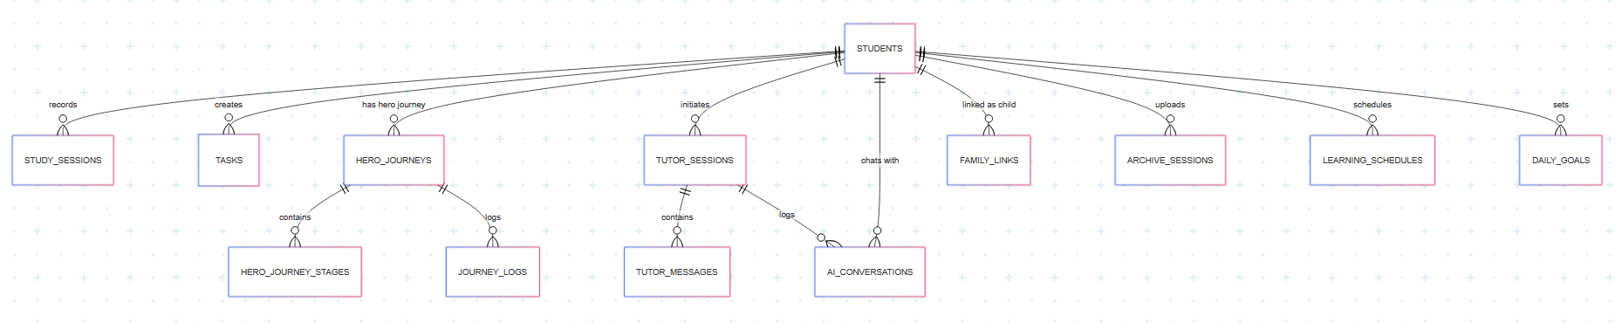
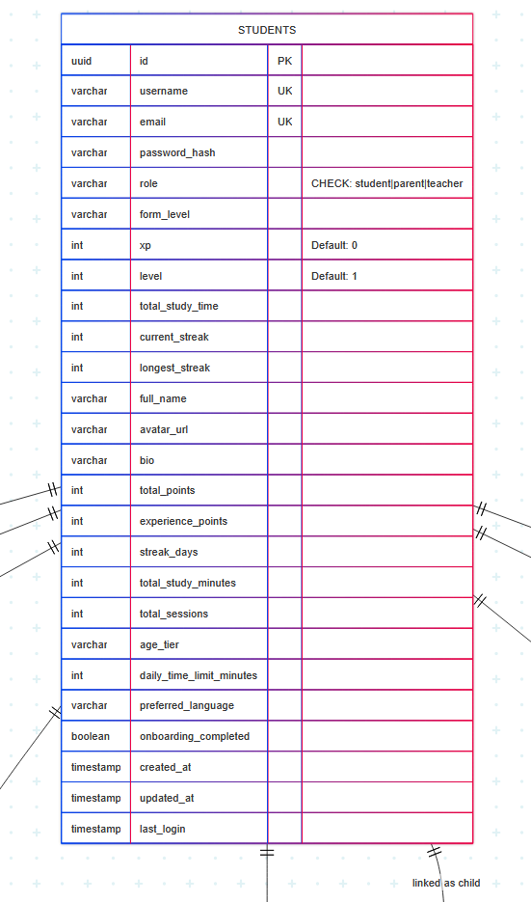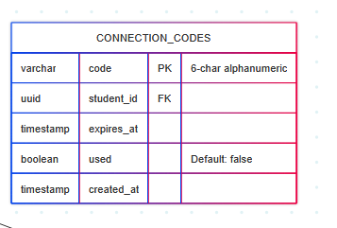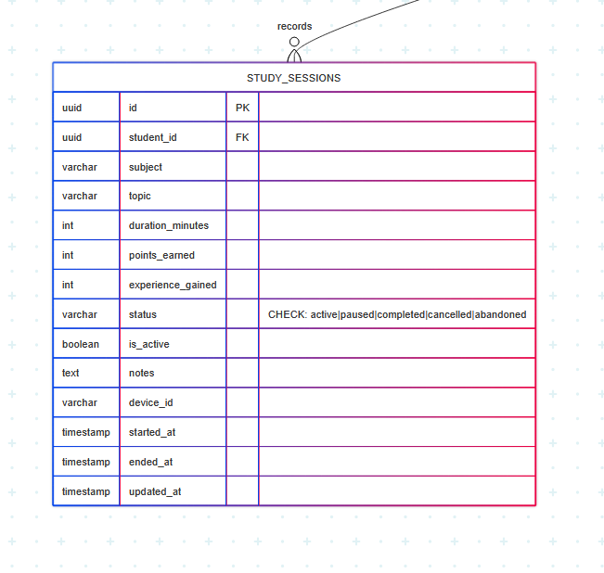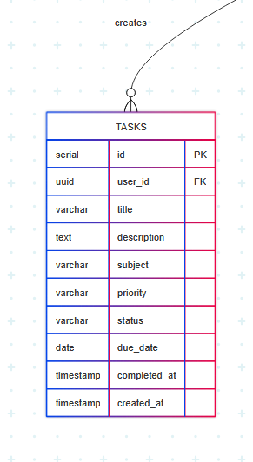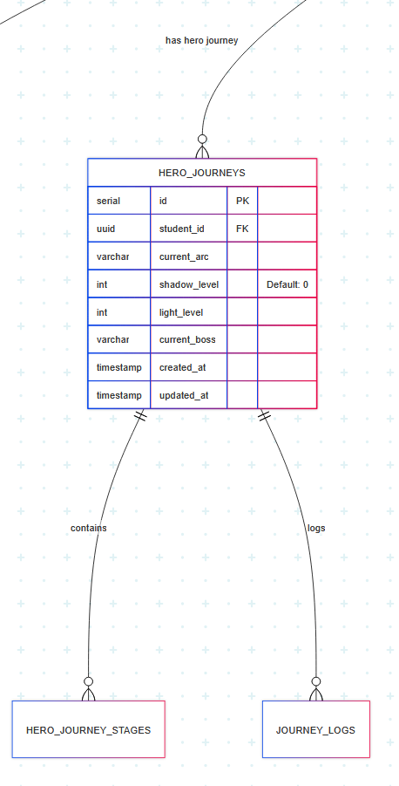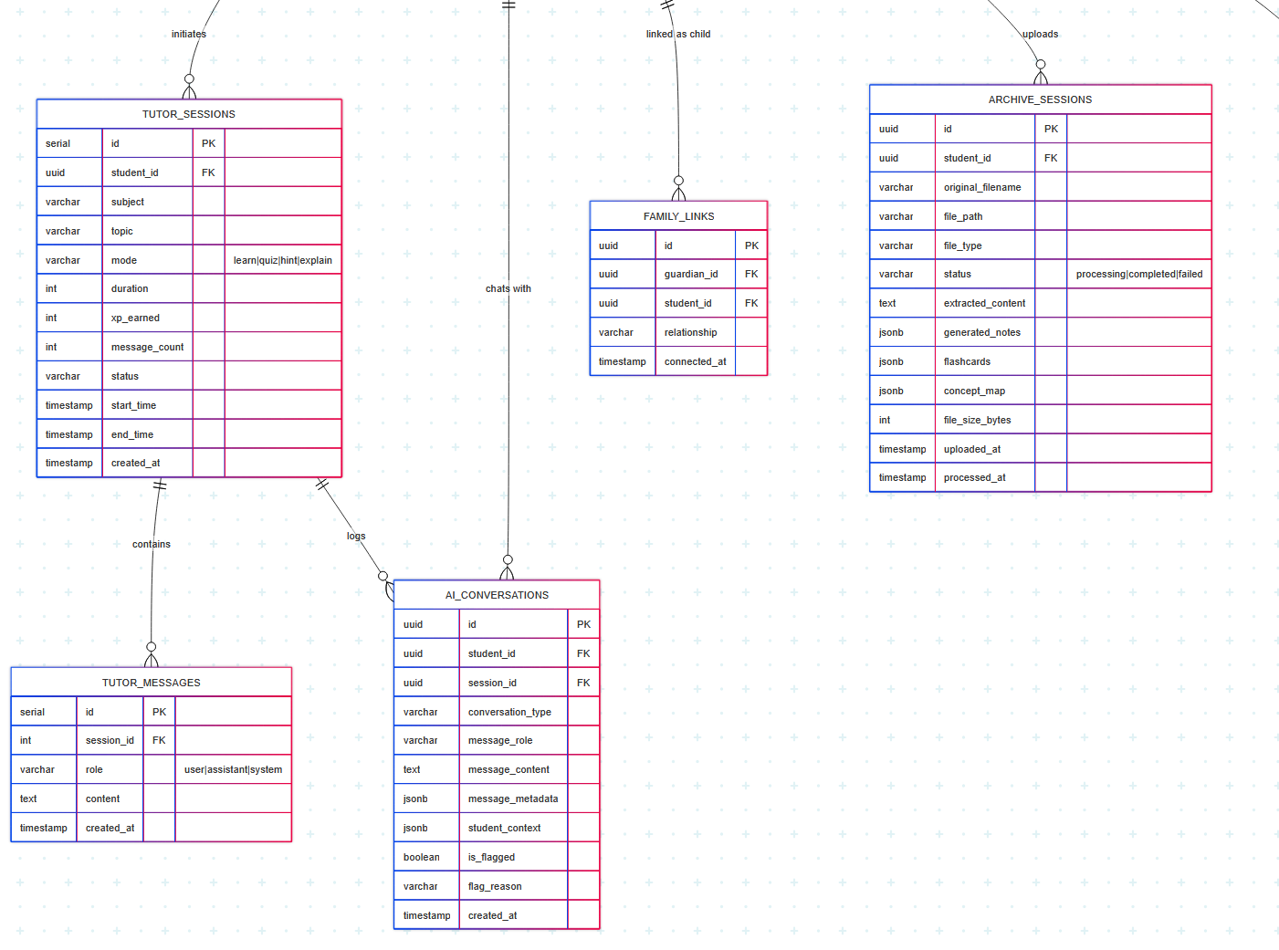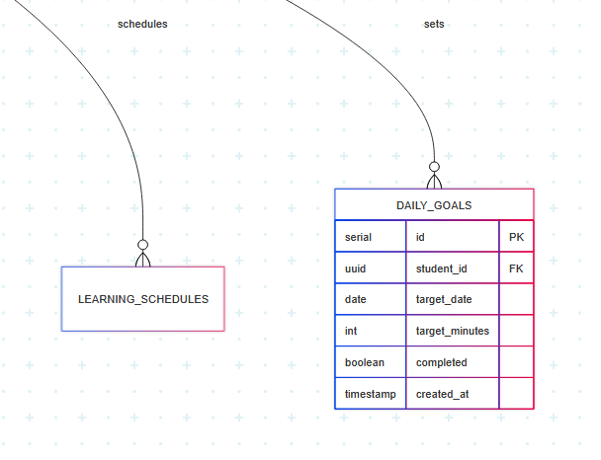

Component Architecture Diagram
The backend uses a functional/procedural architecture and employs Express.js route handlers instead of object-oriented categories.

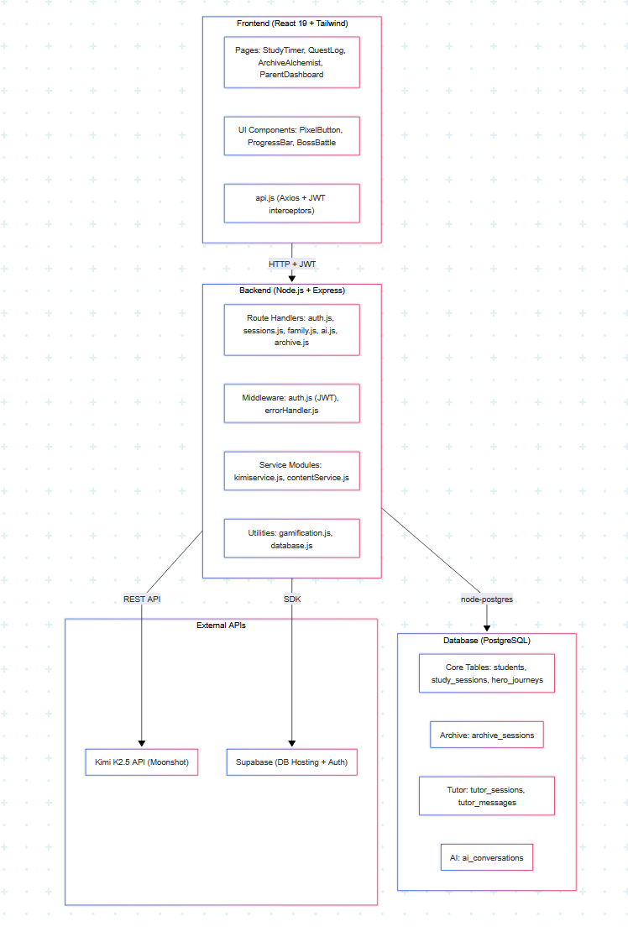

Dynamic Model

Sequence Diagram: Study Session Start/End
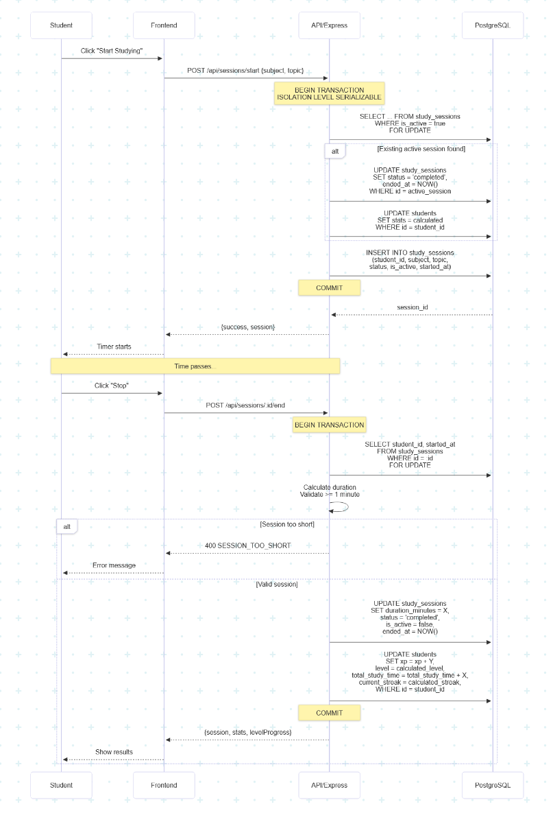

Sequence Diagram: Parent-Child Linking
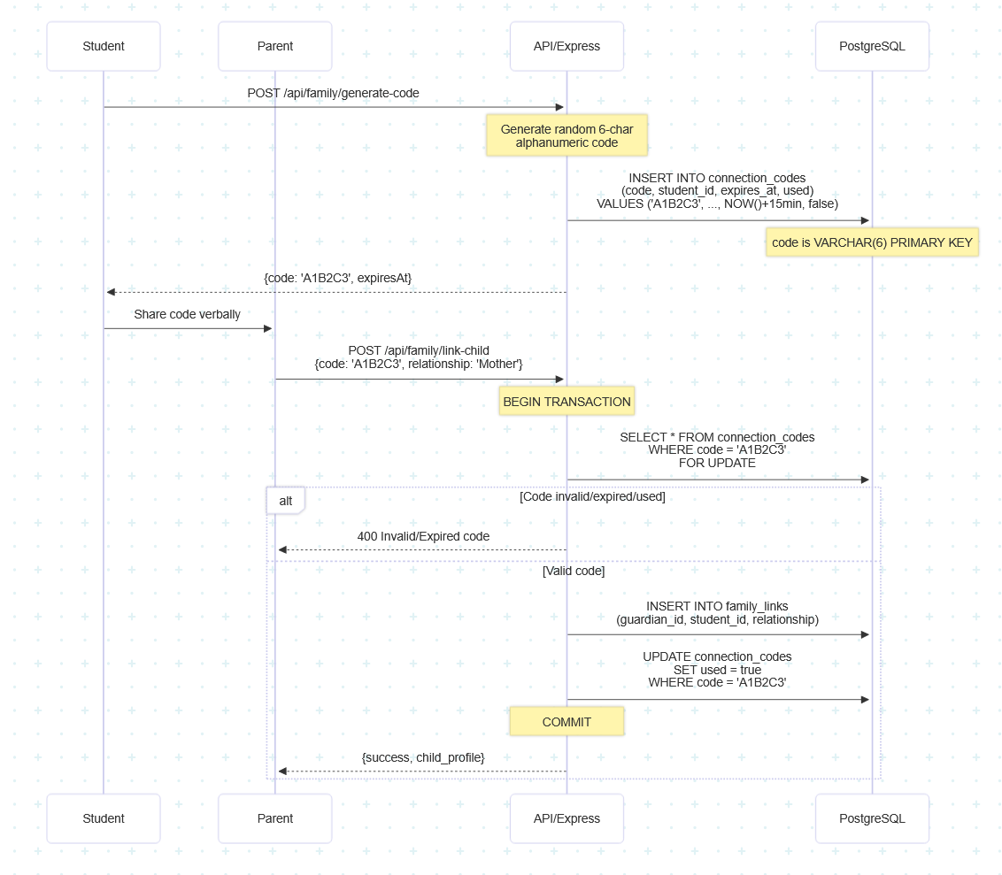

Sequence Diagram: Archive Alchemist

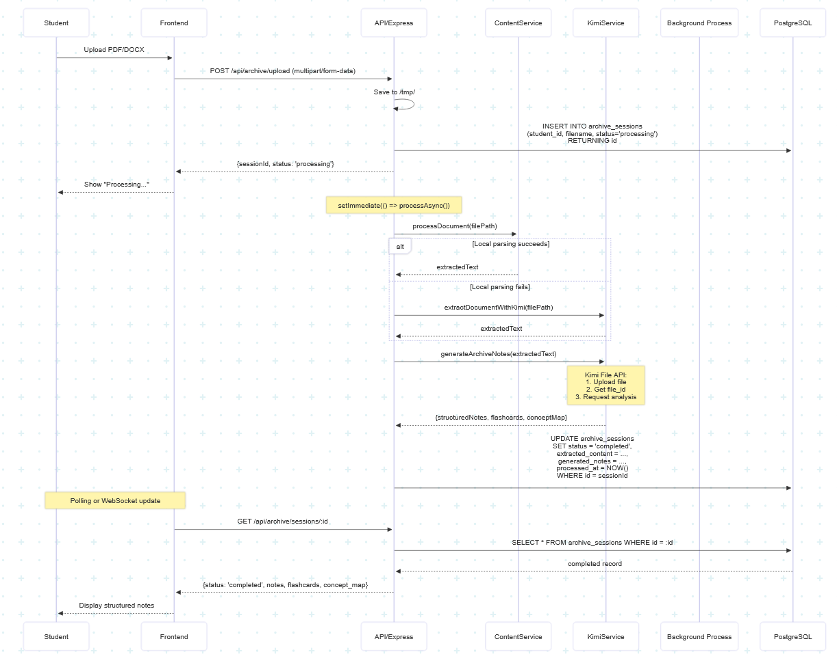

System Design

System Architecture (As-Built)
StudyQuest employs a three-tier architecture, separating presentation layer logic, application layer logic, and persistent storage. The implemented demo includes a React frontend client, a Node.js/Express backend API server, and a Supabase PostgreSQL database. This separation improves maintainability, clarifies responsibilities, and supports independent testing of each layer.
Currently, the provisional prototype uses an HTTP-based REST and Supabase PostgreSQL database; Firebase services, WebSocket instant synchronization, and Redis caching are planned but not yet integrated at this provisional stage.
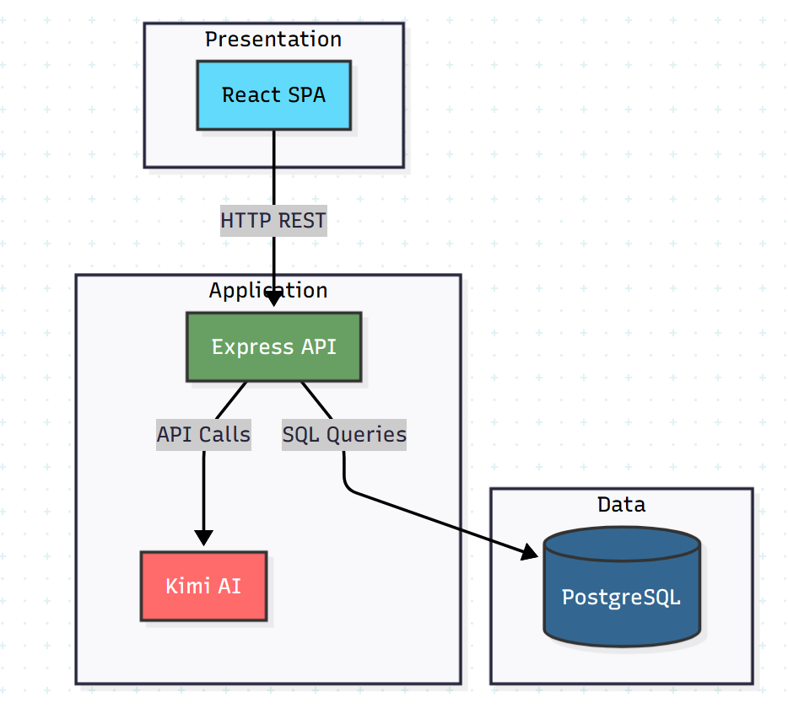

Presentation Layer (Frontend — React):
The frontend is implemented as a React Single Page Application (SPA) with route-based navigation. It provides a user interface for authentication, learning session tracking, tasks, dashboard views, achievements, leaderboard viewing, parent dashboard access, and AI/tutoring features. Role-based navigation is driven by user roles (e.g., student, parent/guardian) stored in the student table and enforced through protected routes on the front end and JWT-protected endpoints on the back end.
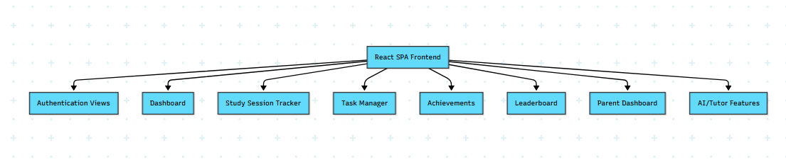
Application Layer (Backend — Node.js + Express):
The backend exposes a REST API via the HTTP protocol and handles authentication, business logic, and database interactions. The server runs on port 5000 in the development environment and provides endpoints for running verification, such as GET /api/health and GET /api/db/test. The backend integrates the Kimi API for study tips, summarization, quiz generation, and tutor responses.
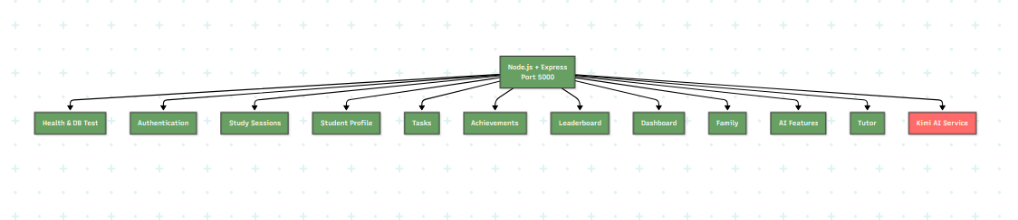
Data Layer (Database — Supabase PostgreSQL database):
Persistent data is stored in a Supabase-hosted PostgreSQL repository. This repository contains tables supporting user profiles, learning sessions, tasks, achievements, parent-child relationships, AI dialogues, and schedules. Key tables include students, study_sessions, tasks, achievements, student_achievements, family_links, and connection_codes. This repository design supports both student features (tracking and gamification) and family involvement (guardian-child association and progress access).
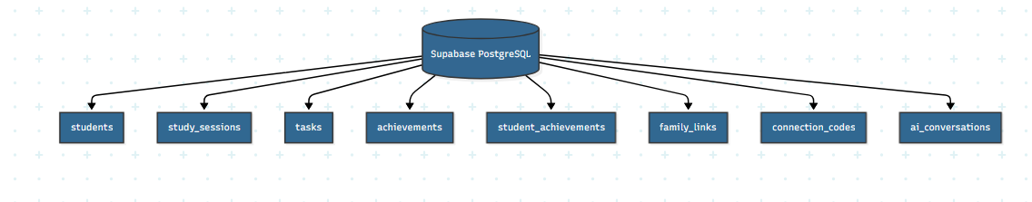

Database Design
StudyQuest uses a PostgreSQL database hosted on Supabase as a persistent storage layer for its temporary prototype system. This database architecture is designed to support the core functionalities implemented in the prototype system: authentication, learning session tracking, gamification (points/levels/achievements), task management, parent/guardian association, and AI/tutor logging.

Core User Tables
STUDENTS

Purpose: Stores all user accounts in the interim prototype (students and guardians are distinguished by the role field).

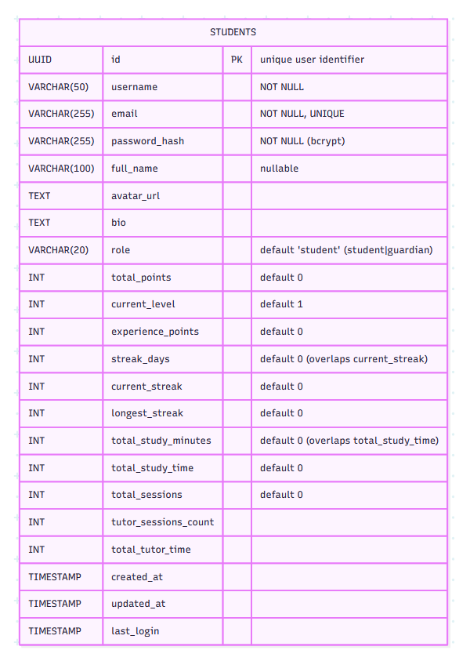

Study Activity Tables
STUDY_SESSIONS

Purpose: Stores each study session started/stopped by a student, including subject and duration.
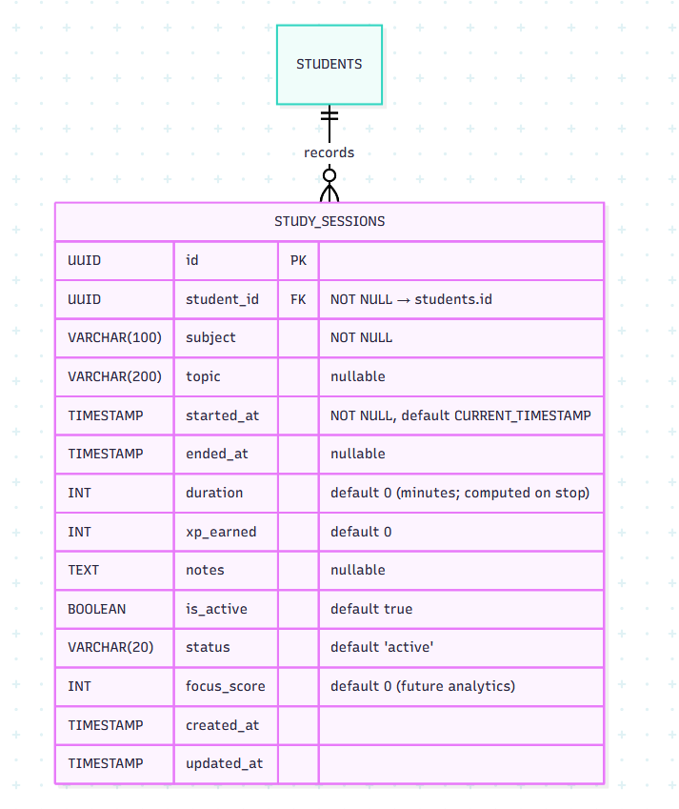

How it supports features:

Study timer tracking (start/stop)
Analytics (history, subject totals)
Points/XP awarding and leveling logic (via xp_earned + aggregates in students)

TASKS

Purpose: Stores tasks/homework items and supports CRUD + status toggling in the prototype.

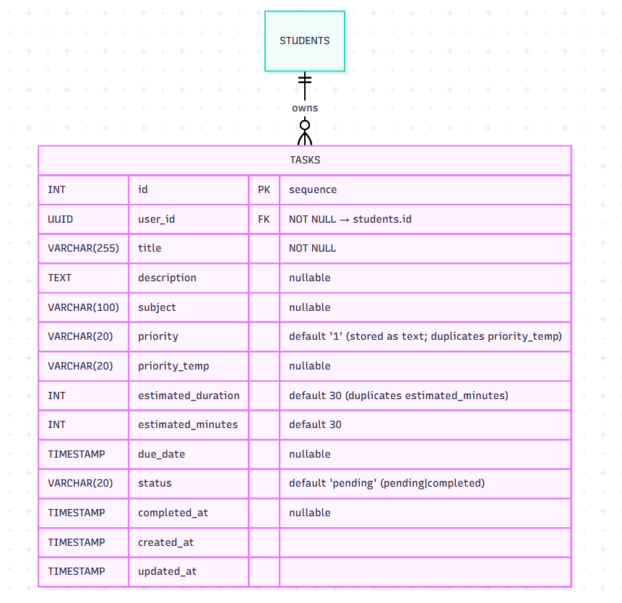

How it supports features:

Student task list
Basic planning workflow tied to user account

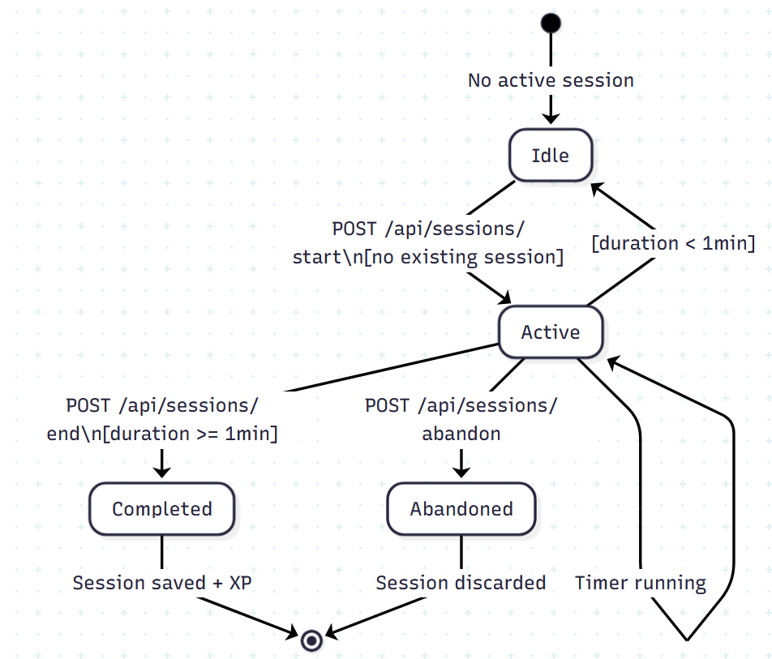

Gamification Tables

achievements

Purpose: Master table for badge/achievement definitions.

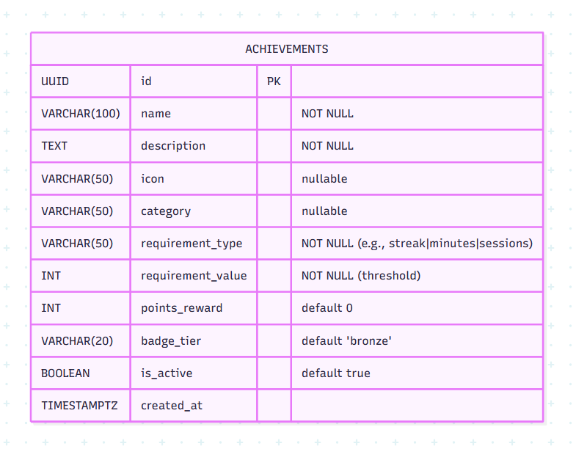

STUDENT_ACHIEVEMENTS

Purpose: Connects to a table that records the achievements (and optional progress) that students have unlocked.

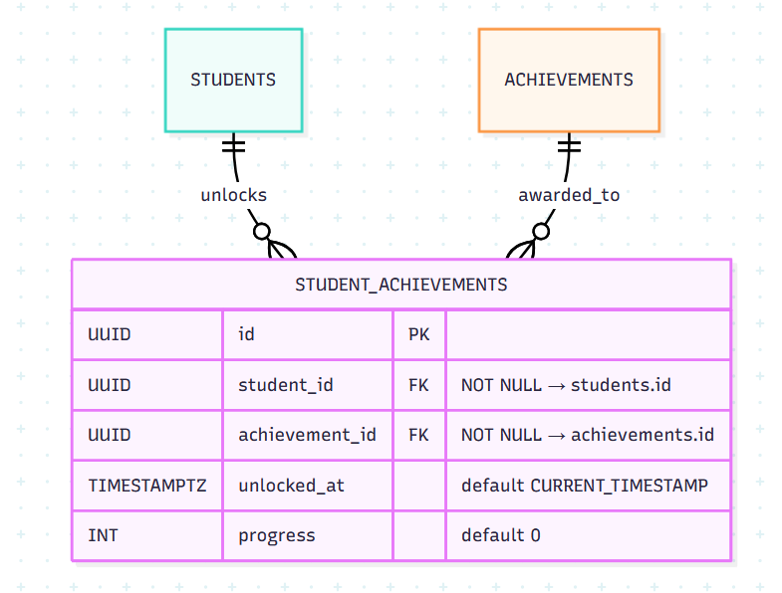

How it supports features:

Achievement unlocking and listing
Progress indication for locked achievements

STUDENT_LEADERBOARD

Purpose: Provides summary data (possibly implemented as a view) that can be used for leaderboards. It includes ranking outputs and pre-calculated statistics.

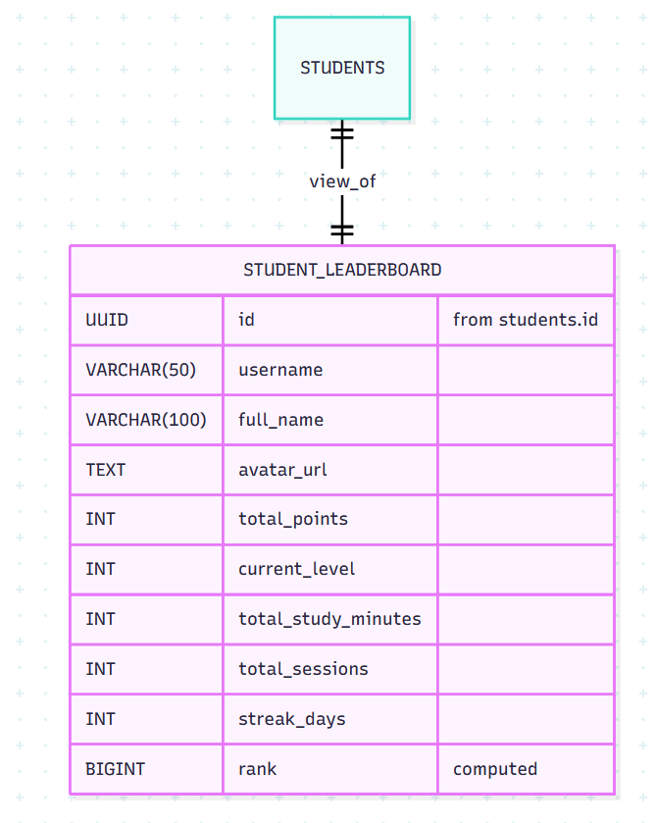

How it supports features:

Fast leaderboard queries without heavy aggregation per request

Family / Parent Linking Tables

CONNECTION_CODES

Purpose: Supports parent/guardian linking through a short-lived 6-character code generated by the student.

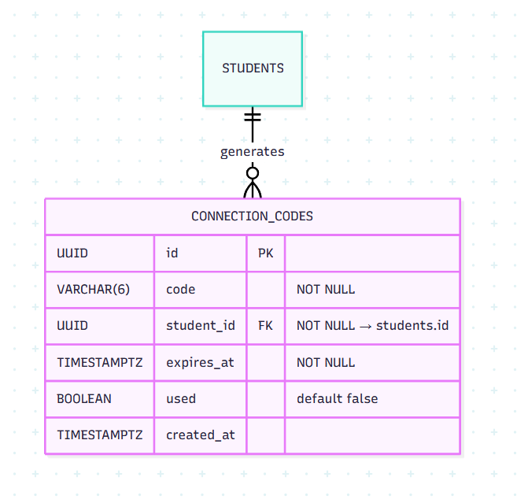

How it supports features:

Safe linking without exposing student account credentials
Expiry + one-time use reduces abuse risk

FAMILY_LINK
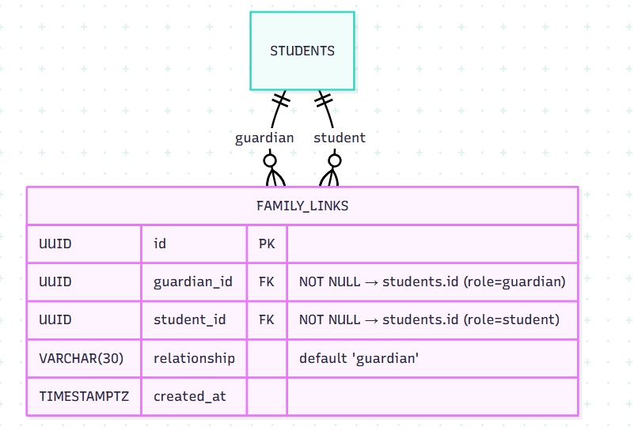

Purpose: Stores the established guardian ↔ student relationship after a valid connection code is used.

AI / Tutoring Tables

AI_CONVERSATIONS

Purpose: Logs AI assistant interactions (prompt + response) for auditing and parent visibility (per project policy).

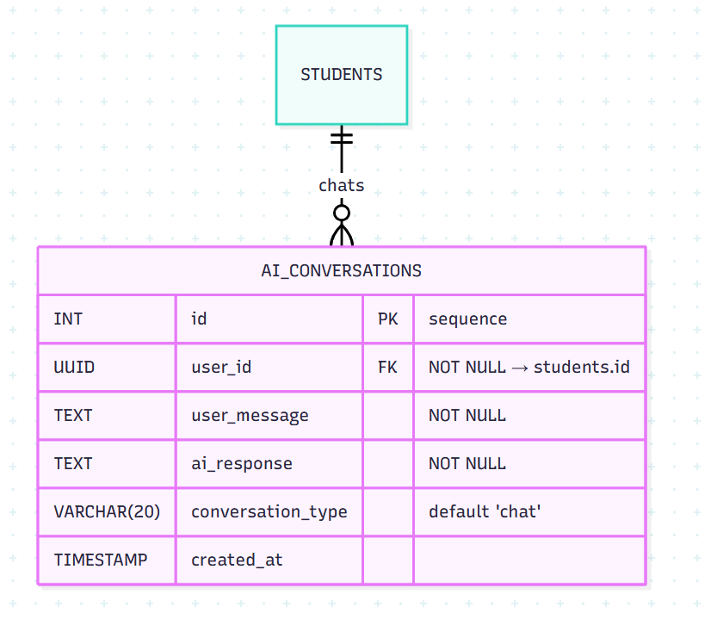

TUTOR_SESSIONS

Purpose: Groups multiple tutor messages into a coherent tutoring session.

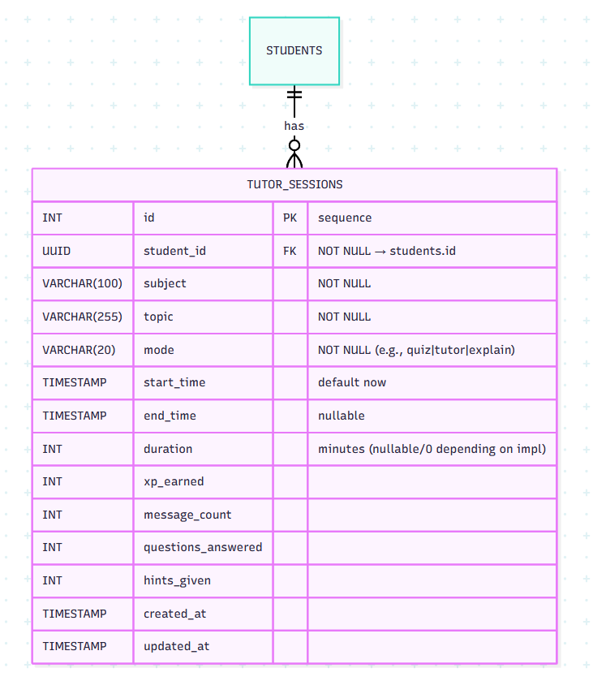

TUTOR_MESSAGES

Purpose: Stores individual chat turns inside a tutor session.

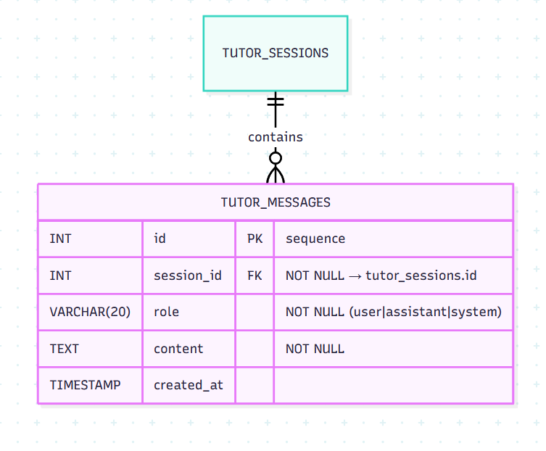

Tables Created but Not Fully Implemented Yet

These tables exist in the schema and represent planned features, but these features have not yet been fully integrated into the current prototyping process.

DAILY_GOALS

Purpose: Stores per-student daily time targets and completion status.

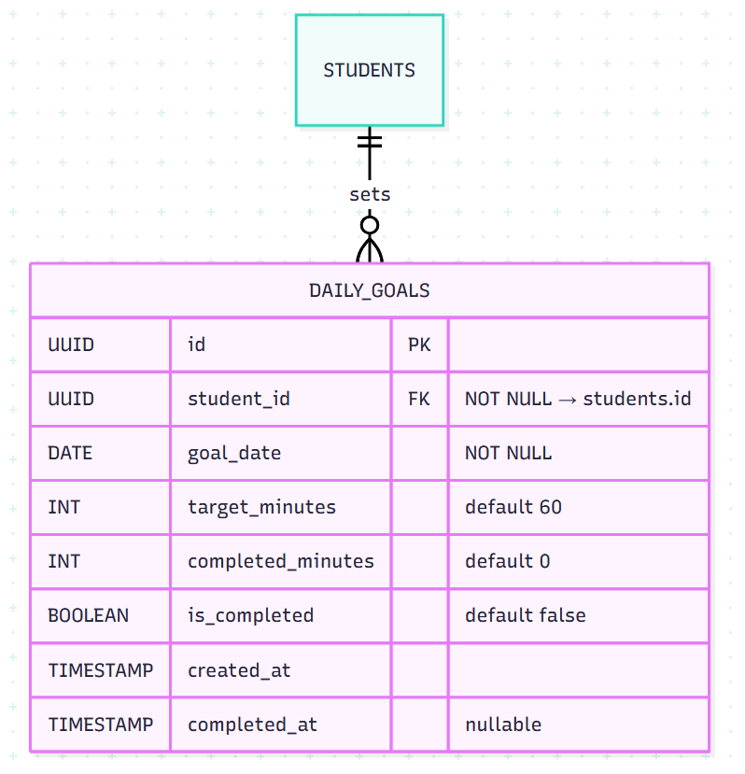

SCHEDULED_SESSIONS

Purpose: Stores calendar-like planned study sessions (schedule planner).

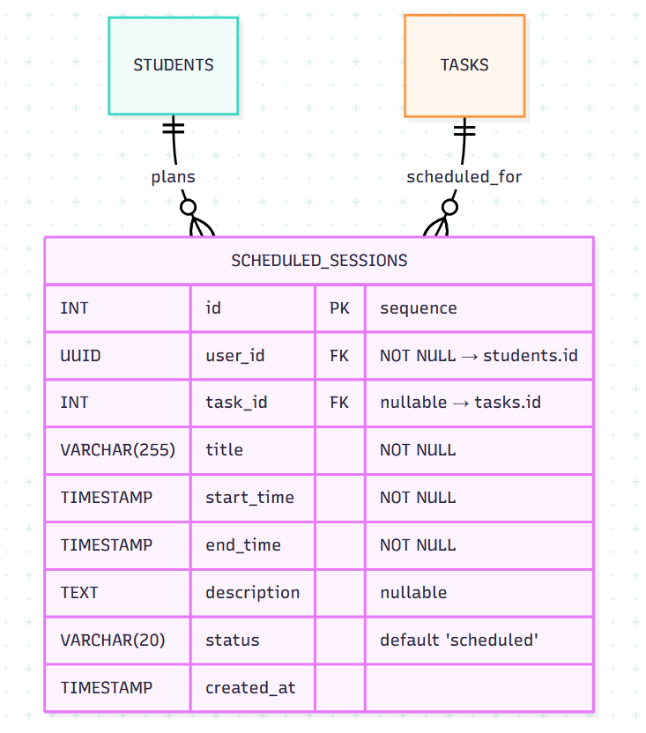

API Design
This section documents the REST API currently implemented in the Express routing archive. It lists the HTTP method, path, authentication requirements, path/query parameters, and the actual JSON payload structure for each endpoint.

Base URL & Conventions

Base URL (development): http://localhost:<PORT>/api
Authentication: JSON Web Token (JWT)
Transport: JSON over HTTP(S)
Token location: Authorization header using Bearer scheme

JWT Authentication Middleware (backend-wide)

All protected routes rely on authenticateToken (from middleware/auth.js), which expects:

Authorization: Bearer <JWT>

Failure responses:

401 (no token)

{ "success": false, "message": "Access denied. No token provided." }

403 (invalid / expired token)

{ "success": false, "message": "Invalid or expired token." }

500 (middleware error)

{ "success": false, "message": "Server error during authentication" }

Student API (/api/student)

All /api/student/* routes require JWT
Header: Authorization: Bearer <JWT>

GET /api/student/stats

Returns the authenticated student’s study stats summary.

Auth: Yes
200

{
"success": true,
"total_study_time": 962,
"badge_tier": "bronze",
"streak_days": 13,
"completed_tasks": 1,
"total_sessions": 2,
"level": 22,
"xp": 10220,
"levelProgress": {
"currentXp": -98,
"requiredXp": 112,
"percentage": -14
},
"dailyGoal": {
"completed": true,
"percentage": 100,
"minutesStudied": 962,
"minutesRemaining": 0,
"goalMinutes": 60
},
"stats": {
"today": 962,
"thisWeek": 962,
"allTime": 962
},
"sessions": [
{
"id": "c528d58-76c4-42eb-a51b-cb67fb07186",
"subject": "Mathematics",
"topic": "Calculus",
"duration": 481,
"xp_earned": 510,
"started_at": "2025-11-29T21:26:31.644Z",
"ended_at": "2025-11-30T05:28:06.348Z",
"status": "completed"
},
{
"id": "35d48990-b0d8-49a3-bfc0-812543097b9",
"subject": "mathematics",
"topic": "Calculus",
"duration": 481,
"xp_earned": 510,
"started_at": "2025-11-29T21:18:09.778Z",
"ended_at": "2025-11-30T05:19:23.159Z",
"status": "completed"
}
],
"weeklyDistribution": [
{ "day_name": "Sunday", "day_number": 0, "minutes": 962 }
]
}

GET /api/student/achievements

Returns achievement definitions plus which ones are unlocked for the authenticated student.

Auth: Yes
200

json

{
"success": true,
"total": 13,
"unlocked": 0,
"achievements": [
{
"id": "9b6d7b2b-3c34-...-...",
"name": "First Steps",
"description": "Start 3 study sessions in a row",
"icon": "👟",
"category": "milestone",
"requirement_type": "sessions_count",
"requirement_value": 3,
"points_reward": 15,
"badge_tier": "bronze",
"created_at": "...",
"unlocked_at": null,
"unlocked": false
}
],
"unlocked_achievements": []
}

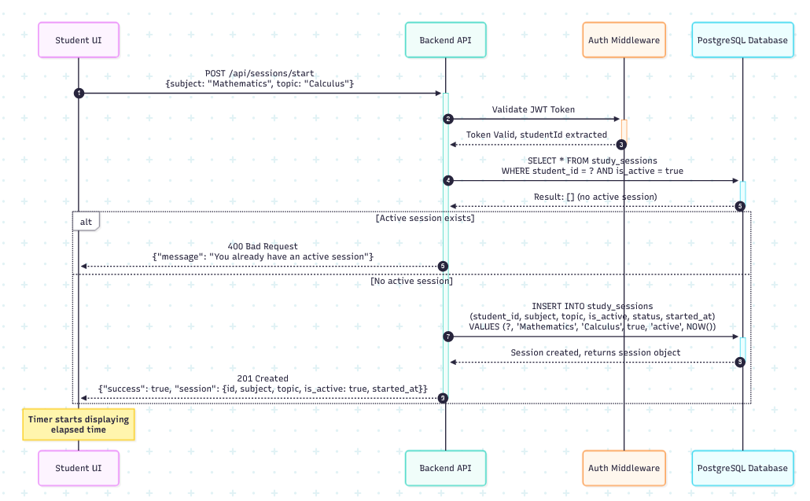

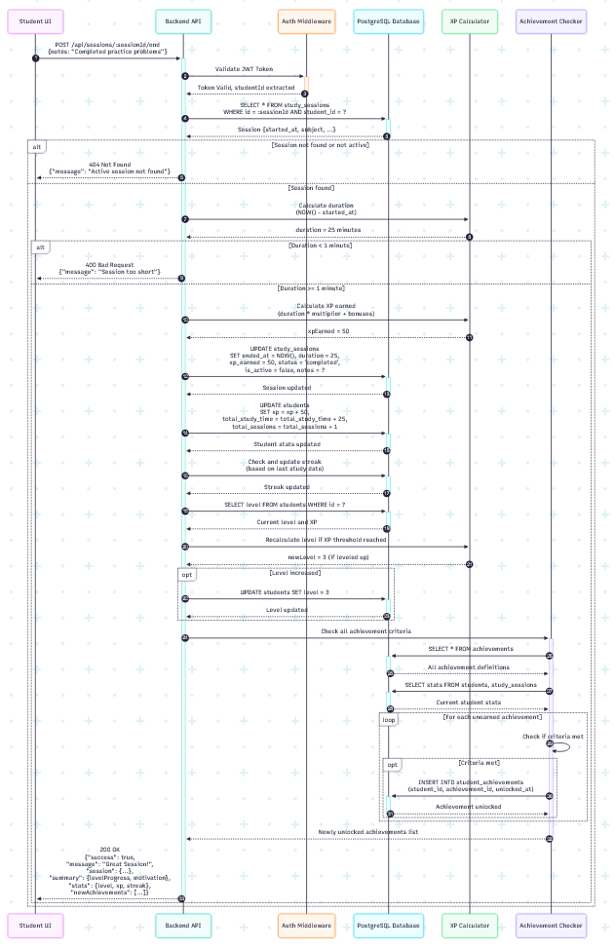

Leaderboard API (/api/leaderboard)

All /api/leaderboard/* routes require JWT
Header: Authorization: Bearer <JWT>

GET /api/leaderboard/global

Auth: Yes
Query params:
period (example: all-time)
Request example

GET /api/leaderboard/global?period=all-time

200

{
"success": true,
"period": "all-time",
"count": 2,
"leaderboard": [
{
"id": "0c3a7672-e120-4799-b2bd-f908638242c1",
"username": "alice",
"level": 22,
"xp": 10220,
"total_points": 0,
"total_study_time": 962,
"total_sessions": 2,
"current_streak": 1,
"rank": 1
},
{
"id": "ab02ac39-5a1e-4750-a02b-b71642fc97b",
"username": "charlie",
"level": 0,
"xp": 0,
"total_points": 0,
"total_study_time": 0,
"total_sessions": 0,
"current_streak": 0,
"rank": 2
}
]
}

GET /api/leaderboard/my-rank

Returns the authenticated student’s rank for the given period.

Auth: Yes
Query params:
period (example: all-time)
Request example

GET /api/leaderboard/my-rank?period=all-time

200

{
"success": true,
"period": "all-time",
"rank": {
"id": "0c3a7672-e120-4799-b2bd-f908638242c1",
"username": "alice",
"level": 22,
"xp": 10220,
"total_points": 0,
"total_study_time": 962,
"total_sessions": 2,
"current_streak": 1,
"rank": 1
}
}

Authentication API (/api/auth)

GET /api/auth/health

Auth: No
200

{ "message": "Auth routes are working!", "timestamp": "2026-02-01T..." }

POST /api/auth/register

Creates a user (defaults to student unless role is provided).

Auth: No
Request body

{
"username": "alice_1",
"email": "alice@example.com",
"password": "Alice123",
"role": "student",
"fullName": "Alice Tan"
}

Valid roles: student, parent (invalid or missing roles default to student)
201

{
"success": true,
"message": "User registered successfully!",
"data": {
"student": {
"id": "uuid",
"username": "alice_1",
"email": "alice@example.com",
"fullName": "Alice Tan",
"role": "student",
"level": 1,
"xp": 0,
"total_study_time": 0,
"current_streak": 0,
"longest_streak": 0,
"created_at": "..."
},
"token": "jwt..."
}
}

400 (examples)

{ "success": false, "message": "Please provide username, email, and password" }

{ "success": false, "message": "Email already registered" }

{ "success": false, "message": "Username already taken" }

POST /api/auth/login

Auth: No
Request body

{ "email": "alice@example.com", "password": "Alice123" }

200

{
"success": true,
"message": "Login successful!",
"data": {
"student": {
"id": "uuid",
"username": "alice",
"email": "alice@example.com",
"fullName": null,
"role": "student",
"level": 1,
"xp": 0,
"total_study_time": 0,
"current_streak": 0,
"longest_streak": 0,
"created_at": "..."
},
"token": "jwt..."
}
}

401

{ "success": false, "message": "Invalid email or password" }

POST /api/auth/register-parent

Convenience endpoint for creating a parent account.

Auth: No
Request body

{ "username": "parent1", "email": "parent@test.com", "password": "Parent123", "fullName": "Test Parent" }

201

{
"success": true,
"message": "Parent account registered successfully!",
"data": {
"user": {
"id": "uuid",
"username": "parent1",
"email": "parent@test.com",
"fullName": "Test Parent",
"role": "parent",
"created_at": "..."
},
"token": "jwt..."
}
}

GET /api/auth/profile

Returns a detailed profile record.

Auth: Yes (JWT)
200

{
"success": true,
"data": {
"id": "uuid",
"username": "alice",
"email": "alice@example.com",
"full_name": null,
"avatar_url": null,
"bio": null,
"role": "student",
"total_points": 0,
"current_level": 1,
"experience_points": 0,
"streak_days": 0,
"total_study_minutes": 0,
"total_sessions": 0,
"created_at": "...",
"last_login": "..."
}
}

GET /api/auth/me

Returns a lightweight identity payload.

Auth: Yes (JWT)
200

{
"success": true,
"data": {
"id": "uuid",
"username": "alice",
"email": "alice@example.com",
"fullName": null,
"role": "student",
"level": 1,
"xp": 0,
"currentStreak": 0
}
}

Tasks API (/api/tasks) — CRUD + Summary Statistics

All /api/tasks/* routes require JWT.

GET /api/tasks

Auth: Yes
200

{
"success": true,
"tasks": [
{ "id": 1, "user_id": "uuid", "title": "...", "status": "pending", "...": "..." }
]
}

GET /api/tasks/summary/stats

Returns counts by status.

Auth: Yes
200

{
"success": true,
"stats": {
"pending": "2",
"in_progress": "1",
"completed": "5",
"overdue": "1",
"total": "9"
}
}

Counts may be returned as strings depending on the PostgreSQL driver/result parsing.

GET /api/tasks/:id

Auth: Yes
Path params: :id
200

{ "success": true, "task": { "id": 1, "title": "...", "status": "pending", "...": "..." } }

404

{ "success": false, "message": "Task not found" }

POST /api/tasks

Auth: Yes
Request body

{
"title": "Finish Chapter 6",
"description": "API write-up",
"subject": "FYP",
"priority": "high",
"dueDate": "2026-02-05",
"estimatedMinutes": 90
}

201

{ "success": true, "task": { "id": 1, "user_id": "uuid", "status": "pending", "...": "..." } }

400

{ "success": false, "message": "Title is required" }

PUT /api/tasks/:id

Updates fields and handles completed_at logic when marking a task completed.

Auth: Yes
Path params: :id
Request body (example)

{ "status": "completed", "priority": "medium" }

200

{ "success": true, "task": { "id": 1, "status": "completed", "completed_at": "...", "...": "..." } }

404

{ "success": false, "message": "Task not found" }

PATCH /api/tasks/:id/toggle

Toggles between completed and pending.

Auth: Yes
Path params: :id
200

{ "success": true, "task": { "id": 1, "status": "completed", "completed_at": "...", "...": "..." } }

DELETE /api/tasks/:id

Auth: Yes
Path params: :id
200

{ "success": true, "message": "Task deleted" }

404

{ "success": false, "message": "Task not found" }
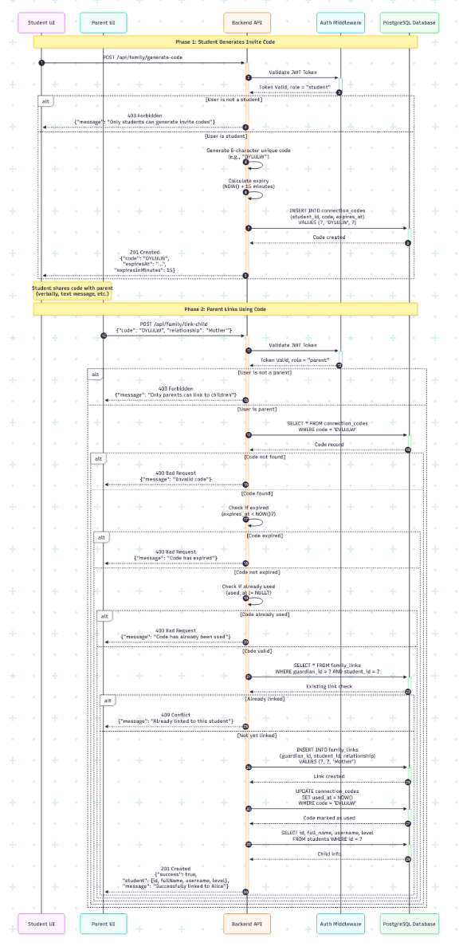

Study Sessions API (/api/sessions) — Start/End/Active/History/Stats

All /api/sessions/* routes require JWT.
POST /api/sessions/start

Starts a new study session for the authenticated student.

Auth: Yes
Request body

{ "subject": "Mathematics", "topic": "Calculus" }

201

{
"success": true,
"message": "Study session started successfully! 📚",
"session": {
"id": "uuid",
"student_id": "uuid",
"subject": "Mathematics",
"topic": "Calculus",
"is_active": true,
"status": "active",
"started_at": "..."
}
}

400 (already has an active session)

{ "success": false, "message": "You already have an active session. Please end it first." }

POST /api/sessions/:sessionId/end

Ends an active study session and awards XP / updates streaks.

Auth: Yes
Path params: :sessionId
Request body

{ "notes": "Did practice questions", "duration": 25 }

If duration is omitted, the server computes it from started_at.

400 (too short)

{ "success": false, "message": "Session too short. Please study for at least 1 minute." }

404

{ "success": false, "message": "Active session not found" }

200

{
"success": true,
"message": "💪 Great Session!",
"session": { "...": "..." },
"summary": {
"levelProgress": { "...": "..." },
"motivation": { "title": "💪 Great Session!", "message": "You studied for 25 minutes and earned 50 XP!" }
},
"stats": {
"level": 2,
"xp": 120,
"totalStudyTime": 50,
"totalSessions": 2,
"currentStreak": 1,
"longestStreak": 1
}
}

GET /api/sessions/active

Auth: Yes
200 (no active session)

{ "success": true, "hasActiveSession": false, "session": null }

200 (active session exists; includes computed currentDuration)

{ "success": true, "hasActiveSession": true, "session": { "...": "...", "currentDuration": 12 } }

GET /api/sessions/history

Auth: Yes
Query params: page (default 1), limit (default 10), optional subject
200

{
"success": true,
"sessions": [ { "...": "..." } ],
"pagination": {
"currentPage": 1,
"totalPages": 3,
"totalSessions": 25,
"sessionsPerPage": 10
}
}

GET /api/sessions/stats

Auth: Yes
200

{
"success": true,
"stats": {
"level": 22,
"xp": 10220,
"levelProgress": { "...": "..." },
"totalStudyTime": 962,
"totalSessions": 2,
"currentStreak": 1,
"longestStreak": 1,
"averageSessionDuration": 481
},
"subjectBreakdown": [
{ "subject": "Mathematics", "session_count": "2", "total_minutes": "962", "avg_duration": "481" }
],
"recentActivity": [
{ "study_date": "2026-02-01", "sessions": "1", "minutes": "60" }
]
}

POST /api/sessions/abandon/:sessionId

Marks a session as abandoned.

Auth: Yes
Path params: :sessionId
200

{ "success": true, "message": "Session abandoned" }

Family Linking API (/api/family) — Parent/Student Linking

The family router applies router.use(authenticateToken), therefore all /api/family/* routes require JWT.

POST /api/family/generate-code

Generates a short-lived invite code.

Auth: Yes
Actor: Student only (parents blocked)
201

{
"success": true,
"code": "DYLULW",
"expiresAt": "2026-01-30T05:12:28.748Z",
"expiresInMinutes": 15
}

403

{ "success": false, "message": "Only students can generate invite codes" }

POST /api/family/link-child

Links a parent account to a student using an invite code.

Auth: Yes
Actor: Parent only (students blocked)
Request body

{ "code": "DYLULW", "relationship": "Mother" }

201

{
"success": true,
"student": { "id": "uuid", "fullName": "Alice", "username": "alice", "level": 164 },
"message": "Successfully linked to Alice"
}

Errors (as-built behavior):
400 missing/invalid/used/expired code
403 if not parent
409 already linked

GET /api/family/children-stats

Returns children linked to the authenticated user.

Auth: Yes
Actor: Intended for parent usage; role is not explicitly enforced in code.
200

{
"success": true,
"children": [
{ "id": "uuid", "fullName": "Alice", "level": 164, "xp": 209890, "relationship": "Mother", "connectedAt": "..." }
]
}

GET /api/family/guardians

Returns guardians linked to the authenticated student.

Auth: Yes
Actor: Student
200

{
"success": true,
"guardians": [
{ "linkId": 1, "guardianId": "uuid", "name": "Test Parent", "email": "parent@test.com", "relationship": "Guardian", "connectedAt": "..." }
]
}

DELETE /api/family/guardians/:linkId

Removes a guardian link owned by the authenticated student.

Auth: Yes
Path params: :linkId
200

{ "success": true, "message": "Guardian removed successfully" }

403 if attempting to remove another user’s link
404 link not found

DELETE /api/family/children/:studentId

Removes a linked child from a parent account.

Auth: Yes
Path params: :studentId
200

{ "success": true, "message": "Child removed successfully" }

404 link not found

Tutor API (/api/tutor) — AI Tutor Sessions

GET /api/tutor/health

Auth: No
200

{ "status": "ok", "message": "Tutor routes working", "timestamp": "..." }

All other tutor routes require JWT.

POST /api/tutor/session/start

Starts an AI tutoring session.

Auth: Yes
Request body

{ "subject": "Mathematics", "topic": "Integration", "mode": "learn" }

Allowed modes: learn | quiz | hint | explain
200

{ "sessionId": "uuid", "message": "AI first message...", "mode": "learn" }

400

{ "error": "Subject, topic, and mode are required" }

{ "error": "Invalid mode" }

404

{ "error": "Student not found" }

POST /api/tutor/session/message

Sends a message to the tutor session and returns the AI response.

Auth: Yes
Request body

{ "sessionId": "uuid", "message": "I don't understand u-substitution" }

200

{
"message": "AI response...",
"stats": { "messageCount": 3, "questionsAnswered": 1 }
}

400

{ "error": "Session ID and message are required" }

or

{ "error": "Session has ended" }

404

{ "error": "Session not found" }

POST /api/tutor/session/end

Ends an AI tutor session.

Auth: Yes
Request body

{ "sessionId": "uuid" }

200

{
"success": true,
"stats": {
"duration": 12,
"messagesExchanged": 5,
"questionsAnswered": 2,
"xpEarned": 34
}
}

GET /api/tutor/sessions

Returns tutor session history.

Auth: Yes
Query params: limit (default 10), optional subject
200

{
"sessions": [
{
"id": "uuid",
"subject": "Math",
"topic": "Integration",
"mode": "learn",
"duration": 12,
"xp_earned": 34,
"start_time": "...",
"message_count": 5,
"questions_answered": 2
}
]
}

GET /api/tutor/stats

Auth: Yes
200

{
"overview": {
"totalSessions": 3,
"totalDuration": 40,
"totalXP": 120,
"totalMessages": 25,
"totalQuestionsAnswered": 6
},
"bySubject": [
{ "subject": "Mathematics", "sessions": "2", "duration": "25", "xp": "80" }
]
}

User Interface Design
This section presents the key screens and user flows for students and parents. The mockups (already implemented in the provided JSX file) demonstrate the visual design and interaction patterns.

Student Mobile App Screens
Home Dashboard
- Purpose: Central hub showing key stats at a glance
- Key Elements:
  - Large "Start Studying" button (primary action)
  - Current level with progress bar to next level
  - Total points prominently displayed
  - Current streak with fire emoji
  - Today's study time
  - Quick access to active challenges
- Design Principles:
  - Bright, energetic color scheme (blues, purples, golds)
  - Large touch targets for mobile
  - Immediate visual feedback for accomplishments
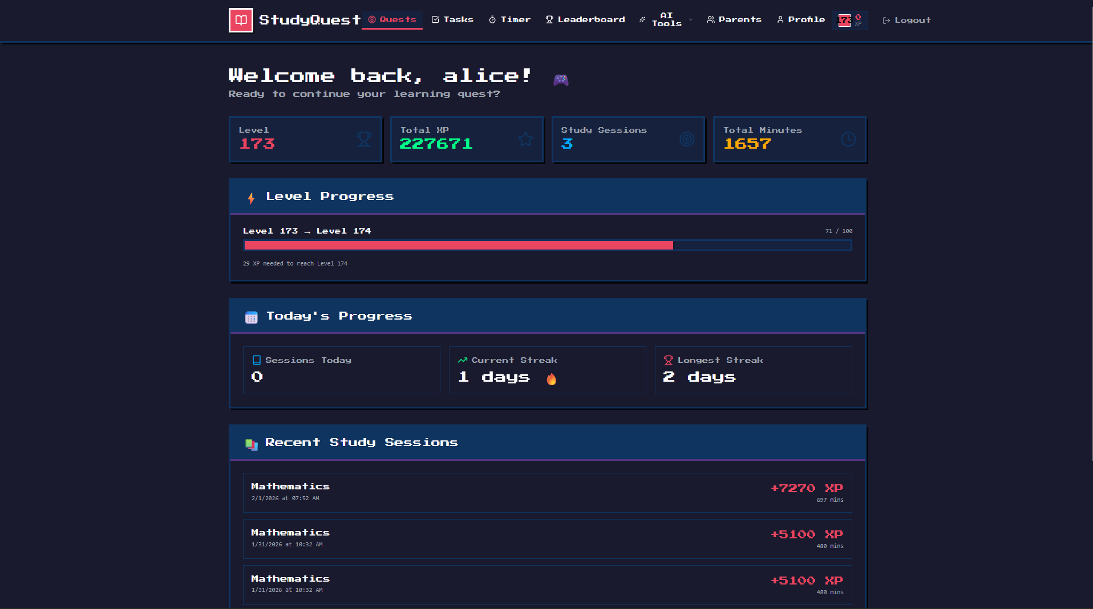
Study Session Screen
- Purpose: Active timer during study
- Key Elements:
  - Large, clear timer display (minutes:seconds)
  - Subject selector dropdown
  - Prominent Stop button (changes color when active)
  - Optional notes field
  - Real-time points counter
- Design Principles:
  - Minimalist interface to avoid distraction
  - Timer keeps running if app is backgrounded
  - Session automatically saves if app crashes
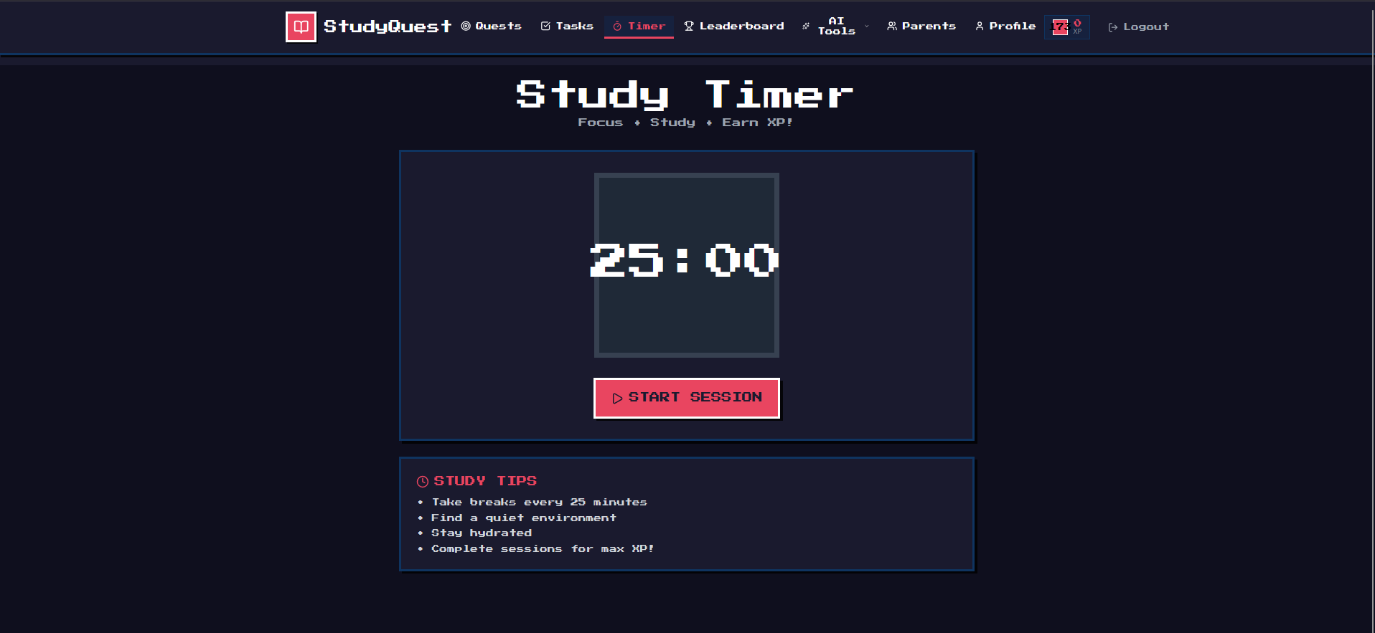
Analytics Screen
- Purpose: Detailed progress visualization
- Key Elements:
  - Total study time (today, week, month, all-time)
  - Line graph: daily study time over 30 days
  - Pie chart: subject distribution
  - Streak calendar showing daily consistency
  - Best study times insight
- Design Principles:
  - Clear, colorful charts
  - Filterable by date range
  - Export functionality for sharing with parents/teachers
Achievements Screen
- Purpose: Display earned and available badges
- Key Elements:
  - Grid layout showing all badges
  - Unlocked badges in color, locked ones grayed out
  - Progress indicators for locked badges
  - Tap badge for details and unlock criteria
  - Featured badges section for displaying on profile
- Design Principles:
  - Celebratory visual style
  - Clear progress toward next unlock
  - Satisfying unlock animation
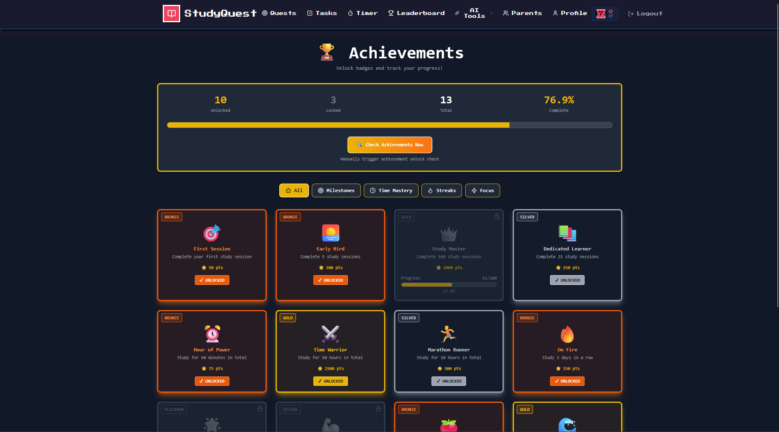
Leaderboard Screen
- Purpose: Social comparison and motivation
- Key Elements:
  - Tab switcher: Global / Friends / Weekly
  - Ranked list with avatars
  - User's own rank highlighted
  - Points and level for each person
  - Filter and search options
- Design Principles:
  - User always visible (sticky at top or highlighted)
  - Celebratory styling for top 3
  - Easy navigation between leaderboard types

Social/Groups Screen
- Purpose: Friend management and study teams
- Key Elements:
  - Friends list with study activity
  - Study groups/teams
  - Create new group button
  - Send friend requests
  - Group leaderboards
- Design Principles:
  - Social feed-like interface
  - Easy invite flow
  - Group progress clearly visualized

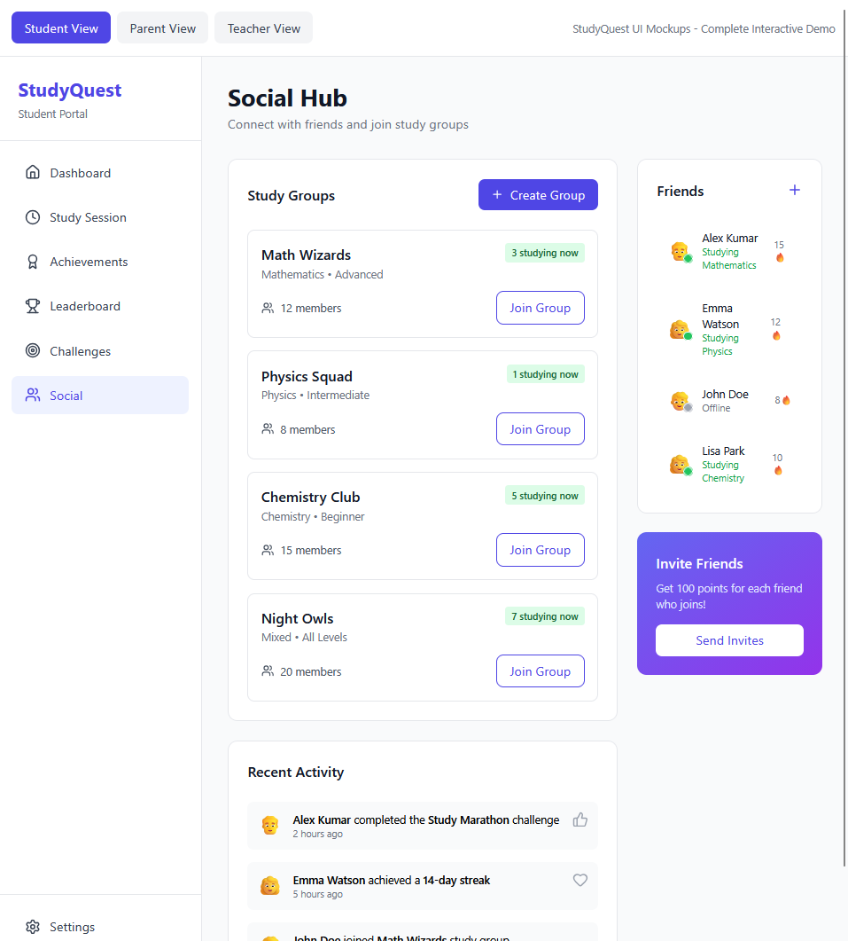

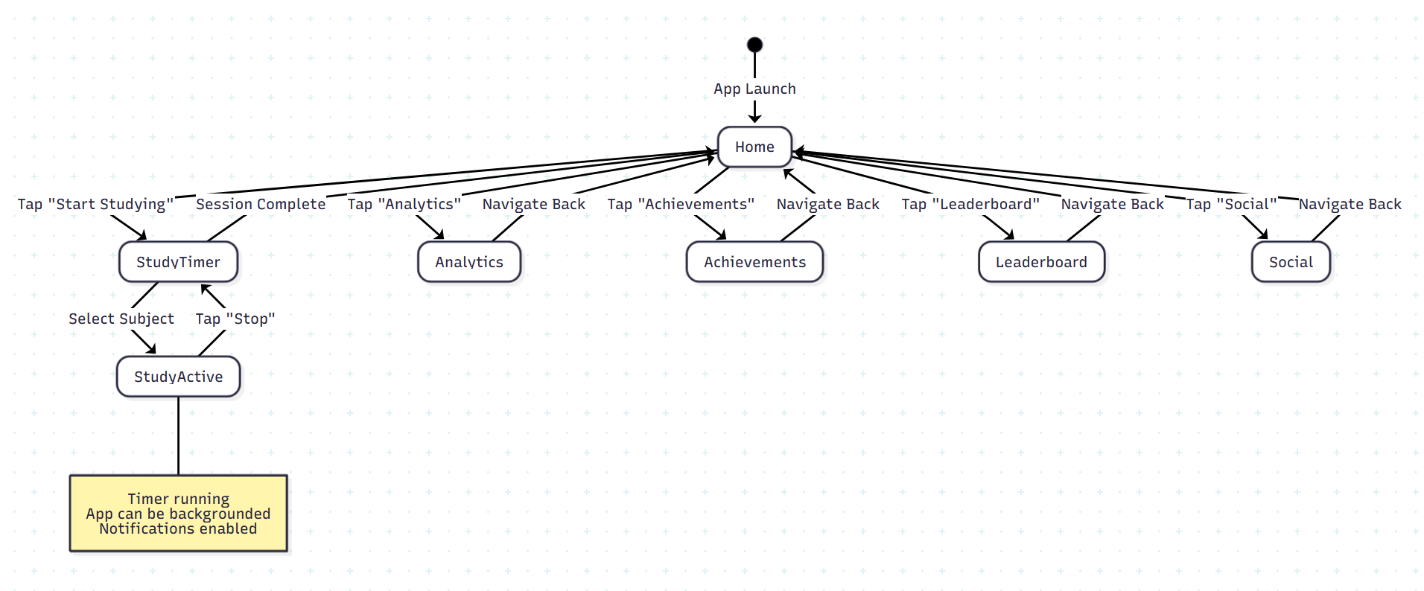
Profile
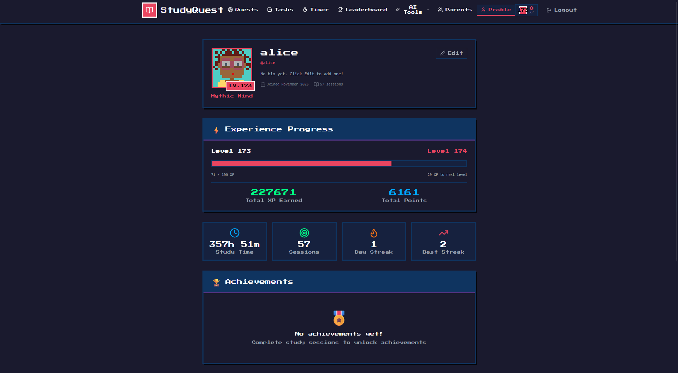
Tasks
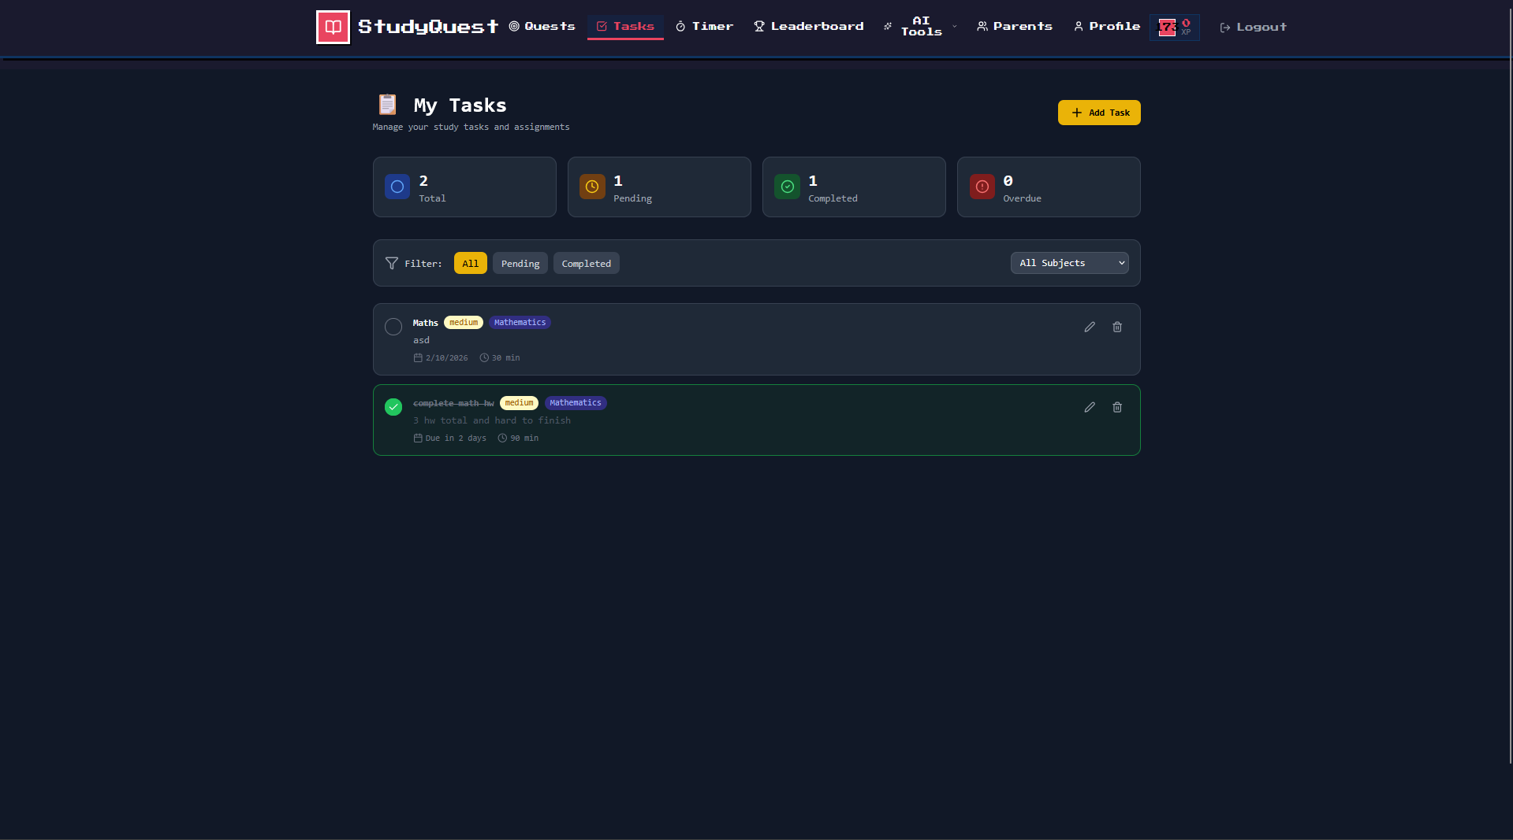

Ai
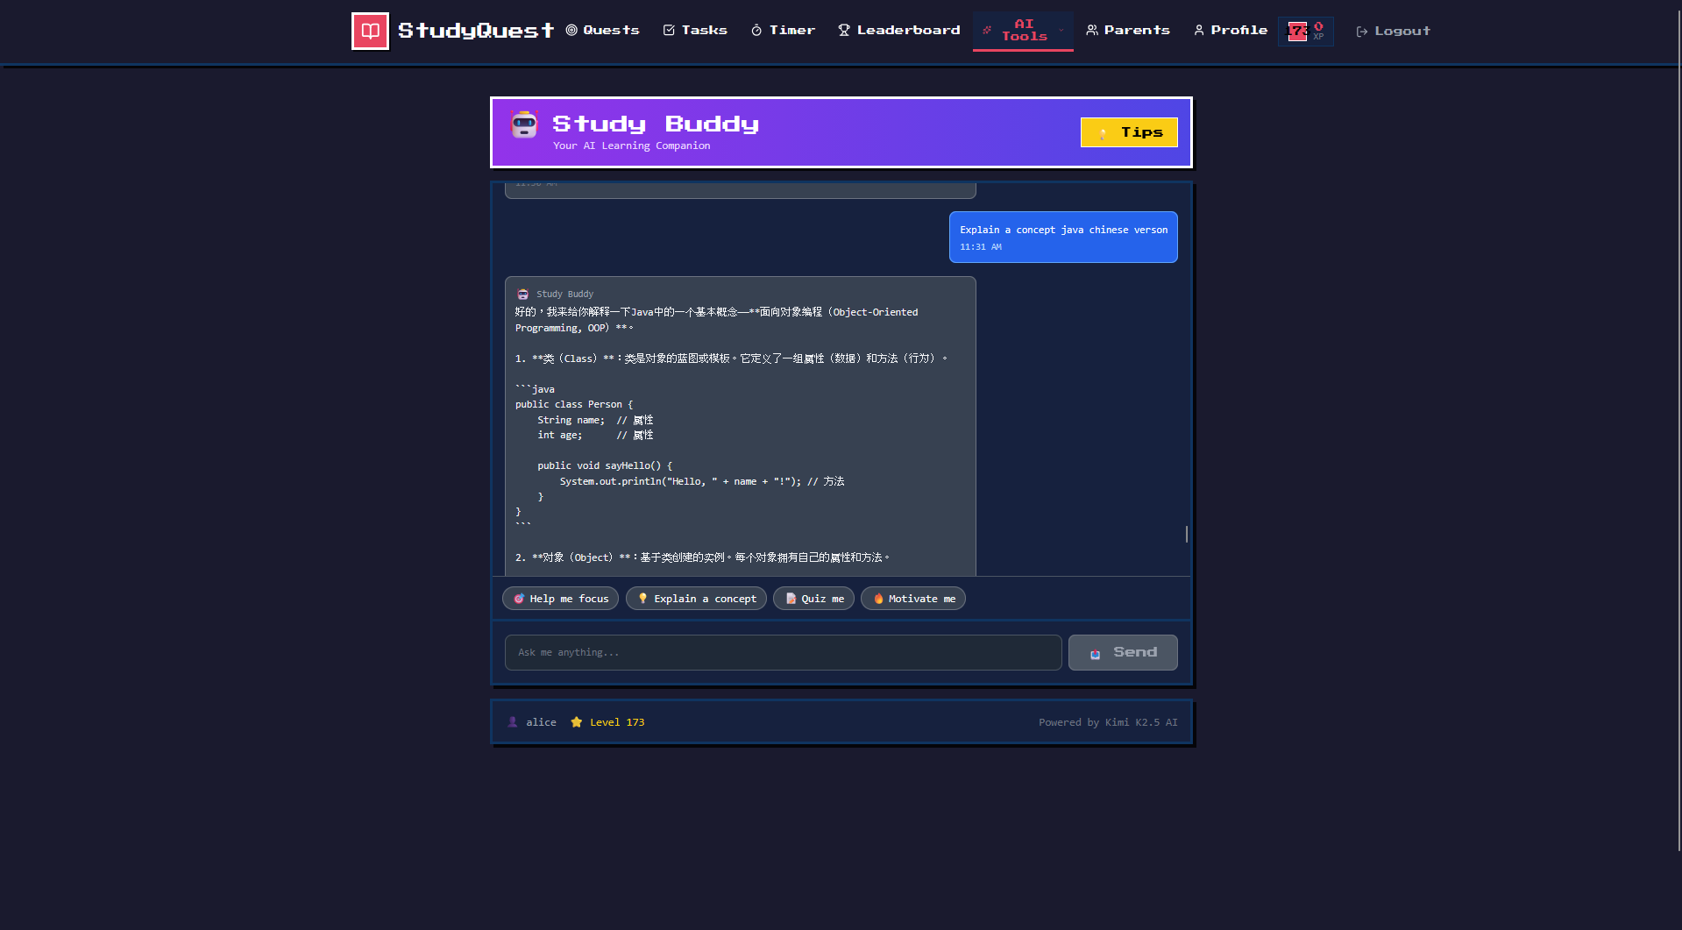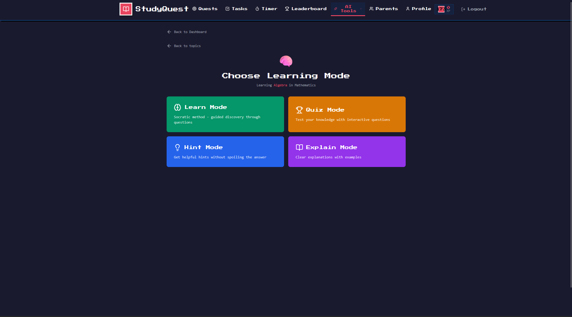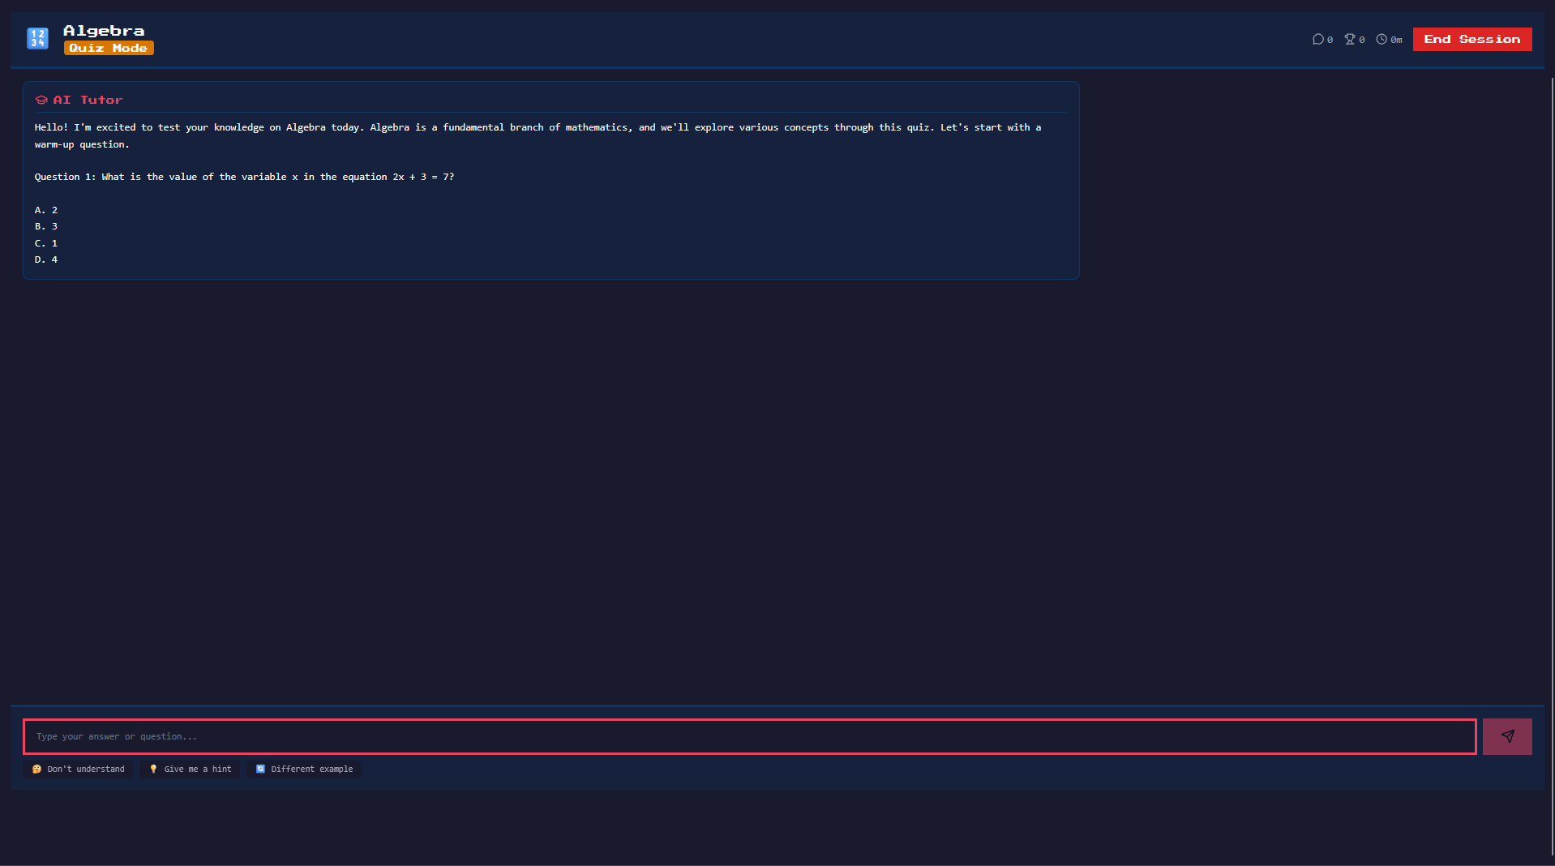
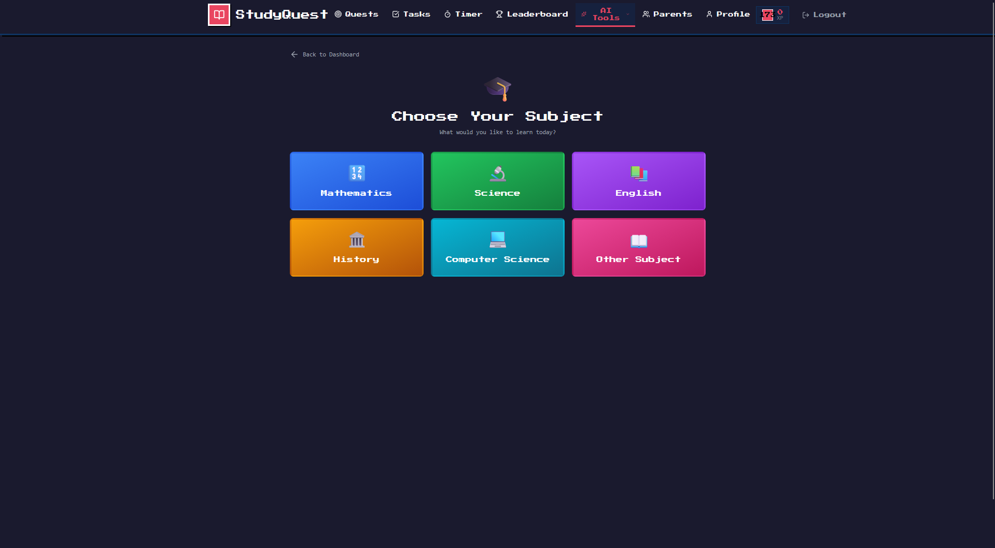

Parent Web Dashboard Screens
Children Overview
- Purpose: Quick status of all children
- Key Elements:
  - Cards for each child with photo/avatar
  - Key stats: level, streak, weekly minutes
  - Quick action buttons (view details, message, set goal)
  - Pending notifications count (verifications, reward requests)
- Design Principles:
  - Professional, data-focused design (not gamified)
  - Easy switching between children
  - Prominent alerts for action items
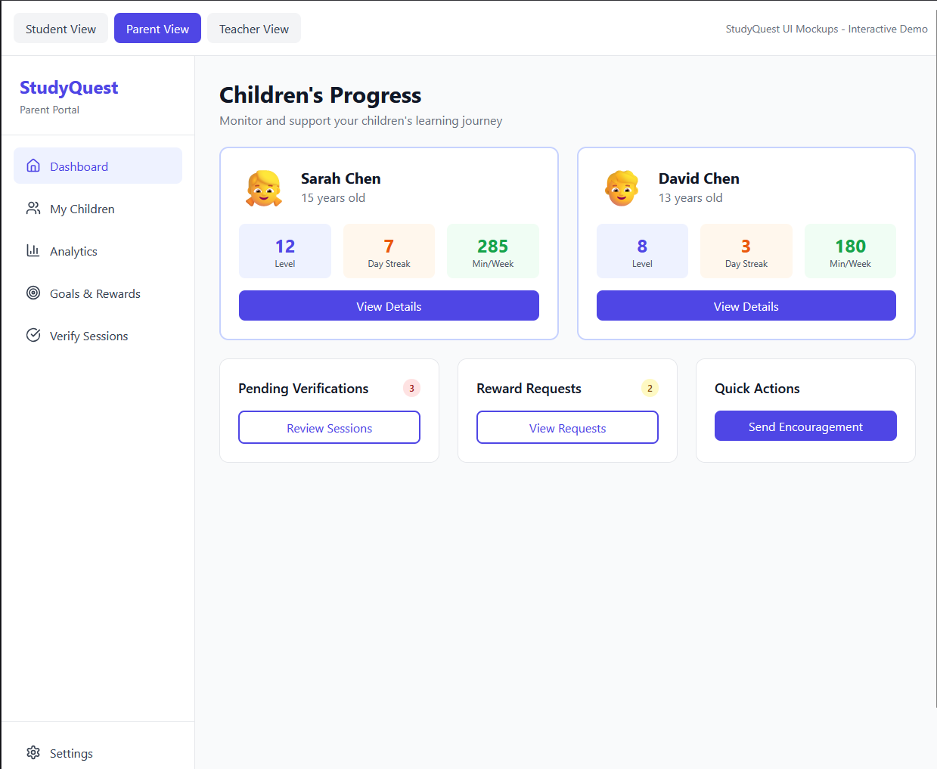
Child Detail Analytics
- Purpose: Deep dive into one child's progress
- Key Elements:
  - Header with child's name, level, total points
  - Time period selector (week, month, 3 months)
  - Total study time with trend indicator
  - Subject breakdown pie chart
  - Daily activity bar chart
  - Best study times heatmap
  - Recent sessions list
  - Session verification queue
- Design Principles:
  - Clear, professional charts
  - Export to PDF functionality
  - Drill-down for details
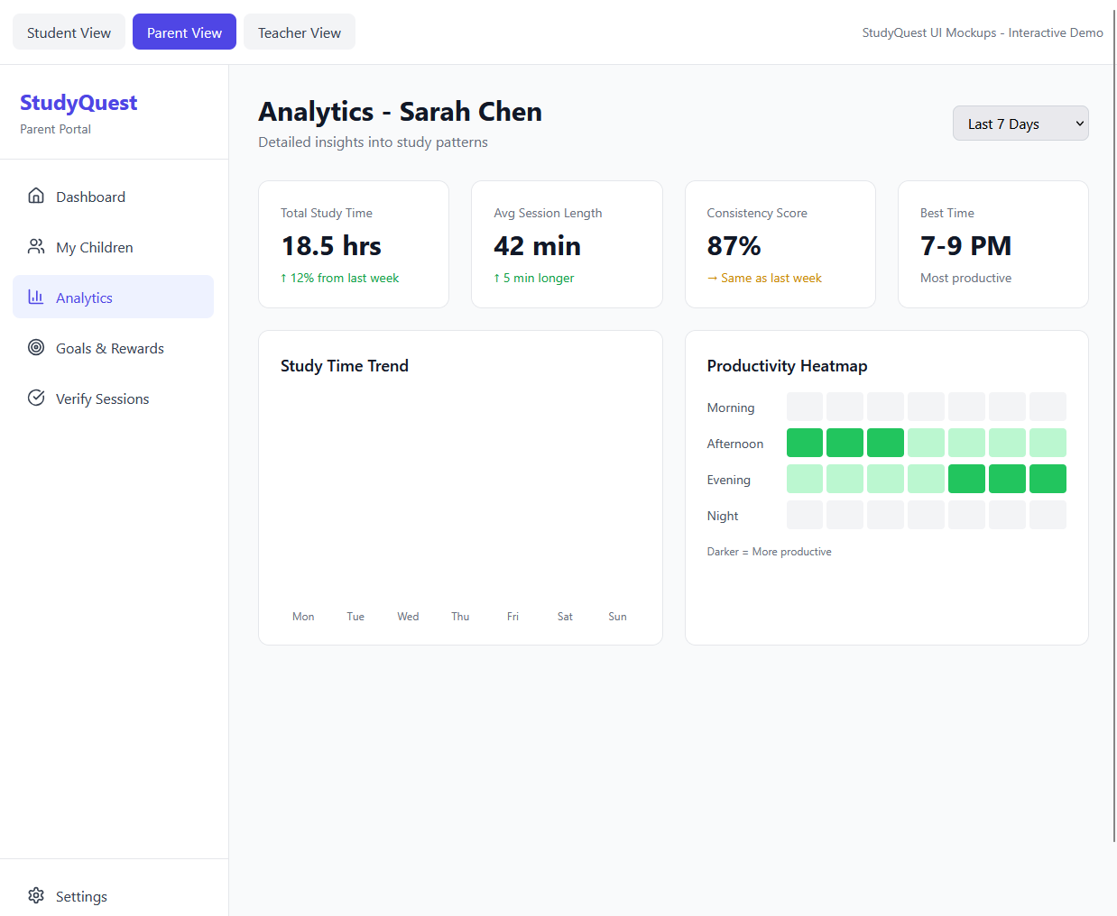
Goals & Rewards
- Purpose: Collaborative goal-setting and reward management
- Key Elements:
  - Active goals with progress bars
  - Create new goal button
  - Custom rewards list
  - Pending redemption requests (highlighted)
  - Redemption history
  - Approve/reject buttons for requests
- Design Principles:
  - Clear approval workflow
  - Goal progress visually obvious
  - Historical context for patterns
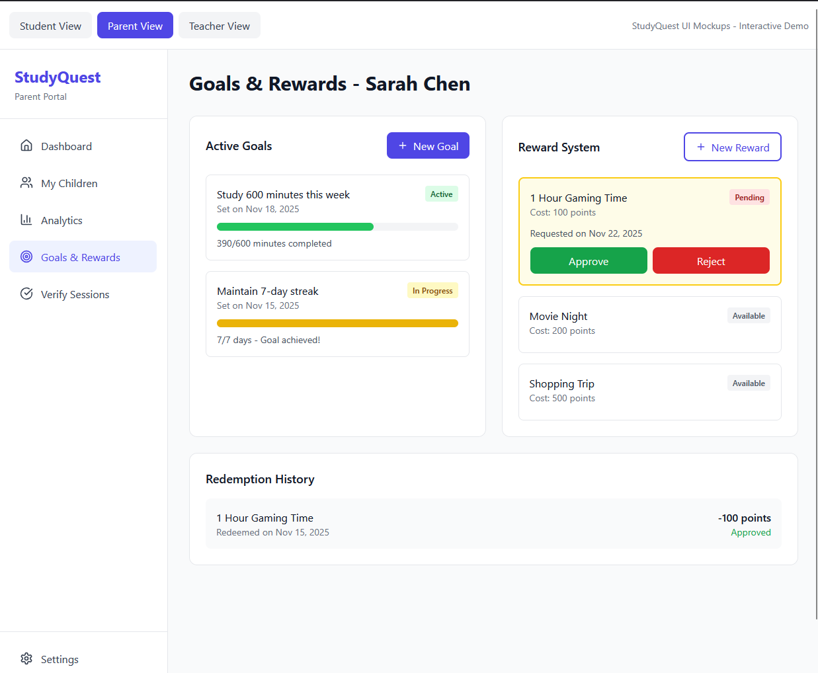
Messages & Encouragement
- Purpose: Positive communication with the child
- Key Elements:
  - Message composer
  - Conversation history
  - Quick encouragement templates
  - Bonus points button
  - Session comment field
- Design Principles:
  - Focus on positive reinforcement
  - Easy, quick interactions
  - Context from recent sessions

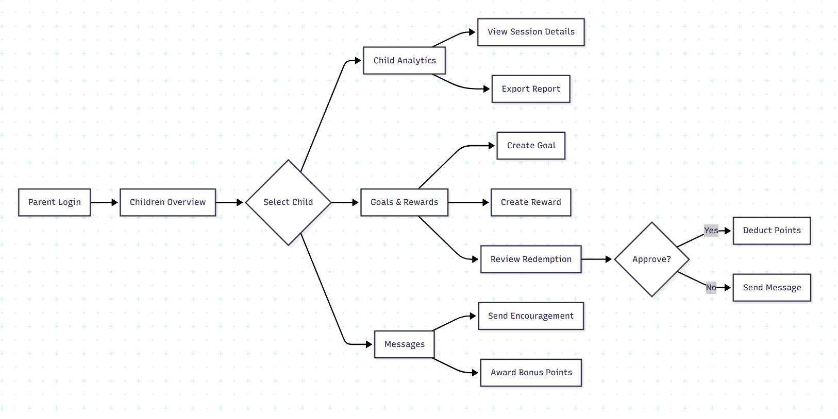

Teacher Web Dashboard Screens
- Class Overview Dashboard
What it does: Shows a summary of all students in your class
Design choices:
- Professional, data-focused layout
- Quick alerts for students who need help
- Easy access to class-wide statistics

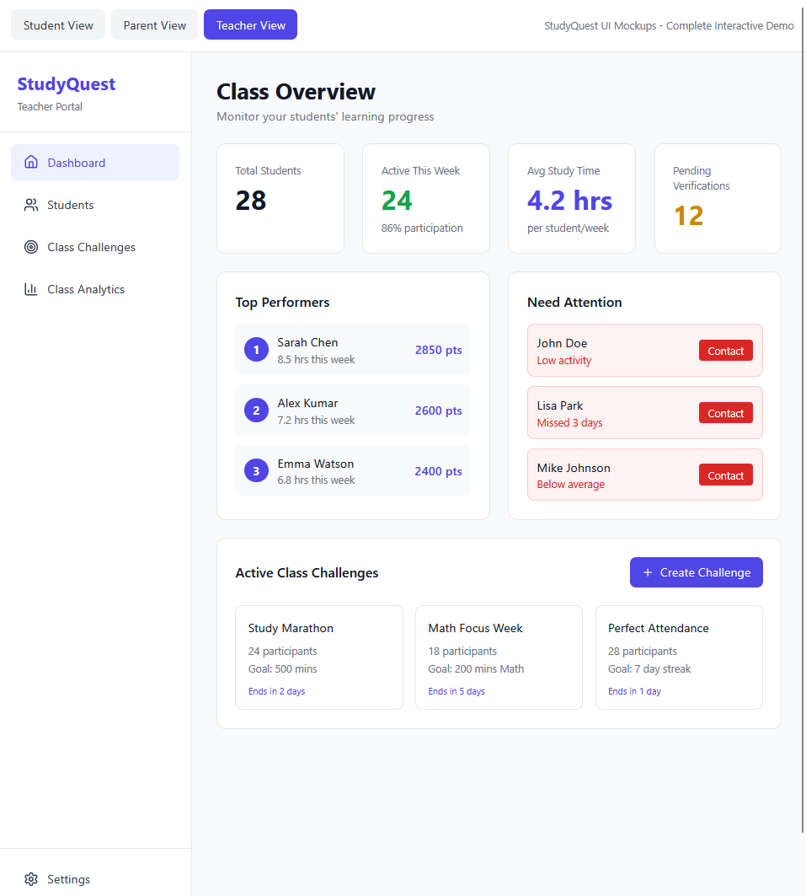

- My Students Screen
What it does: Detailed list of all your students
What you see:
- Table with all students showing:
  - Student name
  - Current level
  - Weekly study time
  - Current streak
  - Last time they were active
  - Status (excellent, good, warning)
- Search and filter options
- View button for each student's detailed report
Design choices:
- Easy-to-scan table format
- Color-coded status indicators
- Quick search to find specific students
- Can sort by any column

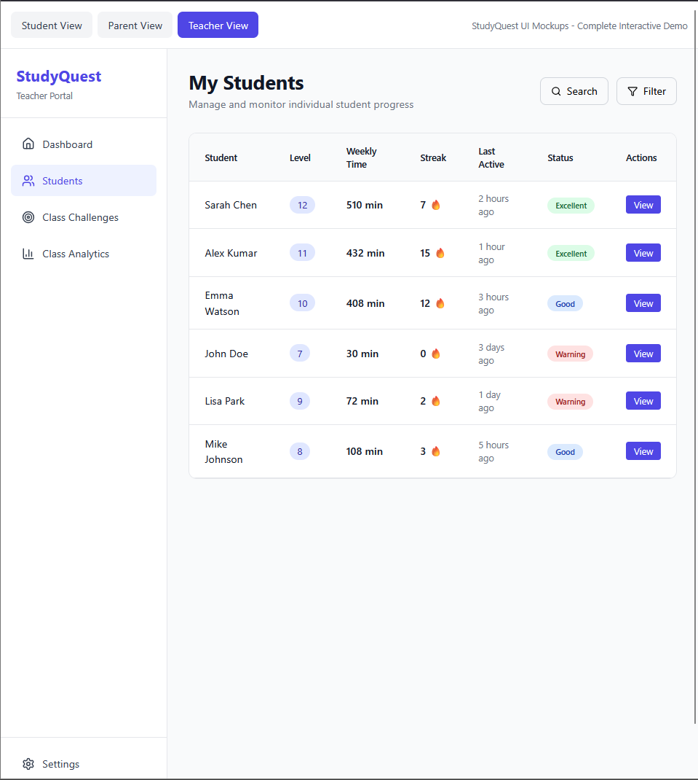

Class Challenges Screen
What it does: Create and manage challenges for your students
What you see:
- List of all active challenges
- For each challenge:
  - Challenge title and type
  - Number of participants
  - Overall progress percentage
  - Start and end dates
  - Reward points offered
- Button to create new challenges
- Tabs to filter: All, Active, Completed, Drafts
- Edit and view details buttons
Design choices:
- Clear view of all challenge activity
- Easy process to create new challenges
- Visual progress bars for each challenge
- Alerts for challenges ending soon

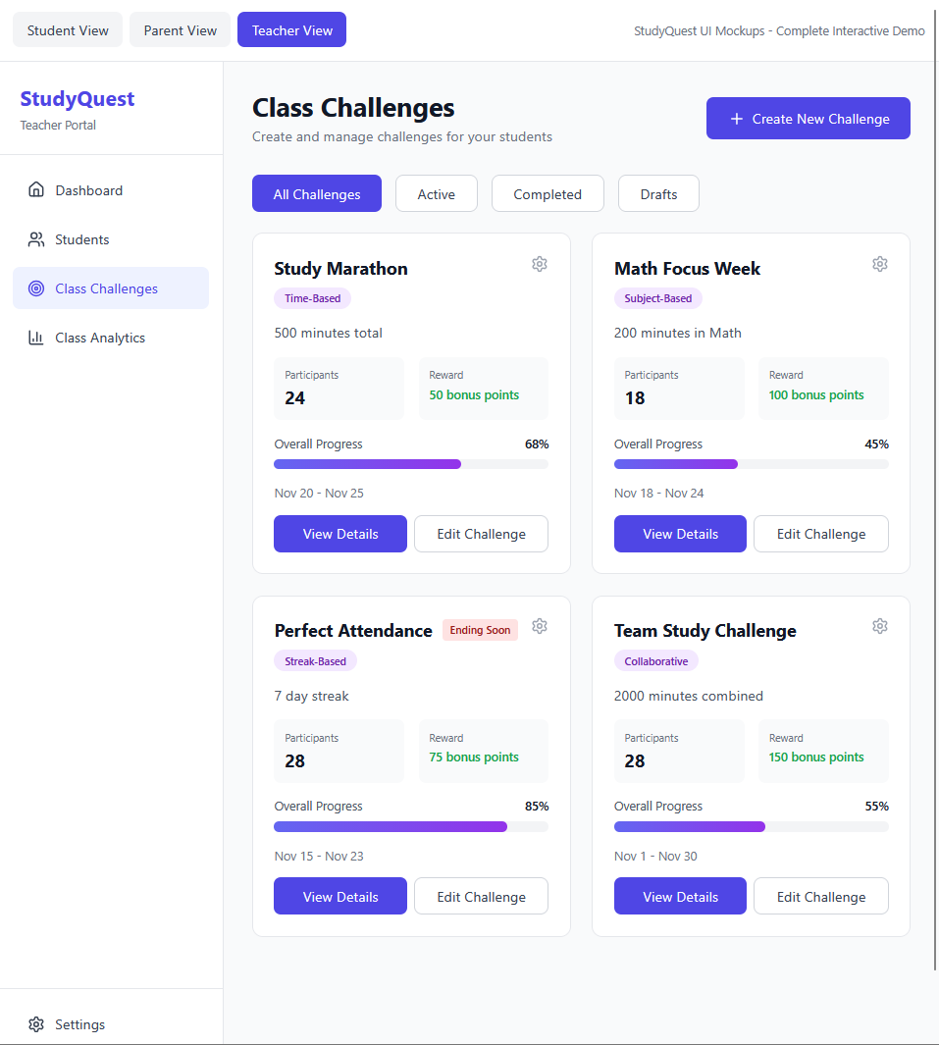

- Class Analytics Screen
What it does: Detailed statistics about class performance
What you see:
- Total study hours for the whole class
- Class average study time per student
- Participation rate percentage
- Average streak days
- Weekly study time chart (bar graph)
- Subject preferences breakdown (which subjects students study most)
- Performance categories (how many students are excellent, good, average, or need support)
- Peak study times (when students study most)
- Total achievements unlocked this week
Design choices:
- Professional charts and graphs
- Can change time periods (last 7 days, 30 days, semester)
- Easy to identify trends and patterns
- Can export data as reports



Mobile Responsiveness
Design Approach:
- Mobile-first design for student app
- Desktop-optimized for parent dashboard
- Responsive breakpoints:
  - Mobile: < 640px
  - Tablet: 640px - 1024px
  - Desktop: > 1024px
Key Responsive Behaviors:
- Navigation: Bottom tab bar on mobile, sidebar on desktop
- Charts: Stack vertically on mobile, side-by-side on desktop
- Lists: Card view on mobile, table view on desktop
- Forms: Full-width on mobile, centered on desktop

Accessibility Features
WCAG 2.1 AA Compliance:
- Color contrast ratios ≥ 4.5:1 for text
- Touch targets ≥ 44x44 pixels
- Clear focus indicators for keyboard navigation
- Alternative text for all images and icons
- Proper heading hierarchy (h1, h2, h3)
Additional Accessibility:
- Screen reader support (ARIA labels)
- Dynamic text sizing (supports system preferences)
- High contrast mode support
- Reduced motion option (respects system settings)

Integration Architecture

Third-Party Services Integration
Firebase Services:
- Authentication: User login, registration, session management
- Cloud Firestore: NoSQL document storage (for real-time features)
- Cloud Functions: Serverless backend logic
- Cloud Storage: File uploads (verification photos)
- Cloud Messaging: Push notifications
PostgreSQL Database:
- Primary data store for structured data
- Hosted on cloud provider (AWS RDS or similar)
- Daily automated backups
- Read replicas for analytics queries
AI APIs:
Kimi K2.5 API:
Purpose: Schedule optimization (complex reasoning)
Model: Kimi-K2.5
Cost: Very low ($0.60/M input, $3.00/M output tokens; )

Real-Time Data Synchronization
WebSocket Connections:
- Used for: Real-time leaderboard updates, live notifications, parent dashboard updates
- Protocol: Socket.io over WebSocket
- Fallback: Long polling for older browsers
Sync Strategy:
- Study sessions: Immediate sync to server when stopped
- Points/levels: Real-time calculation and broadcast
- Leaderboards: Refresh every 5 minutes (cached materialized view)
- Analytics: Computed on-demand, cached for 10 minutes

Security Architecture

Authentication Flow
JWT Token-Based Authentication:
- Access token: Valid for 1 hour
- Refresh token: Valid for 30 days
- Tokens stored securely (mobile: encrypted storage, web: httpOnly cookies)

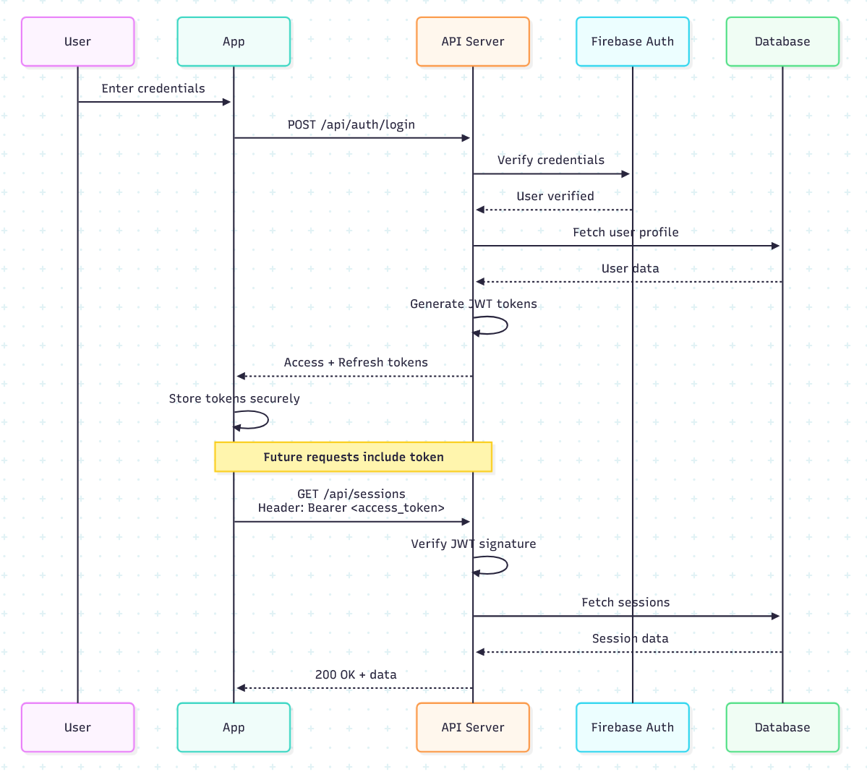

Data Protection
Encryption:
- In transit: TLS 1.3 for all communications
- At rest: Database encryption (AES-256)
- Passwords: bcrypt hashing (cost factor 12)
- Sensitive fields: Additional encryption layer (e.g., parent messages)
Access Control:
- Row-level security in database
- API checks user permissions before queries
- Parents can only access their linked children
- Teachers can only access students who added them
Privacy Controls:
- Student data never sold or used for advertising
- Parents cannot see AI chatbot conversations without student knowing
- Students control privacy settings (private/friends/public)
- Data export available (GDPR compliance)
- Account deletion removes all data within 30 days

Performance Optimization

Caching Strategy
Application-Level Cache:
- Leaderboards: 5-minute cache (Redis)
- User profiles: 10-minute cache
- Achievement definitions: 1-hour cache (rarely change)
- AI schedule recommendations: 7-day cache (regenerate weekly)
Database Optimizations:
- Materialized views for leaderboards (refreshed every 5 minutes)
- Indexes on frequently queried columns
- Partitioning large tables (study_sessions by month)
- Query optimization based on EXPLAIN analysis
Frontend Optimizations:
- Lazy loading for non-critical screens
- Image optimization and CDN delivery
- Code splitting (separate bundles per route)
- Offline capability (service workers for core features)

Scalability Considerations
Horizontal Scaling:
- Stateless API servers (can add more instances)
- Load balancer distributes traffic
- Database read replicas for analytics queries
- Separate write and read paths
Rate Limiting:
- Per-user limits:
  - API calls: 1000 requests/hour
  - AI chatbot: 50 messages/hour
  - Friend requests: 20/day
- Global limits:
  - Study session starts: 10,000/minute
  - Leaderboard queries: 100,000/minute

IMPLEMENTATION

Implementation Work Log

Phase 1: Foundation Phase
In the initial phase, a three-tier architecture and core infrastructure were established. The team configured Supabase PostgreSQL with SSL enforcement enabled and implemented a connection pool layer using the `pg` library, with a maximum concurrent connection count of 10. The Express.js 4.18 backend was bootstrapping through a middleware chain for CORS, JSON parsing, and JWT validation. Database migration 001-003 established the basic schema: the `students` table (containing role-based constraints), the `study_sessions` table (containing state enumerations), and the `tasks` table for task logging functionality. The React 19 frontend was configured with Tailwind CSS and a pixel art design system, and deployed to Vercel via a GitHub repository for automated CI/CD.

Phase Two: Core Functionality
This phase delivered the learning tracking and gamification system. Migration 004 added an achievement system with tiered badges (Bronze, Silver, Gold, Platinum). Migration 007 introduced the `hero_journeys` table to support the "doomsday shadow" procrastination narrative. The learning timer uses atomic transaction implementation: `POST /api/sessions/start` uses the `SERIALIZABLE` isolation level and `SELECT ... FOR UPDATE` to prevent race conditions during multi-device access. The experience point calculation engine uses exponential thresholds (Level 1: 100 experience points, Level 2: 112 experience points, and so on) and real-time progress updates. The parent dashboard, launched via Migration 005 (the `family_links` and `connection_codes` tables), implements a 6-digit alphanumeric invitation code system valid for 15 minutes.

Phase 3: AI Integration
AI learning partners will integrate the Kimi K2.5 API via the Moonshot AI SDK. Migration 011 significantly expands the schema, adding the `ai_conversations` table with JSONB metadata columns, the `tutor_sessions` table (SERIAL primary key), and the `tutor_messages` table with foreign key relationships. The Socratic tutoring pattern is implemented in `kimiService.js`, with age-based prompts (P1-P3 to S4-S6). The archiving alchemy feature is added in Migration 018 (the `archive_sessions` table), implementing asynchronous file processing and background operation via `setImmediate()`. To prevent API abuse and address the limitations of the free rendering plan, we added rate limits (100 requests per user per hour) and AbortController timeouts (45 seconds).

Phase Four: Refinement
Final optimizations include migrating 019 (device ID tracking for multi-device session authentication), performance indexing of frequently queried fields (`student_id` in `study_sessions` and `code` in `connection_codes`), and implementing graceful handlers to close database connections upon receiving a SIGTERM signal. Service Workers are configured as offline caches for PWA application shells, while API calls keep data retrievals up-to-date.

Test Plan and Results — Point Form

Authentication & Onboarding (TP-001)
- Register new student with valid email/username: Pass
- Register duplicate email returns 409 conflict: Pass
- Login with valid credentials returns JWT: Pass
- Login with wrong password returns 401: Pass
- Onboarding PATCH sets age_tier and daily limits: Pass
- Register parent and teacher roles: Pass

10.3.2 Study Session Lifecycle (TP-002)
- Start session with subject/topic returns active session: Pass
- Get active session returns currentDuration: Pass
- End session after 65s calculates duration and XP: Pass
- End session &lt; 1 minute returns 400 SESSION_TOO_SHORT: Pass
- End already-ended session returns 404: Pass
- Student stats auto-update after session: Pass

10.3.3 Concurrent Session Handling (TP-003)
- Start Session A on Device 1: Pass
- Start Session B on Device 2 auto-ends Session A: Pass
- Simultaneous end requests handled with row locking: Pass
- Database enforces only 1 active session per student: Pass
- 20 rapid start requests prevented by partial unique index: Pass

10.3.4 Gamification — XP, Levels & Streaks (TP-004)
- Level up triggers when crossing XP threshold: Pass
- Consecutive days increment current_streak: Pass
- Missed days reset streak and increase shadow_level: Pass
- longest_streak retains peak value after reset: Pass

10.3.5 Achievement System (TP-005)
- First session unlocks "First Session" achievement: Pass
- 5 sessions unlocks "Early Bird": Pass
- 60 minutes unlocks "Hour of Power": Pass
- 3-day streak unlocks "On Fire": Pass
- Duplicate unlock prevented (safe function): Pass
- GET /api/achievements returns unlocked_at timestamps: Pass

10.3.6 Parent-Child Linking (TP-006)
- Generate 6-char code with 15-min expiry: Pass
- Second code marks previous as used: Pass
- Parent links with valid code creates family_links: Pass
- Reused code returns 400 "already used": Pass
- Expired code returns 400 "expired": Pass
- Parent views child stats via /children-stats: Pass
- Student views linked guardians: Pass

10.3.7 AI Study Buddy Chat (TP-007)
- POST /api/ai/chat returns AI response and logs conversation: Pass
- Image URL in media array processed correctly: Pass
- GET /api/ai/history returns grouped conversations: Pass
- Rate limit 20/min enforced: Pass
- Database schema correct (message_role, message_content): Pass

10.3.8 Archive Alchemist — Document Upload (TP-008)
- Upload PDF returns 202 with sessionId and status processing: Pass
- Poll status changes to completed: Pass
- Generated notes, flashcards, concept_map populated: Pass
- File &gt; 15MB rejected with 413: Pass
- .exe file rejected with 400 "Invalid file type": Pass
- URL ingestion creates session and fetches content: Pass

10.3.9 Task Management (TP-009)
- Create task with title/subject/priority: Pass
- GET returns only current user's tasks: Pass
- Update status to completed sets completed_at: Pass
- Delete task removes from database: Pass
- Invalid priority returns 400 constraint error: Pass

10.3.14 Rate Limiting & Security (TP-014)
- 101 anonymous requests triggers 429: Pass
- 21 authenticated requests triggers 429: Pass
- 6 failed logins locks account (15-min window): Pass
- Missing JWT returns 401: Pass
- Expired JWT return: Pass

Critical Evaluation

Problems and Difficulties Encountered

During the development of the mid-stage prototype, we encountered several technical and design challenges. Integrating the Kimi API to implement AI tutoring functionality proved more complex than anticipated, particularly in maintaining conversational context across multiple messages. We needed to implement custom logic to manage session state and ensure that responses consistently adhered to educational guidelines, rather than simply providing direct answers. The database schema design also required multiple revisions as new requirements emerged during implementation. The initial design did not adequately support family linking functionality, so we added a `connection_codes` table and modified the `family_links` structure during development. Identification and role-based access control presented challenges when implementing functionality that required different approaches for students and parents. To ensure that parents could only view the profiles of children they had explicitly approved for association, we needed to carefully consider security at both the API and database levels.

Changes in Project Scope
Some features originally planned for the transitional prototype were postponed to the final release. Social features (including study groups, friend requests, and collaborative challenges) were deemed too complex and required a solid foundation before being implemented, and were therefore moved to the second phase of development. The AI-powered timetable optimizer was also simplified to basic recommendations, rather than the fully personalized system initially envisioned. While the teacher control panel has been designed and documented, it is not yet fully implemented. We decided to focus our resources on the student and parent experience, as this is the core value of StudyQuest.

Limitations of the suggestion system
The current prototype has some limitations. Offline functionality is basic, only supporting viewing cached data, without full offline session tracking and automatic synchronization. Real-time features (such as real-time leaderboard updates and real-time parent notifications) rely on polling instead of WebSocket connections, which increases server load and delays updates. The AI ​​tutoring system is entirely dependent on the availability of the external API. If the Kimi API fails, tutoring functionality will be completely unavailable. We have not yet implemented backup mechanisms or cached responses for frequently used queries. While the gamification elements are fully functional, they may not engage all students. The current system has limited personalization options for rewards and badges, which may reduce engagement from students who are not interested in competition or achievement-driven learning.

Potential Difficulties for Final Development
Scaling the application to handle more users presents several challenges. The current architecture, using simple database queries, can become extremely slow with thousands of concurrent users. Implementing proper caching with Redis and optimizing database queries requires significant effort. Ensuring data privacy compliance, particularly regarding student data and parental access permissions, necessitates careful legal review. The balance between parental oversight and student autonomy remains delicate, and our current permissions model may need improvement based on user feedback. Using real middle school students for testing presents practical challenges, including obtaining appropriate consent, coordinating test times according to school schedules, and gathering meaningful feedback from teenage users who may not be able to clearly express their preferences.

IMPLEMENTATION PLAN
This chapter presents the detailed plan for building StudyQuest from design to deployment. It covers the development methodology, project schedule, team organization, resource allocation, risk management, and testing strategy to ensure successful delivery.

Software Process Model
StudyQuest will be developed using an Agile methodology adapted for our four-person team. While traditional Scrum requires larger teams with dedicated roles, we adopt a lightweight Agile approach that emphasizes iterative development, regular feedback, and continuous improvement while remaining practical for our team size.

Why Agile for StudyQuest
Agile methodology fits StudyQuest's needs for several important reasons:
Iterative Development: Building a gamified educational app requires testing features with real users to see what actually motivates students. Agile's iterative approach lets us build a basic version quickly, get feedback, and improve it based on what we learn. We cannot know in advance exactly which gamification elements will work best, so we need the flexibility to adjust our design as we go.
Changing Requirements: Educational technology evolves rapidly, and user needs may shift during development. Agile embraces change rather than resisting it. If we discover that students want different features than we initially planned, we can adjust our priorities without derailing the entire project.
Regular Demonstrations: The university schedule requires progress demonstrations at specific points. Agile's emphasis on working software at the end of each iteration aligns perfectly with these milestone requirements. We will always have a functional version to demonstrate, even if not all features are complete.
Risk Management: Building everything at once and testing at the end is risky. If fundamental assumptions are wrong, we discover this too late to fix. Agile reduces risk by validating core concepts early through working prototypes and user testing.
Team Collaboration: Our four-person team needs everyone working together effectively. Agile's emphasis on communication, shared responsibility, and collective problem-solving helps small teams coordinate without excessive overhead.

Our Agile Approach
We adapt standard Agile practices to fit our team size and academic context:
Two-Week Sprints: Development will proceed in two-week cycles called sprints. Each sprint produces working, tested features that add value to the application. This timeframe is short enough to maintain focus but long enough to complete meaningful work.
Sprint Planning: At the start of each sprint, the team meets to select features from the prioritized backlog and commit to completing them within two weeks. We break features into small tasks that can be completed in one or two days, making progress trackable and reducing the risk of tasks dragging on indefinitely.
Daily Standups: The team meets briefly every weekday (15 minutes maximum) to share progress, plans, and problems. Each member answers three questions: What did I complete yesterday? What will I work on today? What obstacles am I facing? These short meetings keep everyone aligned without consuming excessive time.
Sprint Reviews: At the end of each sprint, we demonstrate completed features to our supervisors and potential users (fellow students, parents, teachers). This feedback guides the next sprint's priorities. If features work well, we build on them. If they miss the mark, we adjust course.
Sprint Retrospectives: After each review, the team reflects on what went well and what could improve in our development process. This continuous improvement helps us work more effectively over time.
Backlog Management: We maintain a prioritized list of all desired features. High-priority items go at the top, lower-priority items below. The backlog evolves as we learn more about user needs and technical constraints. Features can be added, removed, or re-prioritized at any time between sprints.
Flexible Roles: Instead of fixed roles (Scrum Master, Product Owner), all four team members share responsibilities. We rotate the coordination role each sprint, giving everyone experience leading and ensuring no single point of failure if someone is unavailable.

Comparison with Waterfall
A traditional Waterfall approach (complete requirements → complete design → complete implementation → complete testing) would not work well for StudyQuest:
Delayed Feedback: In Waterfall, users first see the system months after development begins. If gamification features do not motivate students as expected, discovering this after everything is built means extensive rework.
Rigid Requirements: Waterfall assumes requirements are fully known at the start. Educational technology needs evolve rapidly, and locking requirements early risks building the wrong solution.
Late Integration: Building all components separately and integrating at the end often reveals unexpected problems. Agile's continuous integration catches issues early when they are easier to fix.
No Working Software Until the End: Waterfall produces nothing demonstrable until late in the project. Our academic schedule requires multiple progress demonstrations, which Waterfall cannot easily accommodate.

Development Practices
Beyond the sprint structure, we follow these Agile engineering practices:
Continuous Integration: Code is integrated into the main codebase multiple times per day. Automated tests run on every integration to catch problems immediately. This prevents the painful "integration hell" that occurs when developers work in isolation for weeks.
Test-Driven Development: For critical features, we write automated tests before writing the feature code. This ensures code works correctly and remains correct as we make changes. It also makes the system easier to maintain and extend.
Pair Programming for Complex Features: When tackling difficult problems or learning new technologies, two team members work together at one computer. One writes code while the other reviews and suggests improvements. This produces higher-quality code and spreads knowledge across the team.
Code Reviews: All code changes are reviewed by at least one other team member before integration. This catches bugs, ensures code quality, and keeps everyone familiar with the entire codebase.
Refactoring: As we learn better ways to structure code, we improve it continuously rather than letting technical debt accumulate. Clean, well-organized code is easier to modify when requirements change.

Project Schedule
The project spans from September 2025 to April 2026, divided into three main phases that align with the university's milestone schedule.

Phase 1: Foundation and Core Features (Sep 2025 - Jan 2026)
Goal: Build the fundamental features that make StudyQuest useful: study time tracking, basic gamification, and user accounts. By the end of this phase, students can track study time, earn points and levels, and parents can view basic progress through a dashboard.
Sprint 1-2 (Sep 30 - Oct 27)
- Set up development environment and project infrastructure
- Implement user authentication (registration, login, password reset)
- Create database schema and establish connections
- Build basic React frontend structure
- Deploy initial version to testing environment
Sprint 3-4 (Oct 28 - Nov 24)
- Implement study session tracking (start, stop, subject selection)
- Build points calculation and level progression system
- Create student home dashboard with current stats
- Develop analytics screen with basic charts (total time, subject breakdown)
- Complete Initial Report (due Nov 24)
Sprint 5-6 (Nov 25 - Dec 22)
- Implement achievement/badge system
- Create parent account features and child linking
- Build parent dashboard showing child's study time and progress
- Add goal creation and tracking features
- Conduct first round of user testing with 5-10 students
Sprint 7-8 (Dec 23 - Jan 19)
- Implement streak tracking and notifications
- Add reward system (parents create rewards, students redeem)
- Polish user interface based on user feedback
- Fix critical bugs identified in testing
- Prepare for Interim Report and presentation
Deliverable for Interim Report (Feb 2, 2026): Fully functional MVP (Minimum Viable Product) with study tracking, gamification, parent dashboard, and basic goal/reward features.

Phase 2: Social and AI Features (Feb 2026 - Mar 2026)
Goal: Add features that make studying more engaging and personalized: friend connections, study groups, leaderboards, AI chatbot, and schedule recommendations.
Sprint 9-10 (Jan 20 - Feb 16)
- Implement friend request and friendship management
- Build leaderboards (global, friends, weekly)
- Create study groups/teams feature
- Add privacy controls for student profiles
- Interim Presentation and Demonstration (Week 23-24)
Sprint 11-12 (Feb 17 - Mar 15)
- Integrate Groq API for AI chatbot assistance
- Implement conversation interface and message history
- Add parent access to view chatbot conversations
- Build challenge system (daily, weekly, custom challenges)
- Progress Demonstration (Week 28, Mar 9-13)
Sprint 13 (Mar 16 - Mar 29)
- Integrate DeepSeek API for schedule recommendations
- Implement AI insights and study pattern analysis
- Create teacher account features and class management
- Polish social features based on user feedback
Deliverable for Mid-Semester: Complete application with all major features implemented and tested with 20-30 student users.

Phase 3: Refinement and Deployment (Apr 2026)
Goal: Polish the application, conduct thorough testing, fix all known bugs, optimize performance, and prepare for final presentation.
Sprint 14 (Mar 30 - Apr 12)
- Comprehensive bug fixing based on user testing feedback
- Performance optimization (caching, database query optimization)
- Security hardening and penetration testing
- Accessibility improvements (screen reader support, contrast ratios)
- Documentation completion (user guides, API documentation)
Sprint 15 (Apr 13 - Apr 19)
- Final UI/UX polish
- Load testing and scalability verification
- Deployment to production environment
- Create presentation materials and demo videos
- Complete Final Report (due Apr 20)
Final Presentation and Demonstration (Week 34-36, Apr 20-30)
- Deliver polished, production-ready application
- Demonstrate all features with real user data
- Present impact metrics (active users, study time logged, parent satisfaction)

Gantt Chart

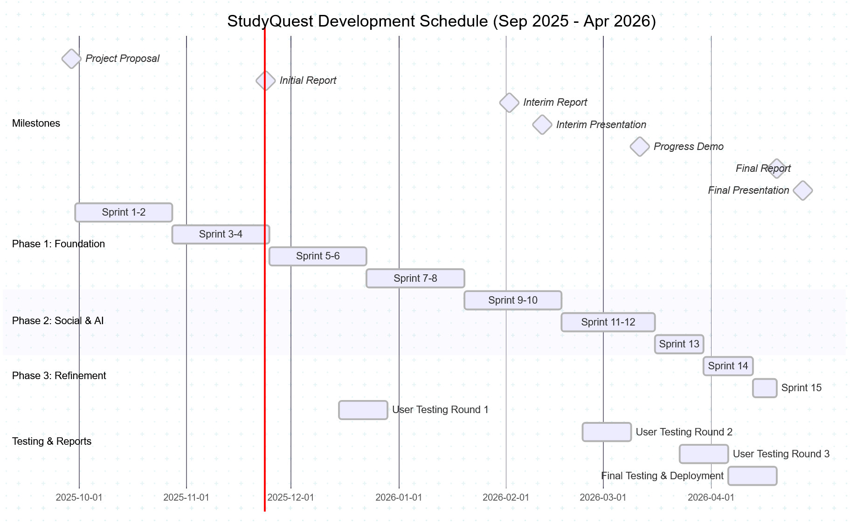

Team Organization and Responsibilities
Our four-person team divides responsibilities based on skills and interests while maintaining flexibility and shared accountability.

Team Member Roles
Cheung King Wa - Frontend Lead & UI/UX Designer
- Primary responsibility: Student mobile app interface
- Build React components for study tracking, analytics, and social features
- Design user-friendly interfaces that appeal to teenagers
- Ensure mobile responsiveness and accessibility
- Secondary: API integration on frontend
Wang Wai Shing - Backend Lead & Database Architect
- Primary responsibility: API development and database design
- Implement RESTful endpoints for all features
- Design and optimize PostgreSQL database schema
- Manage data migrations and database performance
- Secondary: Deployment and DevOps
Liang Fai Hung - AI Integration Specialist & Parent Dashboard
- Primary responsibility: AI features (chatbot, schedule recommendations)
- Integrate Groq and DeepSeek APIs
- Build parent dashboard with analytics visualizations
- Implement recommendation algorithms
- Secondary: Backend API development
Siu Tsz Kin - Testing Lead & Security Engineer
- Primary responsibility: Quality assurance and security
- Write automated tests (unit, integration, end-to-end)
- Conduct security testing and implement protections
- Coordinate user testing sessions
- Secondary: Frontend development

Rotating Coordination Role
Each sprint, one team member serves as Sprint Coordinator:
Responsibilities:
- Facilitate sprint planning and retrospective meetings
- Track sprint progress and identify blockers
- Coordinate with supervisors (Mr. Rory Lau and Mr. Cheng Pok Hong)
- Ensure documentation is updated
- Organize user testing sessions
Rotation Schedule:
- Sprint 1-2: Cheung King Wa
- Sprint 3-4: Wang Wai Shing
- Sprint 5-6: Liang Fai Hung
- Sprint 7-8: Siu Tsz Kin
- (Pattern repeats)
This rotation prevents burnout, develops leadership skills, and ensures no single point of failure.
- 7.3.3 Collaboration Practices
Communication Channels:
- WhatsApp group for daily coordination and quick questions
- Weekly in-person meetings (1.5 hours) for sprint planning and reviews
- GitHub for code collaboration, issue tracking, and documentation
- Shared Google Drive for design documents and reports
Work Allocation:
- Each sprint begins with task breakdown and assignment
- Tasks sized to 1-2 days of work maximum
- Team members can request help if stuck for more than 2 hours
- Pair programming encouraged for complex or unfamiliar features
Knowledge Sharing:
- Code reviews ensure everyone understands major features
- Weekly "tech talk" (15 minutes) where one person teaches something new
- Shared documentation in GitHub wiki
- "Buddy system" where each person has a backup who can cover their work

Resources and Tools

Software Tools and Technologies
Development:
- Frontend: React.js 18, Tailwind CSS, Progressive Web App features
- Backend: Node.js 20, Express.js 4.18
- Database: PostgreSQL 15 (managed on Railway or Supabase)
- Authentication: Firebase Authentication
- AI Services: Groq API (Llama-3), DeepSeek API (R1)
- Version Control: Git, GitHub
- IDE: Visual Studio Code
- API Testing: Postman, Insomnia
Deployment and Hosting:
- Frontend Hosting: Vercel (free tier)
- Backend Hosting: Railway or Render (free tier with student credits)
- Database: Railway PostgreSQL or Supabase (free tier)
- Domain: Free subdomain from hosting provider
Testing:
- Unit Testing: Jest (JavaScript testing framework)
- Integration Testing: Supertest (API testing)
- End-to-End Testing: Playwright (browser automation)
- Load Testing: Artillery (performance testing)
Project Management:
- Task Tracking: GitHub Projects or Trello
- Documentation: GitHub Wiki, Markdown files
- Communication: WhatsApp, email, face-to-face meetings
Design:
- UI Mockups: Figma (free tier)
- Diagrams: Mermaid.js, draw.io
- Image Editing: Canva (free tier)

Hardware and Facilities
Development Devices:
- Each team member uses personal laptop (minimum Intel i5 / M1, 8GB RAM)
- Testing devices: team members' personal smartphones (iOS and Android)
- College computer lab available for additional testing and development
Testing Environment:
- Development server: Free cloud hosting (Vercel, Railway)
- Staging server: Separate instance for testing before production release
- Production server: Final deployment for real users
Internet and Connectivity:
- Campus WiFi for on-campus work
- Personal internet connections for remote work
- All services cloud-based (no local server requirements)

Budget Considerations
StudyQuest is designed to minimize costs using free and student-friendly services:
Free Services:
- GitHub (unlimited private repositories for students)
- Vercel, Railway, Render (generous free tiers)
- PostgreSQL hosting (free tier sufficient for development)
- Firebase Authentication (free tier: 10,000 users)
- Groq API (free tier: generous request limits)
- DeepSeek API (very low cost, ~$10/month during heavy development)
Potential Paid Services (if needed):
- DeepSeek API: Estimated $20-30 for entire project
- Railway database upgrade: $5/month if free tier insufficient
- Domain name (optional): $12/year
Total Estimated Cost: $50-80 for entire project (well within typical student budget)

Deployment Strategy

Development Environment
Purpose: Individual developer testing and experimentation
Setup:
- Each team member runs app locally on their computer
- Uses local PostgreSQL database with test data
- Rapid iteration without affecting others
- Code committed to personal Git branches

Staging Environment
Purpose: Integration testing and stakeholder previews
Setup:
- Deployed to Railway/Render staging instance
- Separate database from production
- Mimics production environment
- Accessible to team and supervisors via URL
Deployment Process:
- Automated deployment when code merged to staging branch
- Runs all automated tests before deploying
- Team reviews on real devices (phones, tablets)

Production Environment
Purpose: Real users access the live application
Setup:
- Deployed to Railway/Render production instance
- Production PostgreSQL database
- Custom domain name
- Full monitoring and logging
Deployment Process:
- Manual deployment to production after successful staging testing
- Database migrations run automatically
- Rollback plan ready if critical issues discovered
- Deployed Friday evenings to minimize disruption
Rollback Plan:
- Keep previous version deployable for 48 hours
- If critical bug found, revert to previous version
- Fix bug in staging, re-test, re-deploy

Monitoring and Maintenance
Application Monitoring:
- Error tracking: Automatic alerts for crashes or exceptions
- Performance monitoring: Track response times, database query speeds
- User analytics: Monitor active users, feature usage
Database Backups:
- Automatic daily backups to separate geographic location
- Backup retention: 30 days
- Monthly backup restoration test to verify backups work
Security Updates:
- Dependency updates weekly (automated via Dependabot)
- Security patches applied within 24 hours of discovery
- Regular security audits

APPENDICES

A1 Original Project Plan (from Interim Report)

A1.1 Development Practices
• Continuous Integration: Code integrated multiple times daily; automated tests on every integration
• Test-Driven Development: Automated tests written before feature code for critical components
• Pair Programming: Two members working together for complex features or new technologies
• Code Reviews: All changes reviewed by at least one other member before integration
• Refactoring: Continuous code improvement to prevent technical debt accumulation

A1.2 Phase 1: Foundation and Core Features (Sep 2025 – Jan 2026)
Goal: Build fundamental features—study time tracking, basic gamification, user accounts.

Sprint 1-2 (Sep 30 – Oct 27):
• Set up development environment and project infrastructure
• Implement user authentication (registration, login, password reset)
• Create database schema and establish connections
• Build basic React frontend structure
• Deploy initial version to testing environment

Sprint 3-4 (Oct 28 – Nov 24):
• Implement study session tracking (start, stop, subject selection)
• Build points calculation and level progression system
• Create student home dashboard with current stats
• Develop analytics screen with basic charts
• Complete Initial Report (due Nov 24)

Sprint 5-6 (Nov 25 – Dec 22):
• Implement achievement/badge system
• Create parent account features and child linking
• Build parent dashboard showing child's study time and progress
• Add goal creation and tracking features

Sprint 7-8 (Dec 23 – Jan 19):
• Implement streak tracking and notifications
• Add reward system (parents create rewards, students redeem)
• Polish user interface based on user feedback
• Fix critical bugs identified in testing
• Prepare for Interim Report and presentation

Deliverable (Feb 2, 2026): Functional MVP with study tracking, gamification, parent dashboard.

A1.3 Phase 2: Social and AI Features (Feb 2026 – Mar 2026)
Goal: Add friend connections, study groups, leaderboards, AI chatbot, schedule recommendations.

Sprint 9-10 (Jan 20 – Feb 16):
• Implement friend request and friendship management
• Build leaderboards (global, friends, weekly)
• Create study groups/teams feature
• Add privacy controls for student profiles
• Interim Presentation and Demonstration (Week 23-24)

Sprint 11-12 (Feb 17 – Mar 15):
• Integrate Groq API for AI chatbot assistance
• Implement conversation interface and message history
• Add parent access to view chatbot conversations
• Build challenge system (daily, weekly, custom challenges)
• Progress Demonstration (Week 28, Mar 9-13)

Sprint 13 (Mar 16 – Mar 29):
• Integrate DeepSeek API for schedule recommendations
• Implement AI insights and study pattern analysis
• Create teacher account features and class management
• Polish social features based on user feedback

Deliverable: Complete application with all major features.

A1.4 Phase 3: Refinement and Deployment (Apr 2026)
Goal: Polish, thorough testing, bug fixes, performance optimization, final presentation.

Sprint 14 (Mar 30 – Apr 12):
• Comprehensive bug fixing based on user testing feedback
• Performance optimization (caching, database query optimization)
• Security hardening and penetration testing
• Accessibility improvements (screen reader support, contrast ratios)
• Documentation completion (user guides, API documentation)

Sprint 15 (Apr 13 – Apr 19):
• Final UI/UX polish
• Load testing and scalability verification
• Deployment to production environment
• Create presentation materials and demo videos
• Complete Final Report (due Apr 20)

Final Presentation (Week 34-36, Apr 20-30):
• Deliver polished, production-ready application
• Demonstrate all features with real user data
• Present impact metrics

A1.5 Team Organization (Original Plan)
• Cheung King Wa – Frontend Lead & UI/UX Designer
• Wang Wai Shing – Backend Lead & Database Architect
• Liang Fai Hung – AI Integration Specialist & Parent Dashboard
• [Note: Interim Report mentioned 4th member Siu Tsz Kin as Testing Lead, but actual team is 3 members per declaration]

A1.6 Resources and Tools (Planned)
• Frontend: React.js 18, Tailwind CSS, PWA features
• Backend: Node.js 20, Express.js 4.18
• Database: PostgreSQL 15 (Railway or Supabase)
• AI: Groq API (Llama-3), DeepSeek API (R1)
• Deployment: Vercel (frontend), Railway(backup)/Render (backend)

Revised Project Plan (Actual Execution)

A2.1 Changes Summary
• AI APIs: Changed from Groq/DeepSeek to Kimi K2.5 (Moonshot AI) for superior Chinese/English support and File API capabilities
• Team Size: 3 members (Cheung King Wa, Wang Wai Shing, Liang Fai Hung) — no 4th member
• Social Features: Deferred real-time chat/groups

• Schedule: Archive Alchemist added March 2026 (not in original plan); Teacher Module partial completion only

A2.2 Phase 1 Actual (Sep 30 – Jan 19, 2026)
• Sprint 1-2: Environment setup completed (135 hrs vs 120 planned)
• Sprint 3-4: Study timer with Mission 62 atomic transactions completed (165 hrs vs 140 planned)
• Sprint 5-6: Achievement system and hero_journeys added (145 hrs vs 130 planned)
• Sprint 7-8: Kimi API integration instead of Groq; async processing implemented (175 hrs vs 150 planned)
• Status: Interim Report delivered Feb 2, 2026 with functional AI and family features

A2.3 Phase 2 Actual (Jan 20 – Mar 29, 2026)
• Sprint 9-10: Basic friend system and leaderboards completed; real-time chat deferred (120 hrs vs 160 planned)
• Sprint 11-12: Archive Alchemist added (not in original scope); used Kimi File API (160 hrs vs 140 planned)
• Sprint 13: Revision Mode completed; Teacher Module partial (basic class management only)
• Status: Feature-complete except deferred social features

A2.4 Phase 3 Actual (Mar 30 – Apr 20, 2026)
• Sprint 14: Testing TP-001 to TP-015, UAT with 5 families, ERD corrections (110 hrs vs 100 planned)
• Sprint 15: Final Report compilation, diagram fixes, presentation prep (95 hrs vs 80 planned)
• Status: On track for April 20 deadline

A2.5 Actual Effort
• Total: 1,105 person-hours (368 hrs/person)
• Variance: +20% over estimate (185 hours additional)
• Major overruns: Mission 62 concurrency fixes (+25 hrs), Kimi integration complexity (+25 hrs), Archive Alchemist addition (+20 hrs)

A2.6 Actual Team Responsibilities
• Cheung King Wa: Frontend Lead (React 19, PWA, Archive Alchemist UI)
• Wang Wai Shing: Backend Lead (Database, API, Mission 62 transactions)
• Liang Fai Hung: AI Integration (Kimi API, prompts, document processing)

A2.7 Actual Tech Stack
• Frontend: React 19, Tailwind CSS, PWA with service workers
• Backend: Node.js 20, Express 4.18, JWT authentication
• Database: Supabase PostgreSQL 15 (not Railway), Row Level Security enabled
• AI: Kimi K2.5 API (Moonshot AI) — replaced Groq/DeepSeek
• Deployment: Vercel (frontend), Render (backend)

REFERENCES
BBC News. (2025, July 22). Is education tech boom helping or harming pupils?
https://www.bbc.com/news/articles/cdezp6yg9ppo

Schwartz, D. (2024, February). How technology is reinventing education.
Stanford Graduate School of Education.
https://news.stanford.edu/stories/2024/02/technology-in-education

Stamford American School Hong Kong. (2025, January 6). How important is technology in education? Benefits, challenges, and impact on students.
https://www.sais.edu.hk/blog/how-important-is-technology-in-education-benefits-challenges-and-impact-on-students/

Tang, C. (2025, March 21). HK schools should embrace proper use of smartphones and AI tools. China Daily Hong Kong.
https://www.chinadailyhk.com/hk/article/607480

Asgar, D. (2025). Analysing the effectiveness of different AI-based tutoring systems and their impact on education across global contexts: A literature review. National High School Journal of Science.
https://nhsjs.com/2025/analysing-the-effectiveness-of-different-ai-based-tutoring-systems-and-their-impact-on-education-across-global-contexts-a-literature-review/

Goldman, A. (2024, July 18). Students' lack of focus is the top barrier to learning, school leaders say. Education Week.
https://www.edweek.org/leadership/students-lack-of-focus-is-the-top-barrier-to-learning-school-leaders-say/2024/07

Hari Rajan, M., Herbert, C., & Polly, P. (2024). Disrupted student engagement and motivation: Observations from online and face-to-face university learning environments. Frontiers in Education, 8, 1320822.
https://doi.org/10.3389/feduc.2023.1320822

Hempenstall, K. (2025). The impact of parental involvement on the education outcomes of their children. National Institute for Direct Instruction.
https://www.nifdi.org/resources/hempenstall-blog/972-the-impact-of-parental-involvement-on-the-education-outcomes-of-their-children-2025.html

Kestin, G., Miller, K., Klales, A., Milbourne, T., & Ponti, G. (2025). AI tutoring outperforms in-class active learning: An RCT introducing a novel research-based design in an authentic educational setting. Scientific Reports, 15, 17458.
https://doi.org/10.1038/s41598-025-97652-6

Paulo, D. A., & Othman, D. (2025, May 23). Teenage students often use AI to do homework, a survey finds. This is the impact on their grades. CNA Insider.
https://www.channelnewsasia.com/cna-insider/secondary-students-using-artificial-intelligence-ai-homework-grades-singapore-5146911

Stanford, L. (2023, July 25). Does parent involvement really help students? Here's what the research says. Education Week.
https://www.edweek.org/leadership/does-parent-involvement-really-help-students-heres-what-the-research-says/2023/07

Chen, C.-H., & Chiu, C.-H. (2016). Employing intergroup competition in
multitouch design-based learning to foster student engagement, learning
achievement, and creativity.
https://www.sciencedirect.com/science/article/abs/pii/S0360131516301658

Fredricks, J. A., Blumenfeld, P. C., & Paris, A. H. (2004). School
engagement: Potential of the concept, state of the evidence.
https://www.scirp.org/reference/referencespapers?referenceid=2817381

Goldman, A. (2024, July 18). Students' lack of focus is the top barrier
to learning, school leaders say. Education Week.
https://www.edweek.org/leadership/students-lack-of-focus-is-the-top-barrier-to-learning-school-leaders-say/2024/07

Hempenstall, K. (2025). The impact of parental involvement on the
education outcomes of their children.
https://www.nifdi.org/resources/hempenstall-blog/972-the-impact-of-parental-involvement-on-the-education-outcomes-of-their-children-2025.html

Khan, A., Ahmad, F. H., & Malik, M. M. (2017). Use of digital game based
learning and gamification in secondary school science: The effect on
student engagement, learning and gender difference.
https://www.researchgate.net/publication/318457365_Use_of_digital_game_based_learning_and_gamification_in_secondary_school_science_The_effect_on_student_engagement_learning_and_gender_difference

Kuh, G. D. (2009). The National Survey of student engagement: Conceptual
and empirical foundations.
https://onlinelibrary.wiley.com/doi/10.1002/ir.283

Ruiz, J. J. R., Sanchez, A. D. V., & Figueredo, O. R. B. (2024). Impact
of gamification on school engagement: A systematic review.
https://www.frontiersin.org/journals/education/articles/10.3389/feduc.2024.1466926/full

Appendices

